Repository <https://github.com/natarazworld/NTSPBMS615Repo.git>

<https://github.com/natarazworld/NTSPBMS615Repo.git>

Git Hub : <https://www.youtube.com/watch?v=_frCuw5JWdQ&list=PLVlQHNRLflP-C43xWt10PB3gKC8DDPB12>

Gradle : <https://www.youtube.com/watch?v=5JkqrUu4kGM>

<https://www.youtube.com/watch?v=CfATtI9_nMA>

<https://www.youtube.com/watch?v=A12Z8LjJEMo>

<https://www.youtube.com/watch?v=jTJwieViWQQ&t=7074s>

**Microservices Introduction Videos: Spring Rest & Microservices**

Day-1 [https://youtu.be/Tlp45YhOE-8](https://l.facebook.com/l.php?u=https%3A%2F%2Fyoutu.be%2FTlp45YhOE-8%3Ffbclid%3DIwAR1htMB_oTj9-4MWbzB9rk9E_FaKO94pEkkqBT6LUstz91O7nFwsBBksEuo&h=AT2piIgHExr9vRcYVFfU70dBE82o35lURkeztvYaxScN6DQlX_nDzdrpEbIfmeZoGTojlnuq71dYmVoN80gbNoiv8-k3GLZNLtimSqOydBpLFgNGLpbeaKbiz2EP5RfQl9R8&__tn__=-UK-R&c%5b0%5d=AT05PAF6wtEL5U5msvUwOZS2cTEpcdD9SUzX9wqAilFYdLtkVpJiE_gwQynSemoPTGQ4OOv8dngPplm303F4h0ZXeRKLEm2L8BarnfdophVtU2QpdsBRchmEv_cZLa2Jd7TflMqHHZApaGy5axQxoe8lwVNGzk3kcRh8eIxjsuCOF-GfEa-zG_JX2NNcqLZ99tmT84Z-6f-H)

Day-2 [https://youtu.be/EpaNqWAVadI](https://l.facebook.com/l.php?u=https%3A%2F%2Fyoutu.be%2FEpaNqWAVadI%3Ffbclid%3DIwAR26XRHmswsytH72hYCctZrjPDAfrIe9eWgkmMxfUPlt0sATh-Ug7Px5CGQ&h=AT1qOwXCErOme3DJZRFZ4CUMqv-vuYSq5aWMKnehBhsl9MZWbo14wLsusMWhDhiToXPA9NlvyLeeZD1fJRJmZX0TJcoZxFznOr25cCx2ULbw4SuSpdRa4OUrXJW-xT6JO1kx&__tn__=-UK-R&c%5b0%5d=AT05PAF6wtEL5U5msvUwOZS2cTEpcdD9SUzX9wqAilFYdLtkVpJiE_gwQynSemoPTGQ4OOv8dngPplm303F4h0ZXeRKLEm2L8BarnfdophVtU2QpdsBRchmEv_cZLa2Jd7TflMqHHZApaGy5axQxoe8lwVNGzk3kcRh8eIxjsuCOF-GfEa-zG_JX2NNcqLZ99tmT84Z-6f-H)

Day-3 [https://youtu.be/BWfLY15xj_w](https://l.facebook.com/l.php?u=https%3A%2F%2Fyoutu.be%2FBWfLY15xj_w%3Ffbclid%3DIwAR34j_y7dHTjyFmhTkho012TB38YkrG2EI5JUpSqII5Ju7NdoEyihcHeWbo&h=AT2rPLLDC6FYkG1VEVrmINRk4bCI_UTGUhQNPBG0buQW3uXE_Q9qndy8aT_rPma85XidHKwflRY084zUGkEtFx8DQy7ZjguG28p29Hk6hUUDuJG-TvNJa0jc_sFnkQ6xC5pk&__tn__=-UK-R&c%5b0%5d=AT05PAF6wtEL5U5msvUwOZS2cTEpcdD9SUzX9wqAilFYdLtkVpJiE_gwQynSemoPTGQ4OOv8dngPplm303F4h0ZXeRKLEm2L8BarnfdophVtU2QpdsBRchmEv_cZLa2Jd7TflMqHHZApaGy5axQxoe8lwVNGzk3kcRh8eIxjsuCOF-GfEa-zG_JX2NNcqLZ99tmT84Z-6f-H)

Day-4 [https://youtu.be/UQJ8ToGWN4Y](https://youtu.be/UQJ8ToGWN4Y?fbclid=IwAR0Fw0cHlZ4wF5I9apviLZcvMd5rIR_RUwsXR1QkMl6bVUSV2vTYE27dCAs)

Day-5 [https://youtu.be/05Kg91stFtU](https://youtu.be/05Kg91stFtU?fbclid=IwAR3fsWOKI3ZpbsXZ0wN73dowj9H9C7t0F7qtky46JzDS_2spELgq07SWdN0)

Day-6 [https://youtu.be/p9MJ-aSNlM0](https://youtu.be/p9MJ-aSNlM0?fbclid=IwAR3fsWOKI3ZpbsXZ0wN73dowj9H9C7t0F7qtky46JzDS_2spELgq07SWdN0)

**Junit5, HttpUnit & Mockito Workshop Session-1 | by Mr. Nataraj**

https://www.youtube.com/watch?v=6VVplfYp40M

https://www.youtube.com/watch?v=AI3b3FY2iD0

https://www.youtube.com/watch?v=7Xq4j0Q7aPE

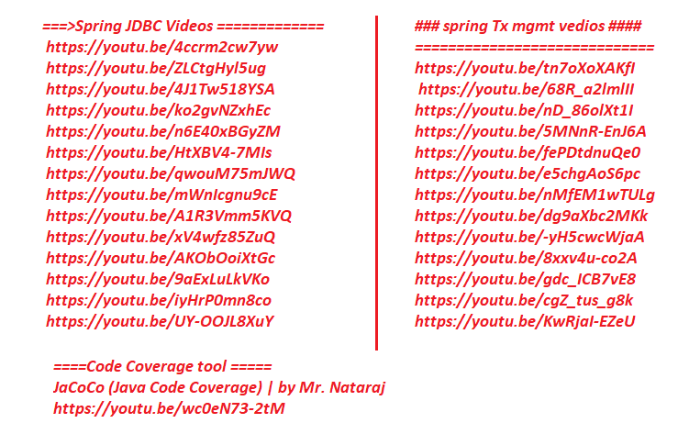

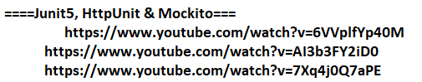

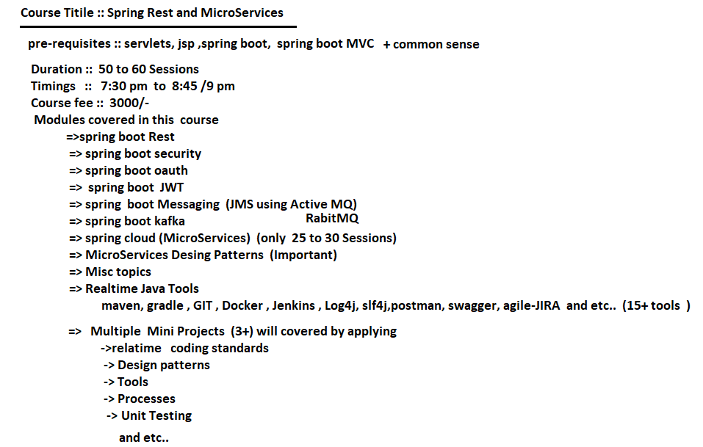

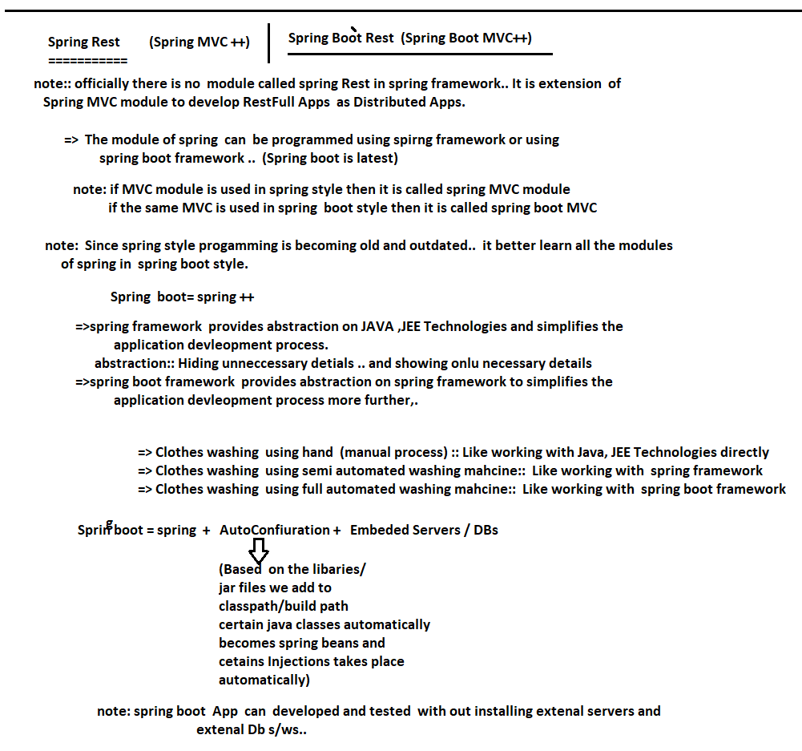

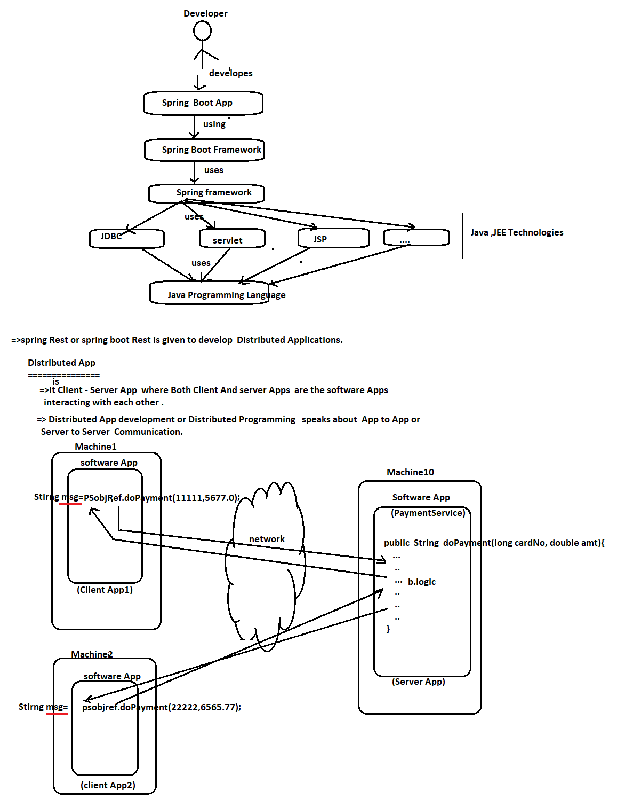

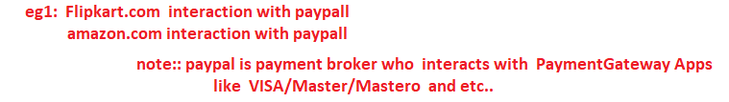

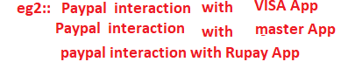

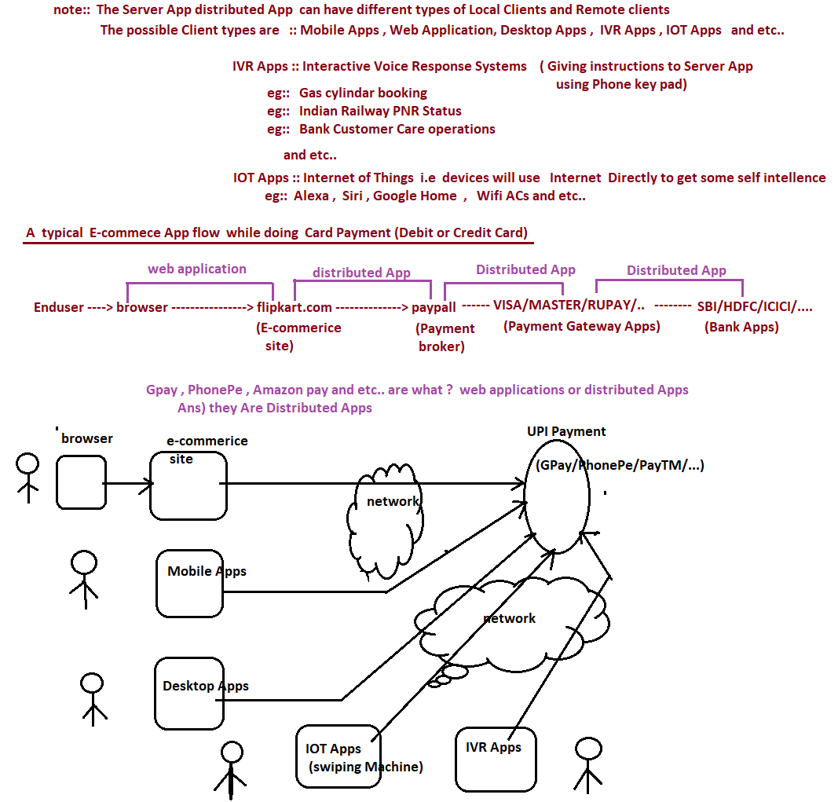

NTSPBMS615-More on Distributed Apps- May 24th 2022

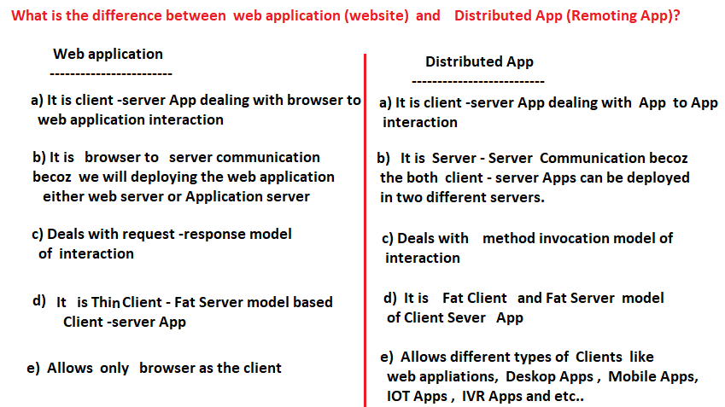



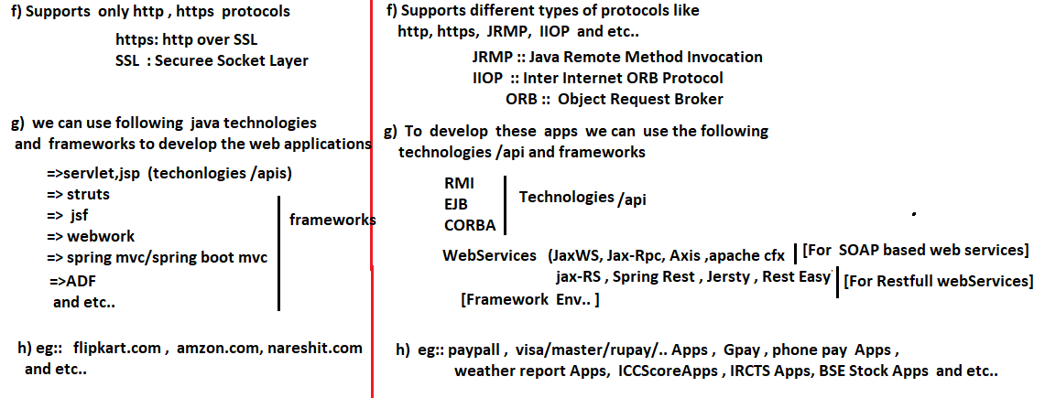

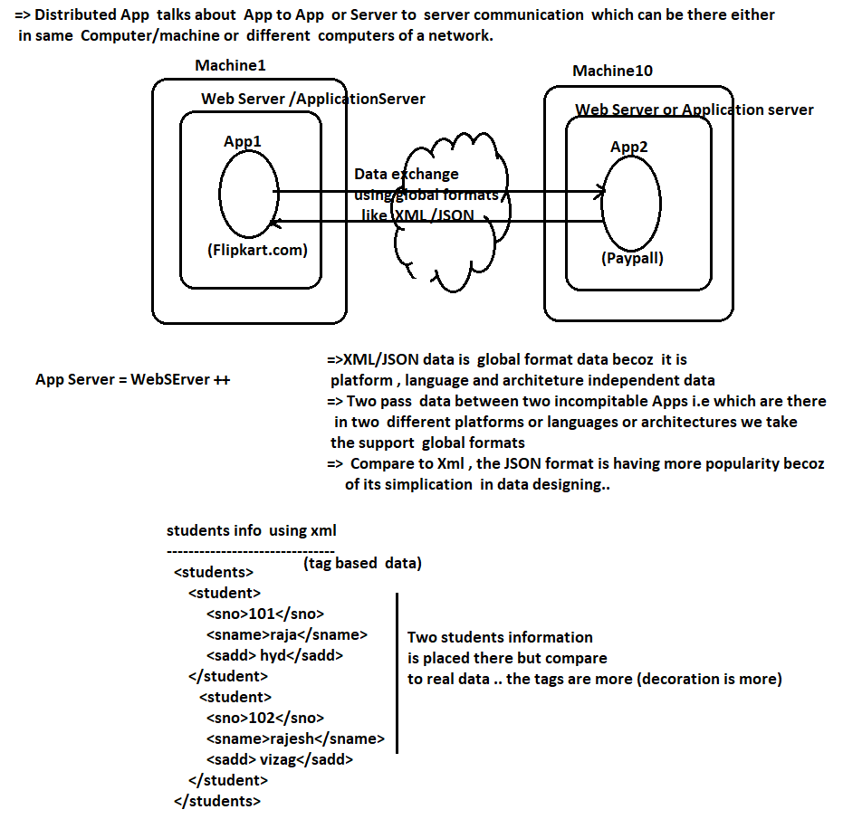

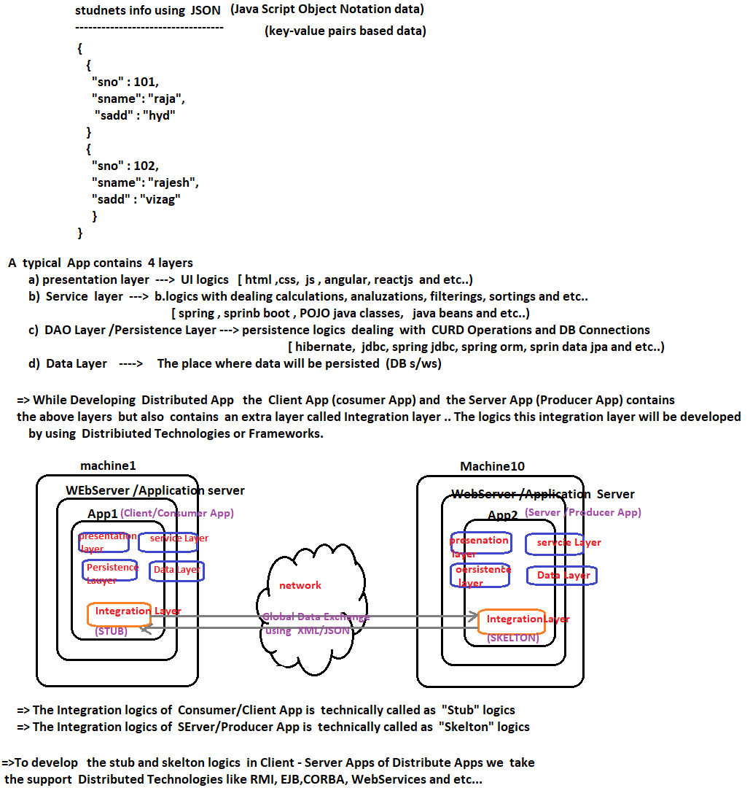

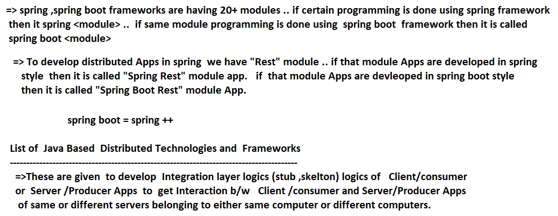

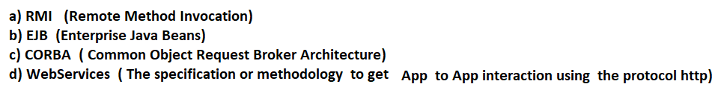

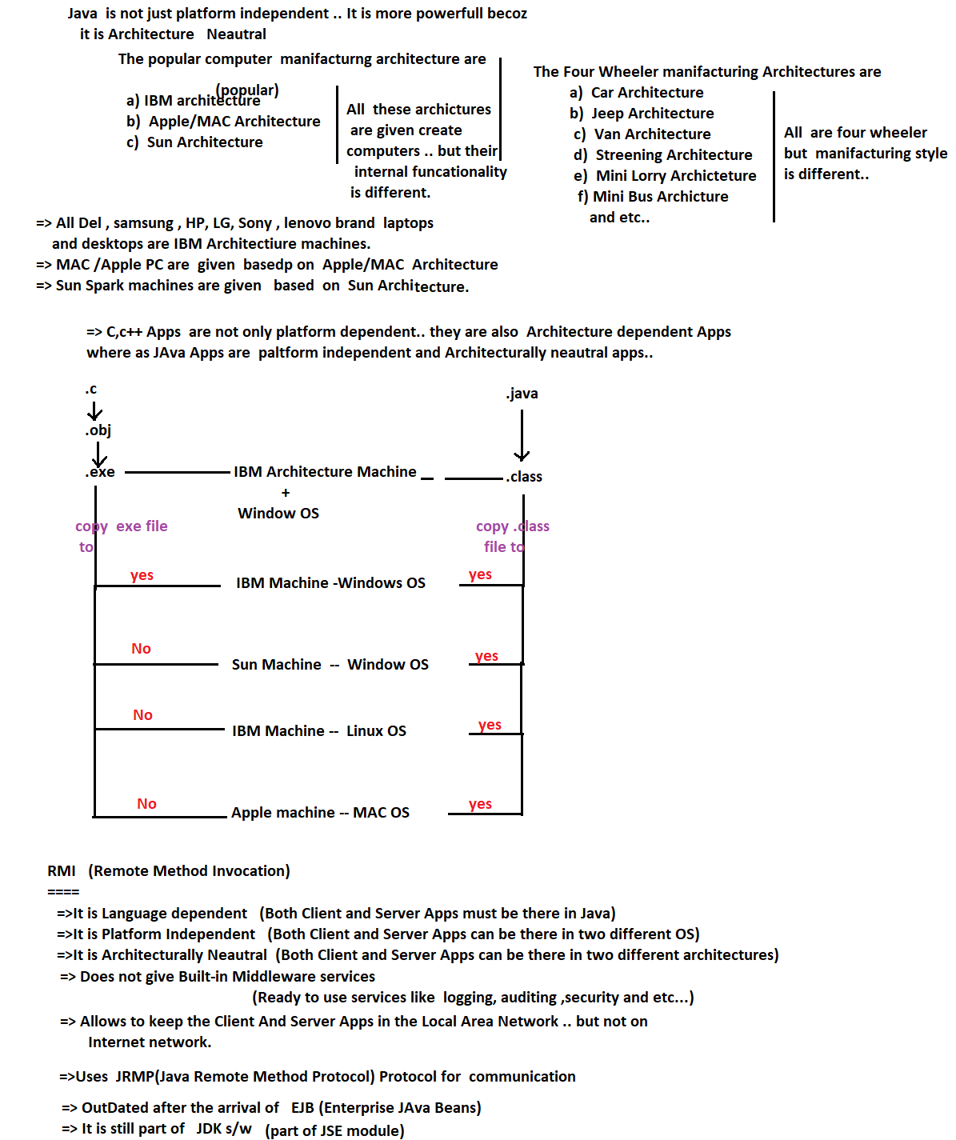

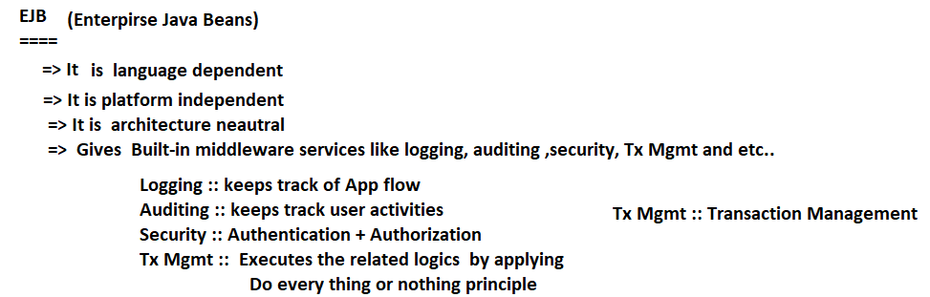

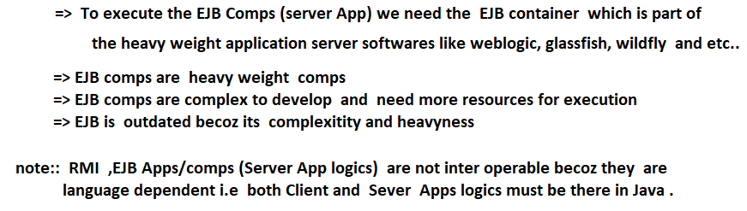

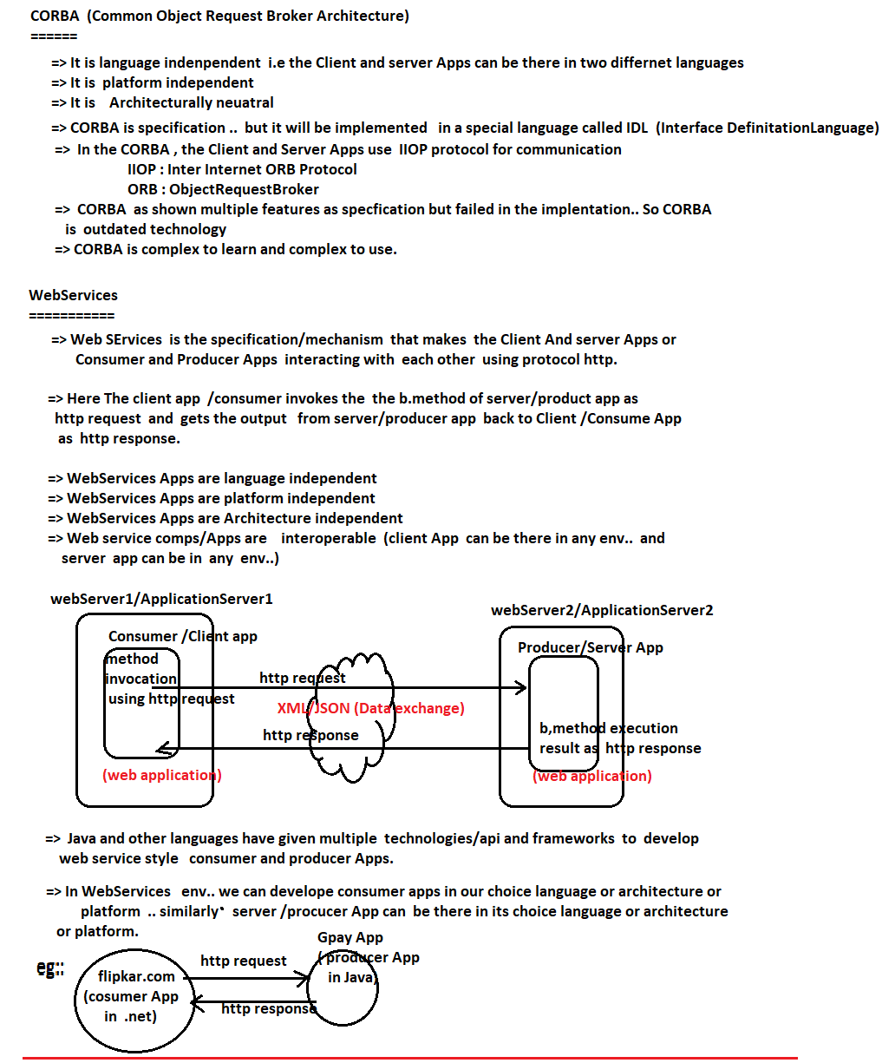

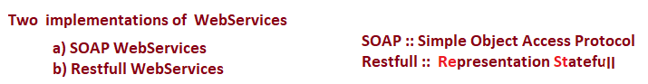

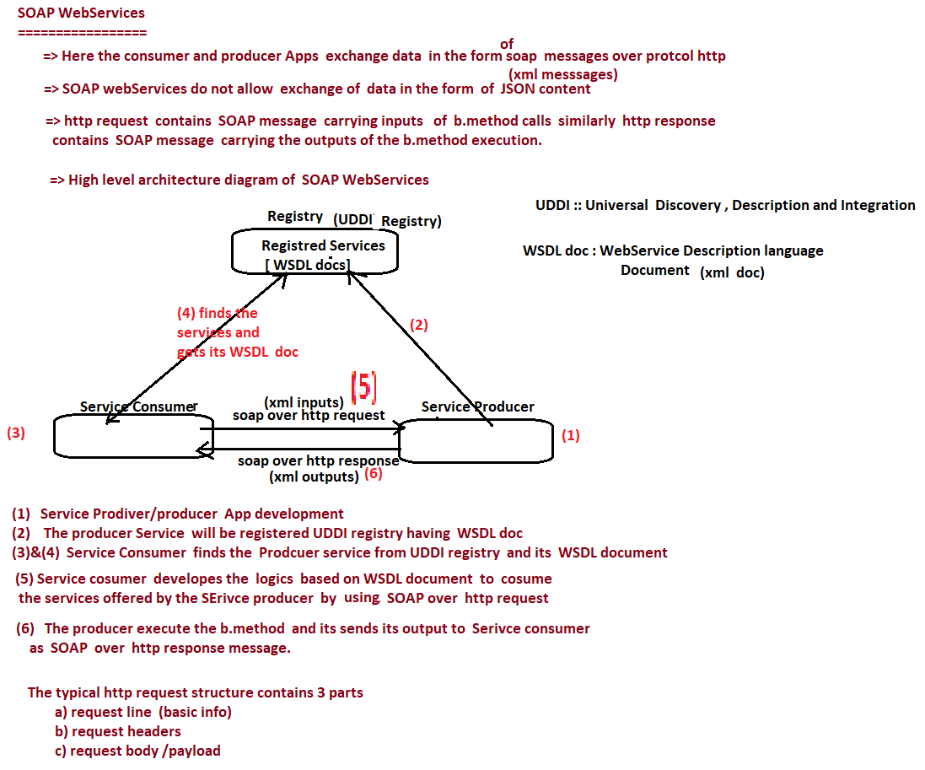

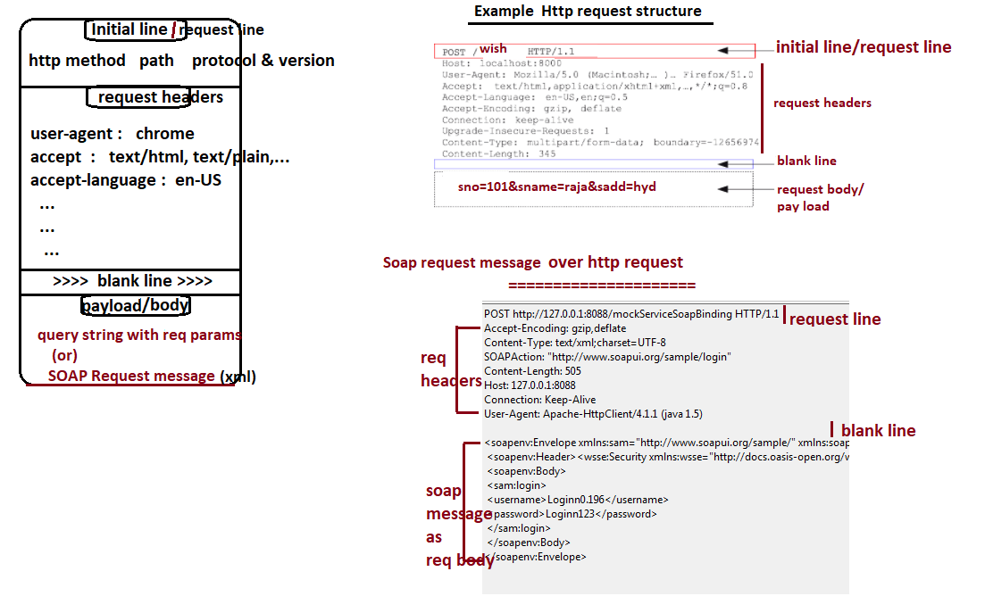

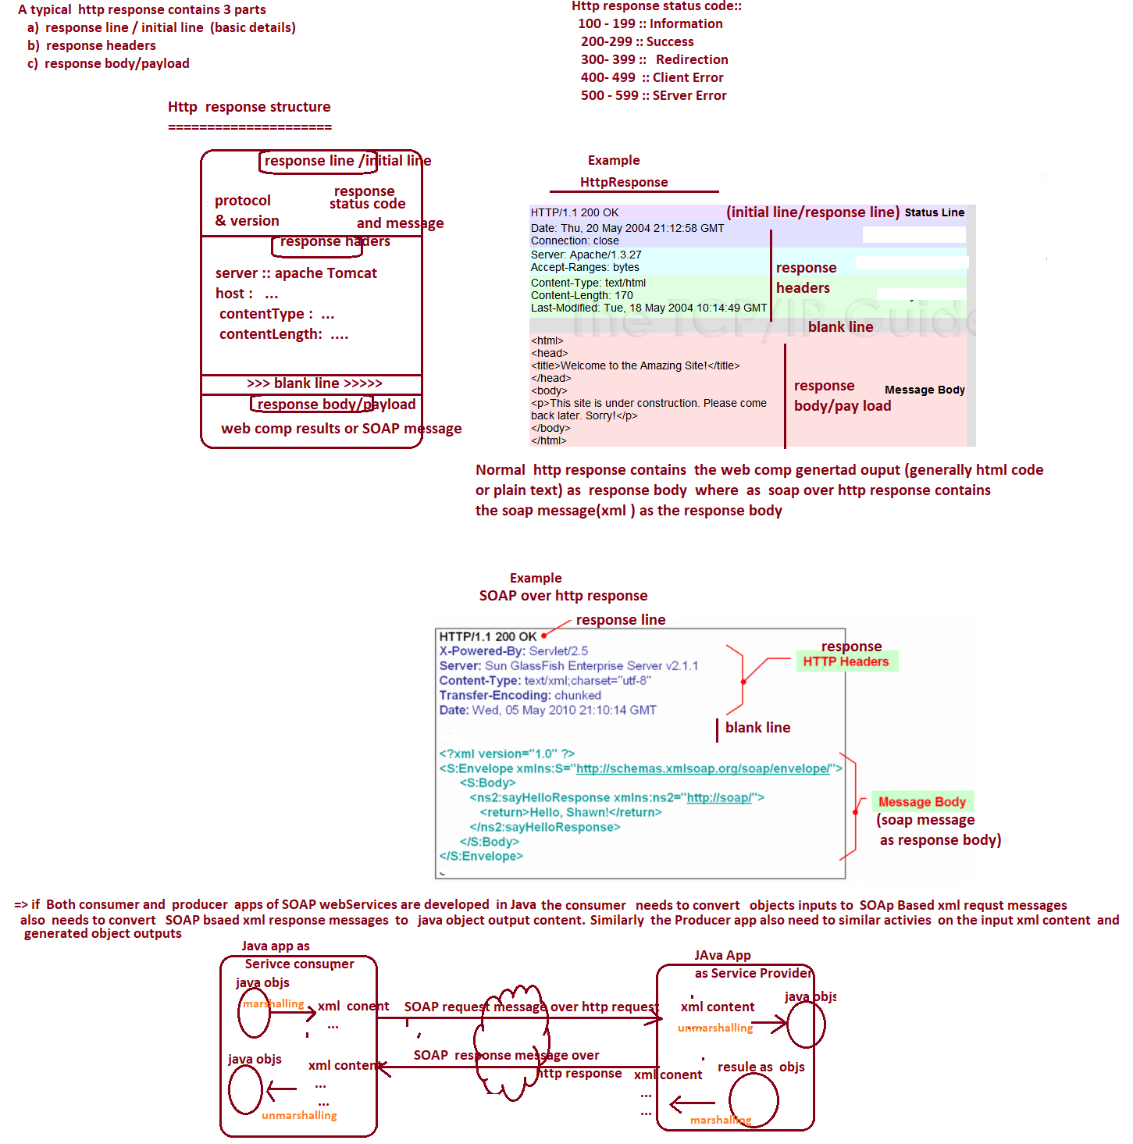

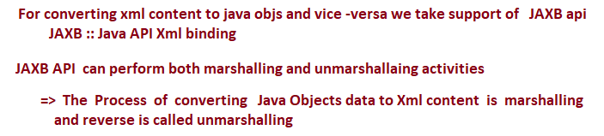

NTSPBMS615-May28th-2022 -SOAP WebServices and RestFullWebServices

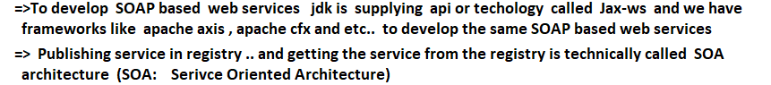

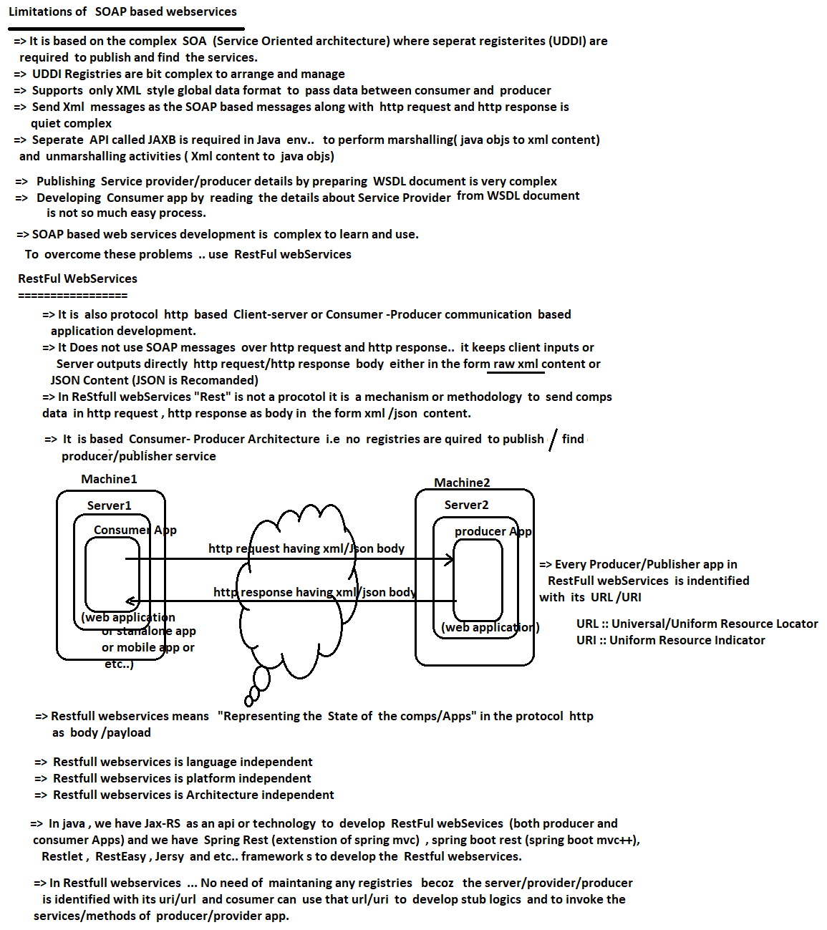

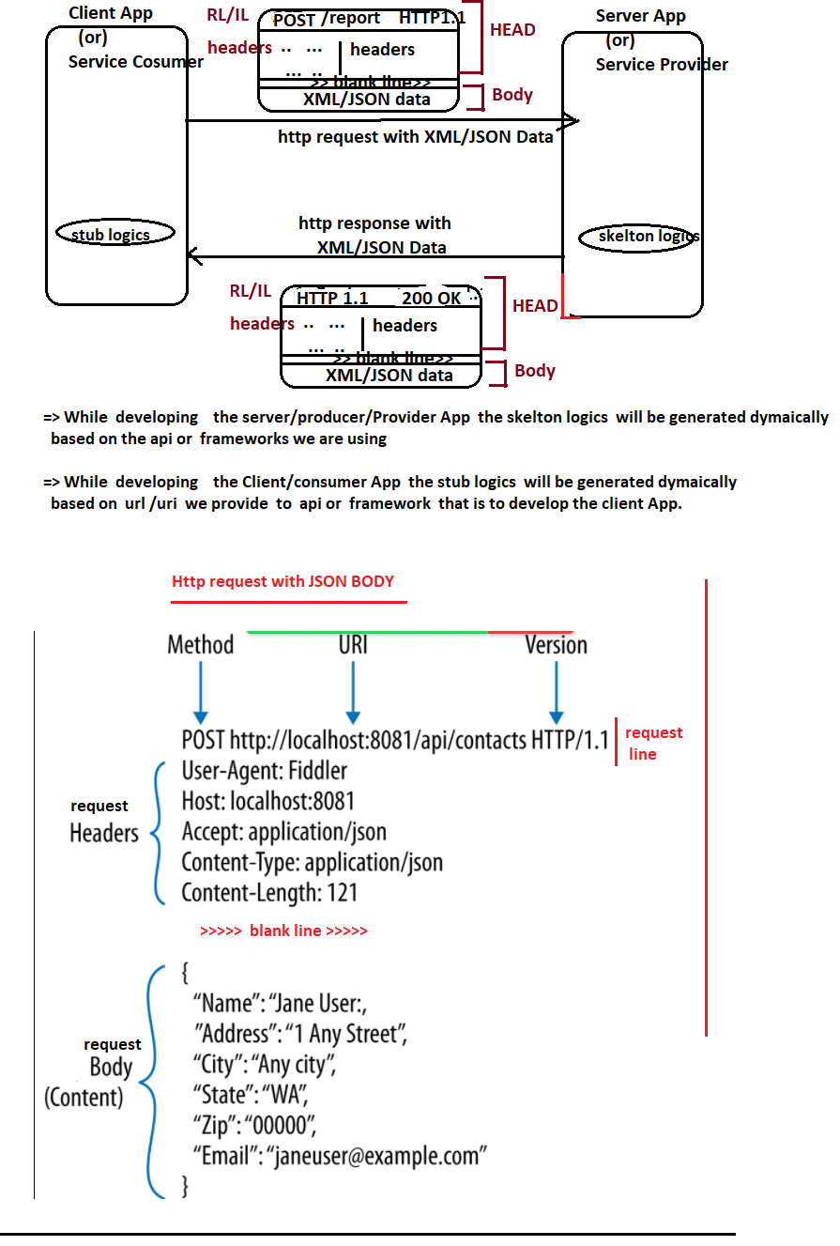

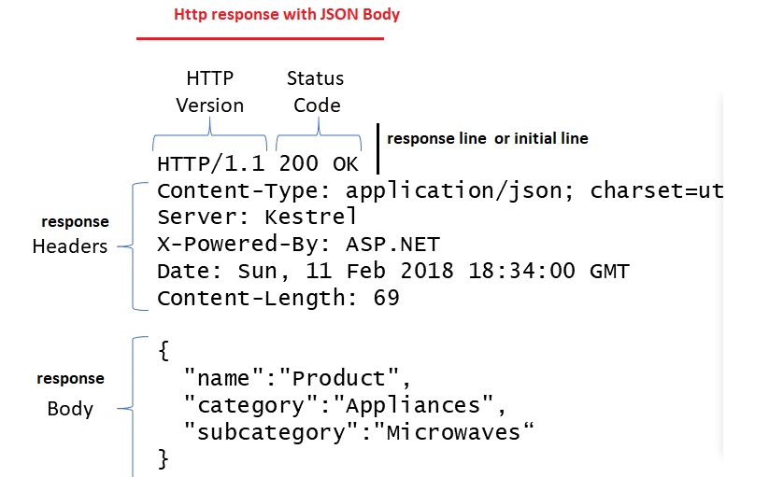

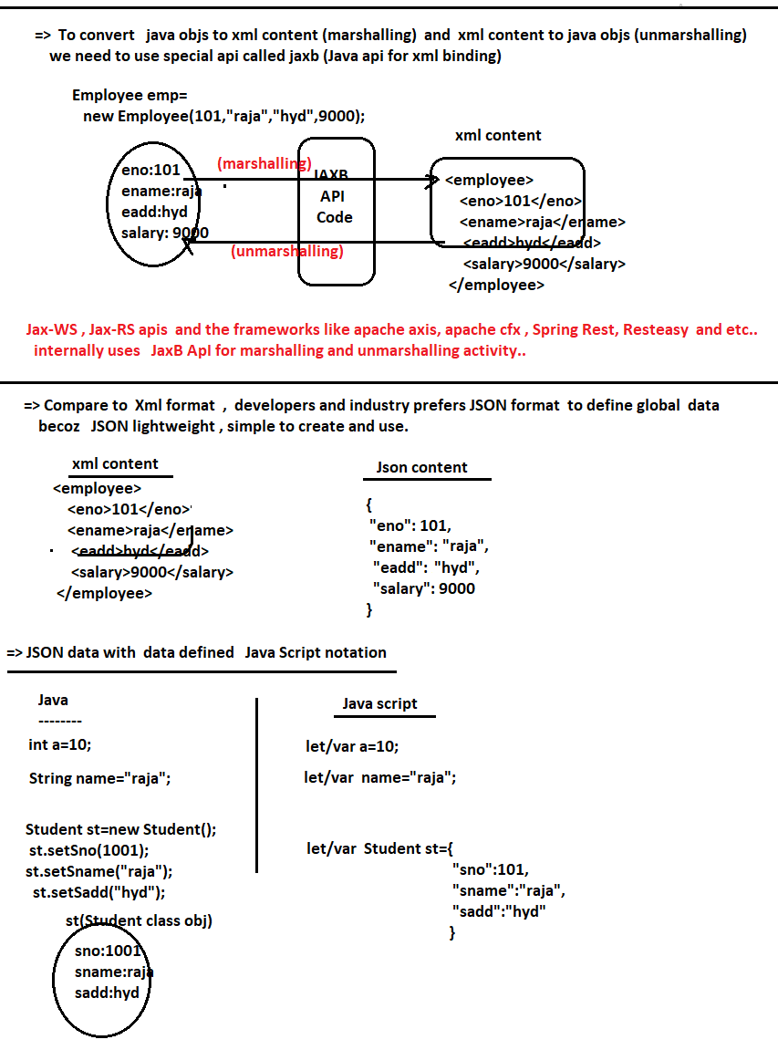

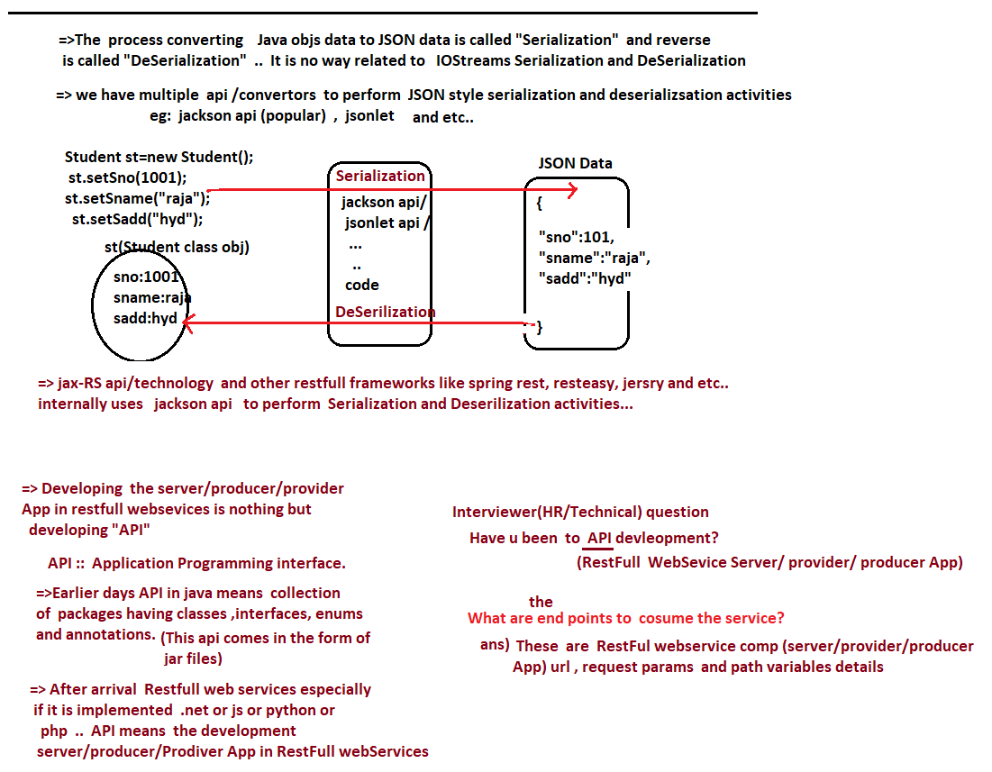

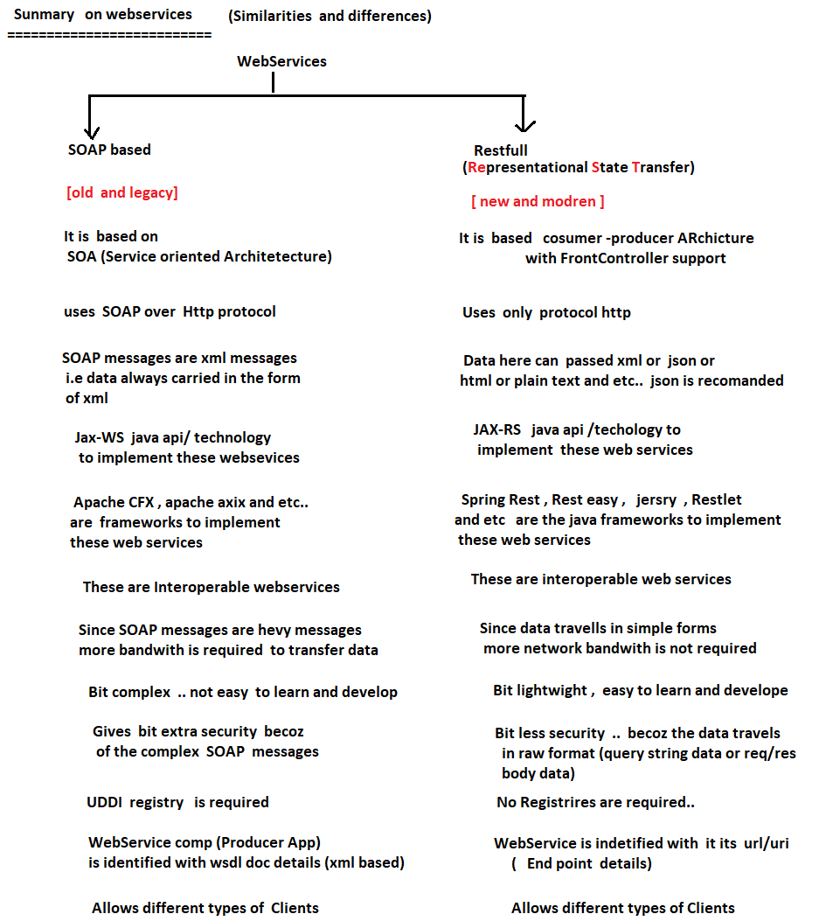

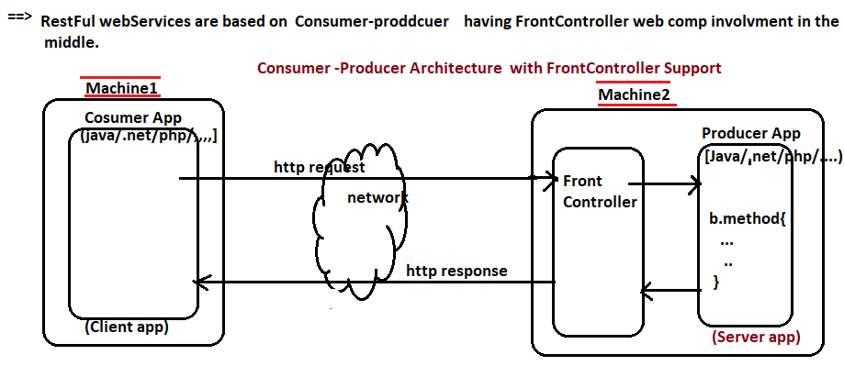

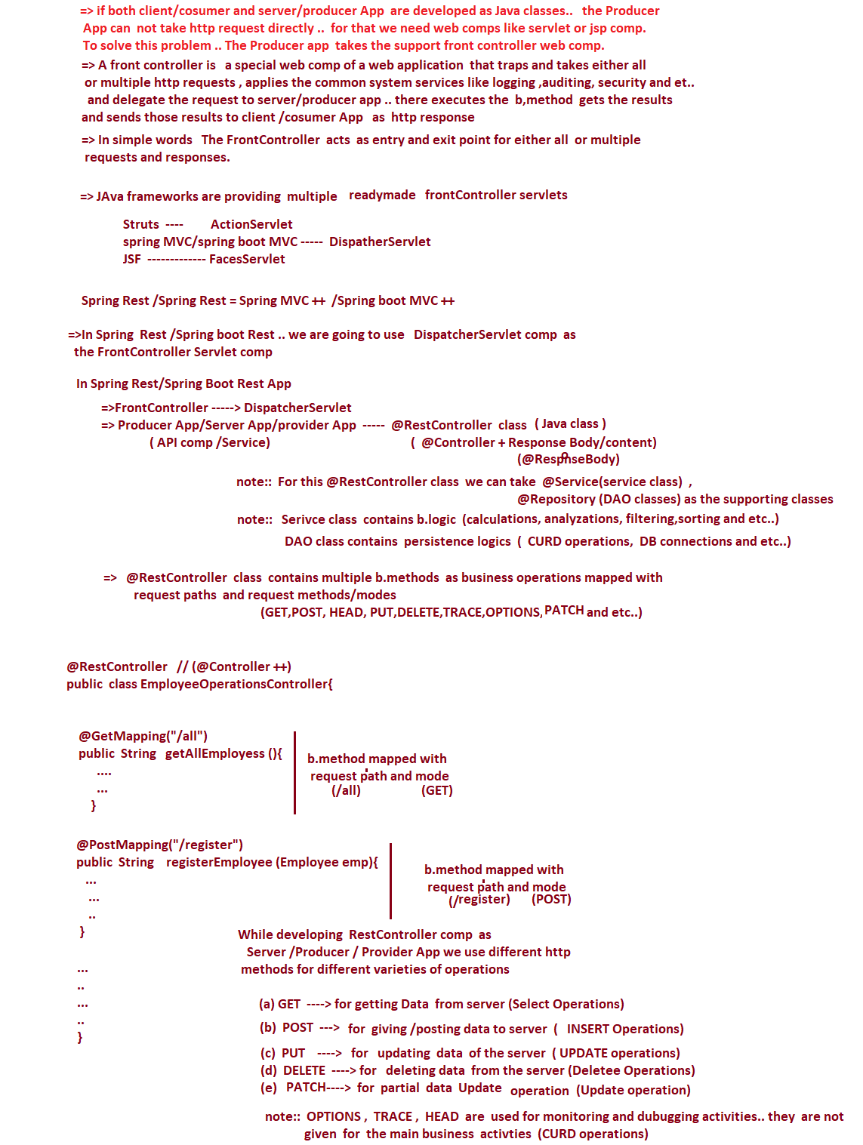





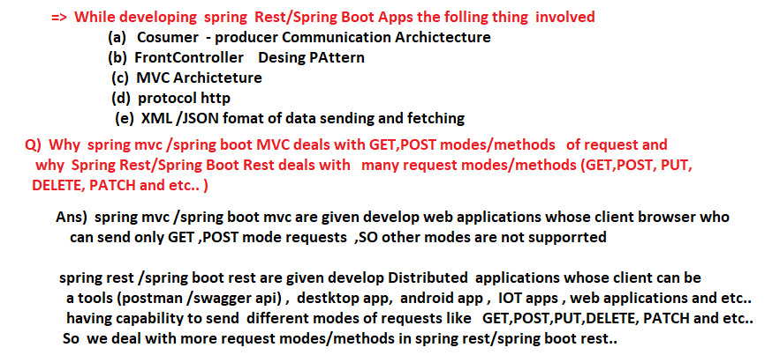

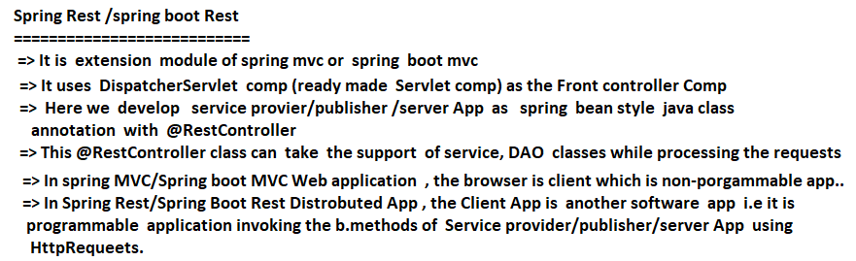

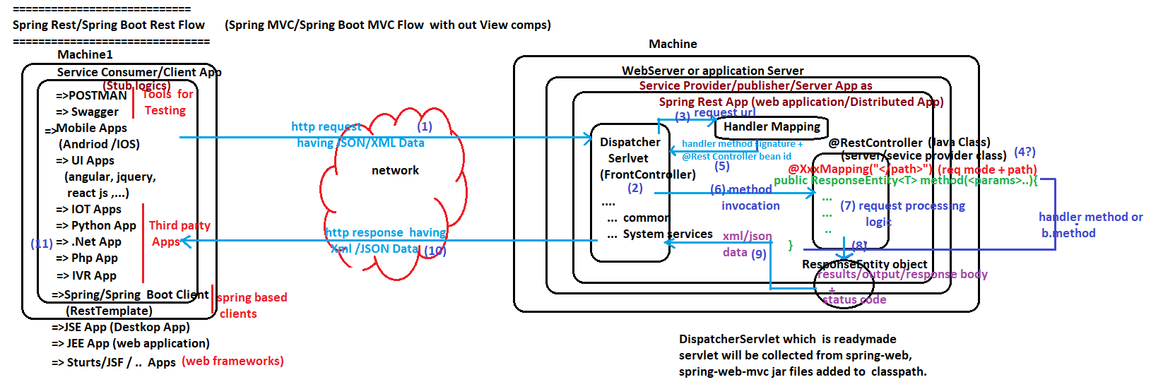

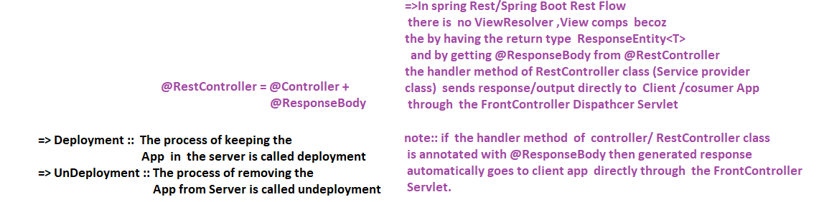

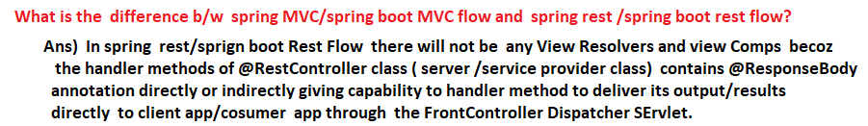

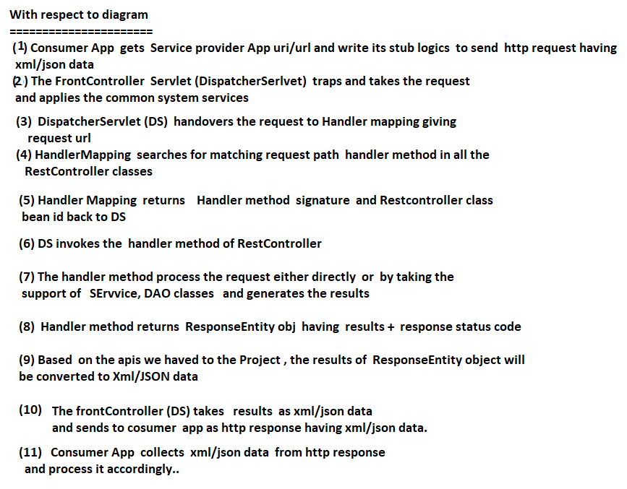

NTSPBMS615-June2nd-2022 -Frist Spring RestApp Development

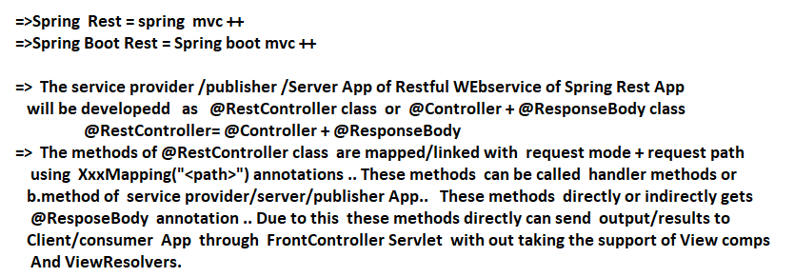

Spring Rest & MicroServices

Day-1- <https://www.youtube.com/watch?v=Tlp45YhOE-8>

Day-2- <https://www.youtube.com/watch?v=EpaNqWAVadI>

Day-3- <https://www.youtube.com/watch?v=BWfLY15xj_w>

Day-4- <https://www.youtube.com/watch?v=UQJ8ToGWN4Y>

Day-5- <https://www.youtube.com/watch?v=05Kg91stFtU>

Day-6- <https://www.youtube.com/watch?v=p9MJ-aSNlM0>

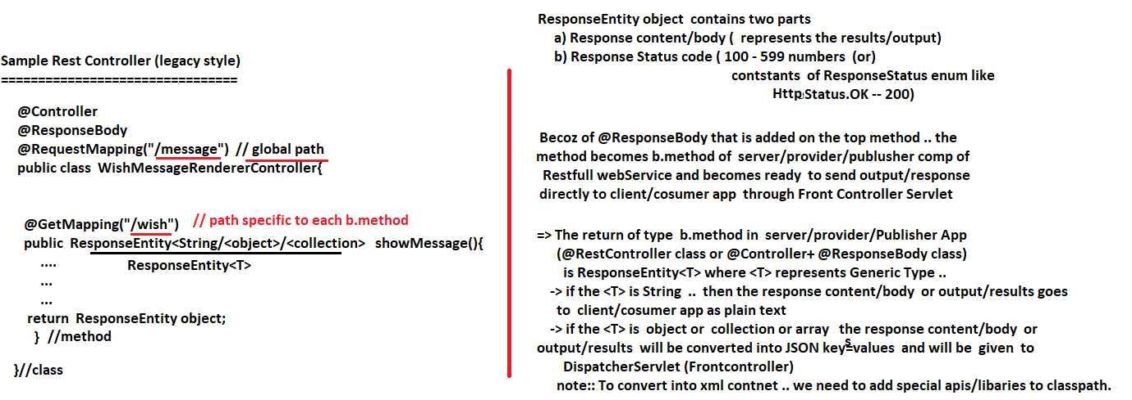

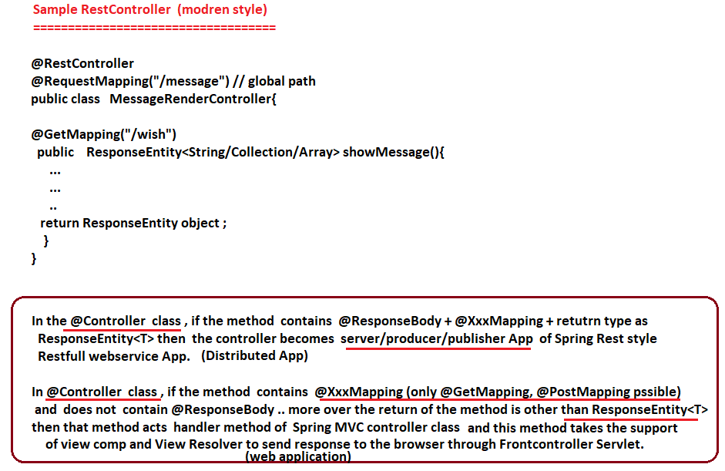

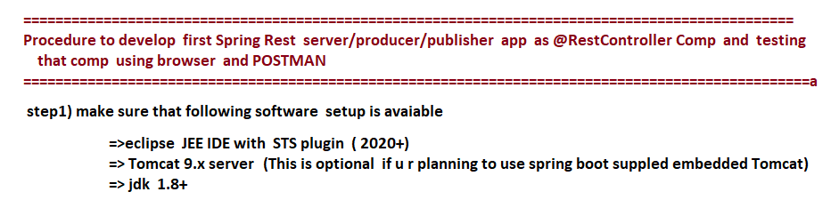

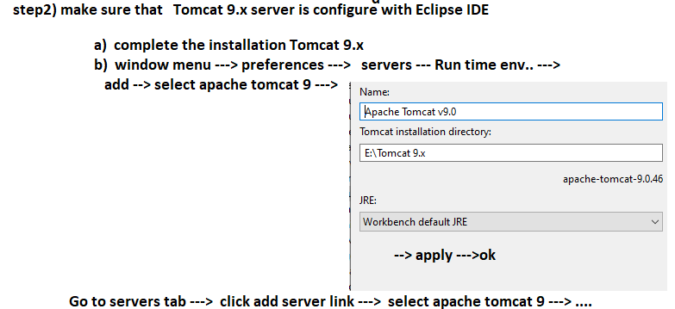

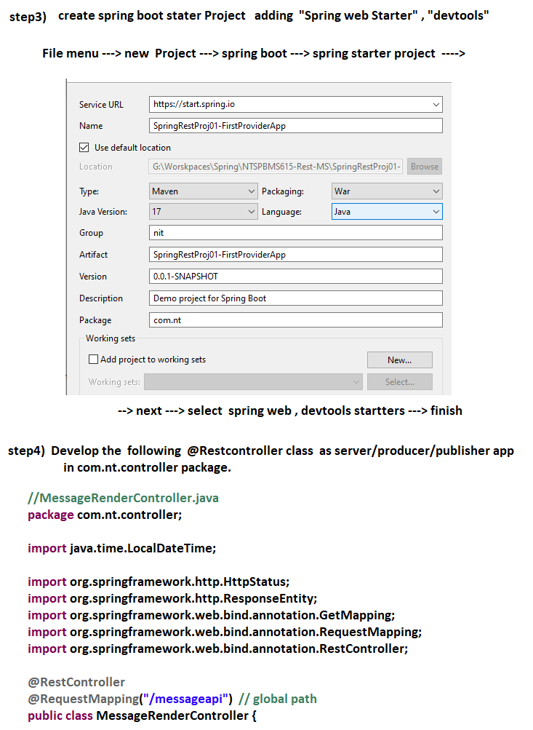

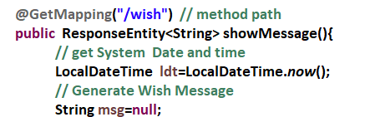

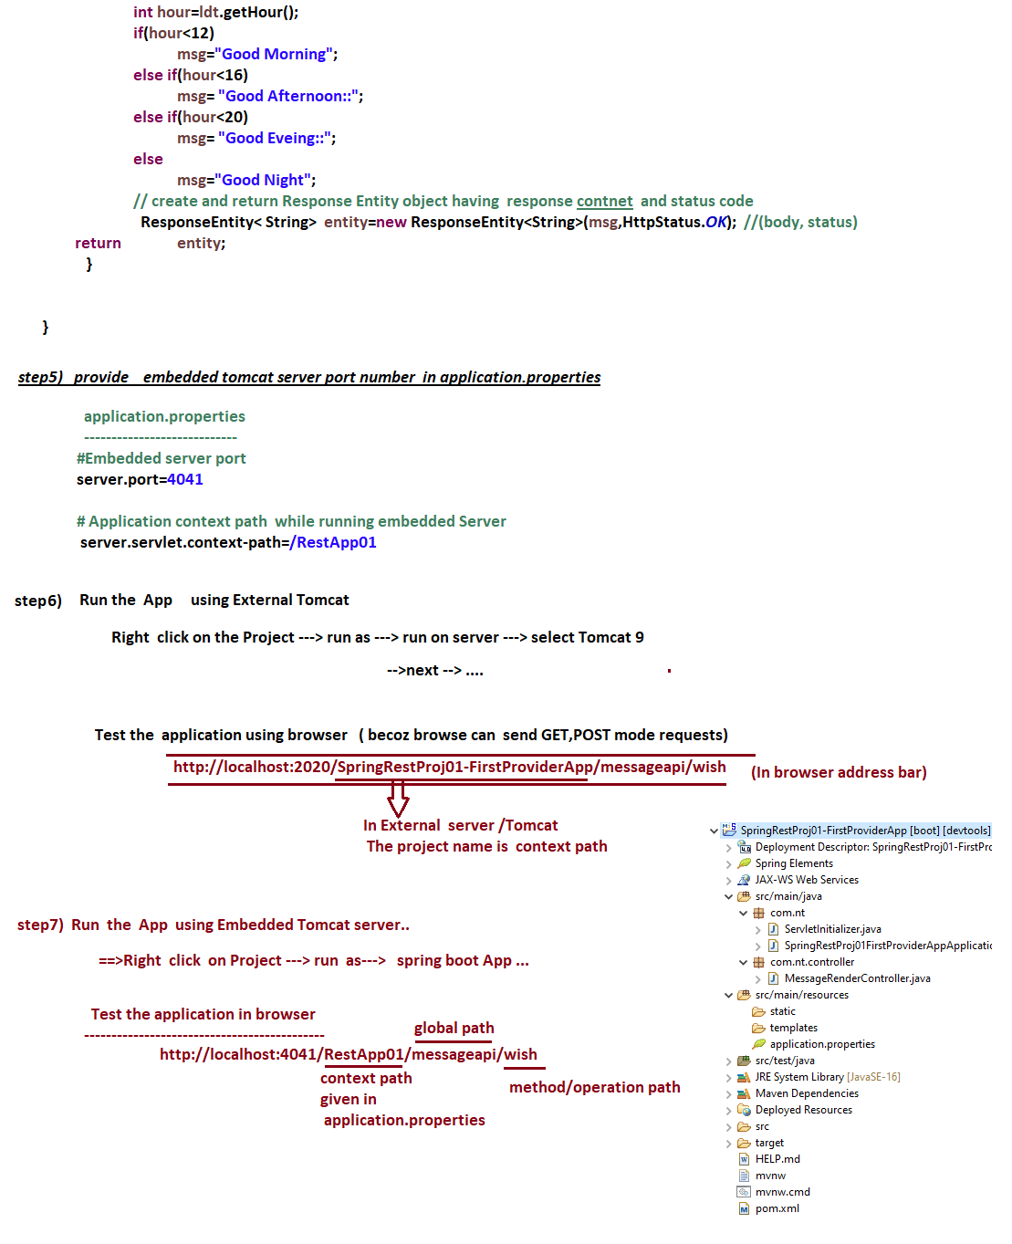

NTSPBMS615-June 3rd-2022 -Frist Spring RestApp Testing Using POSTMAN Tool



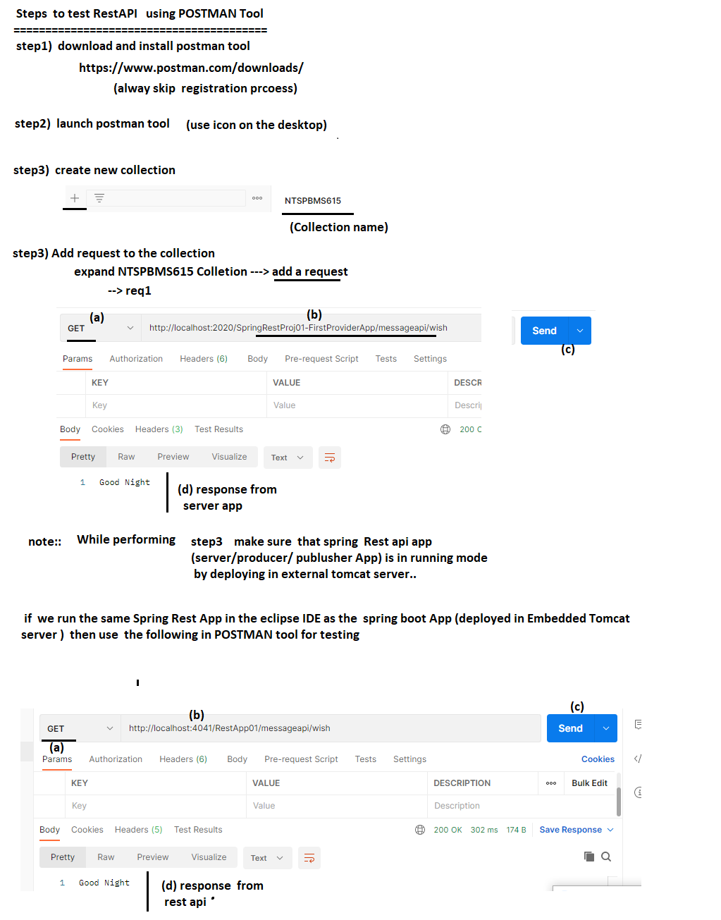

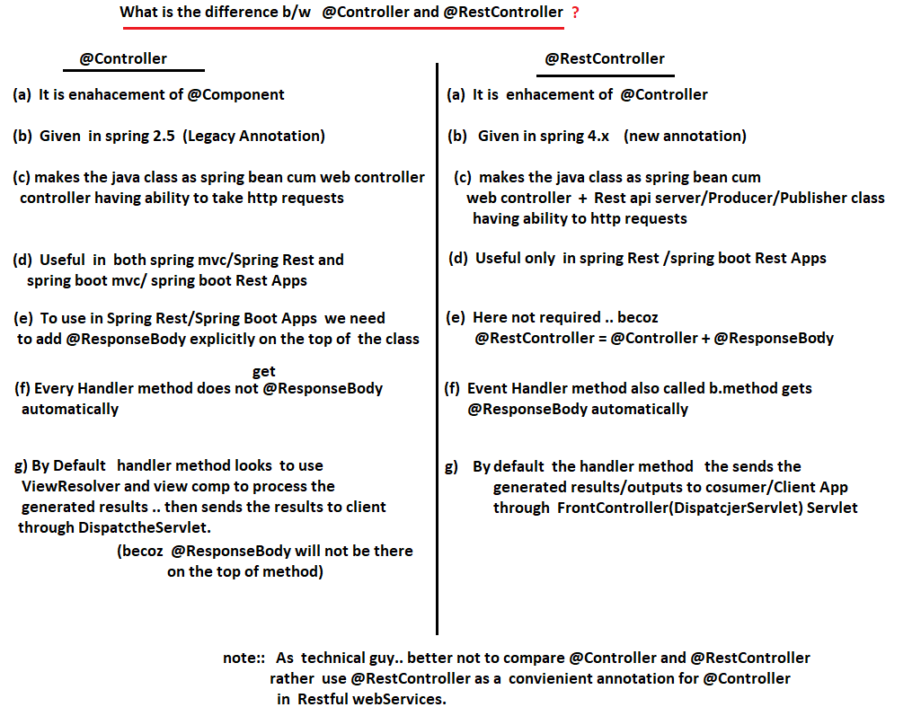

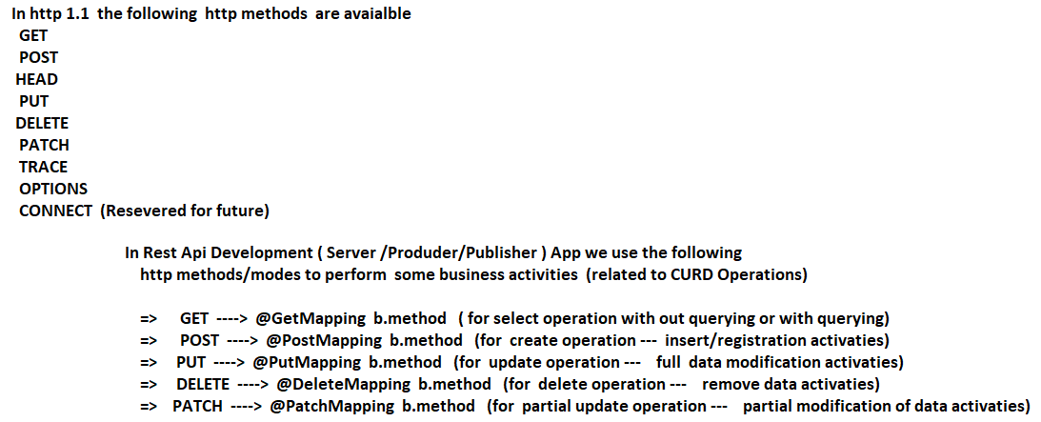

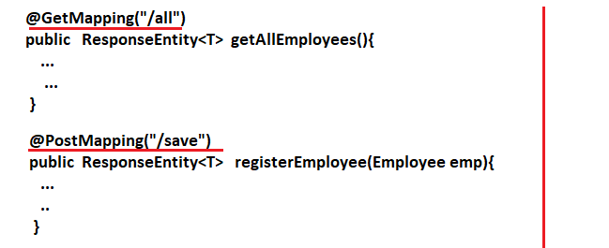

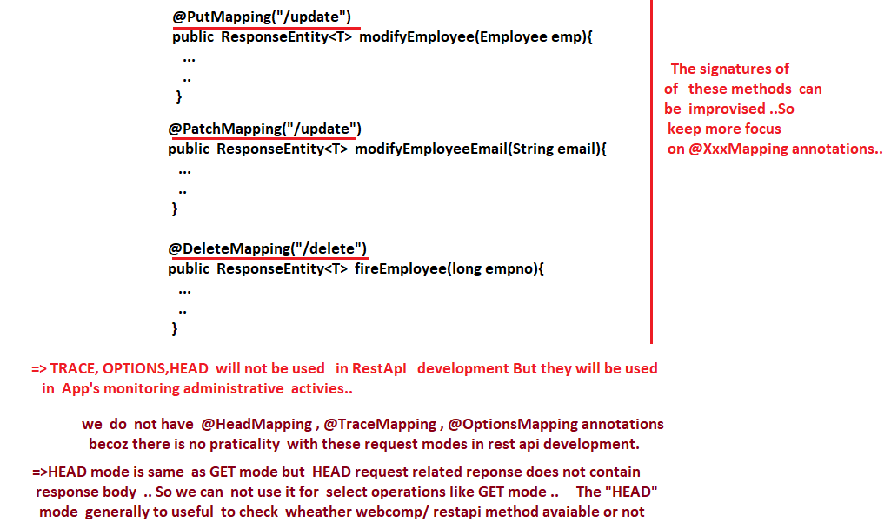

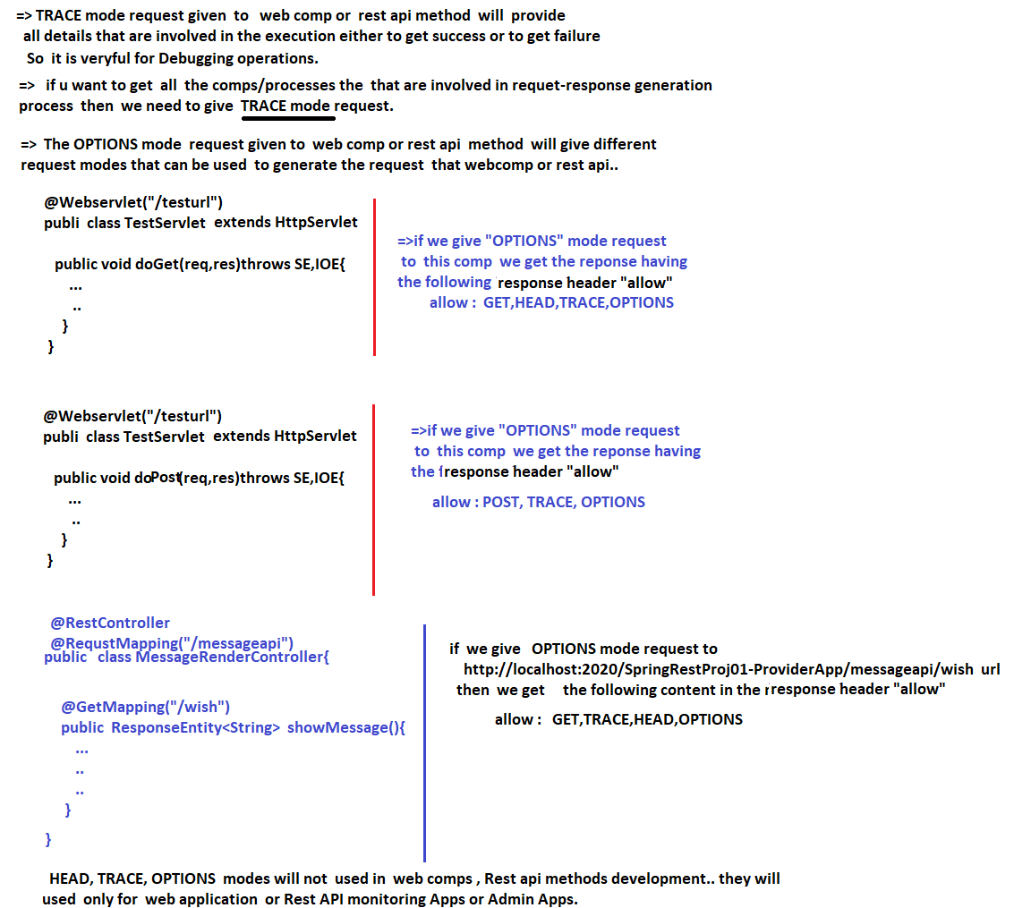

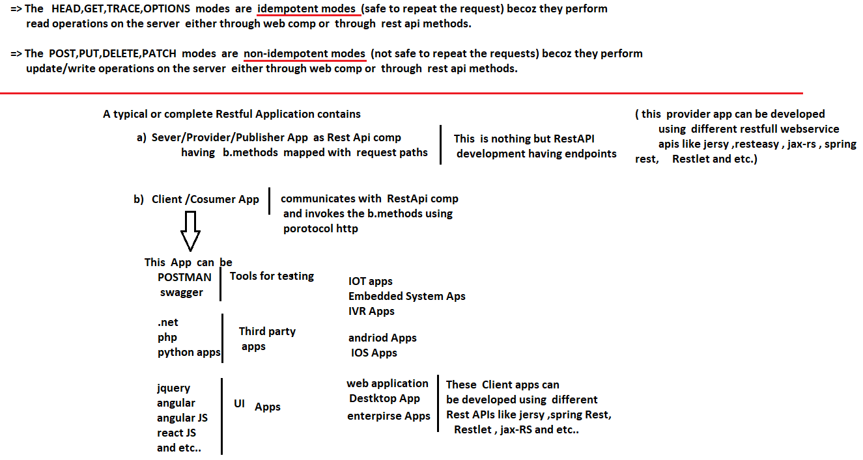

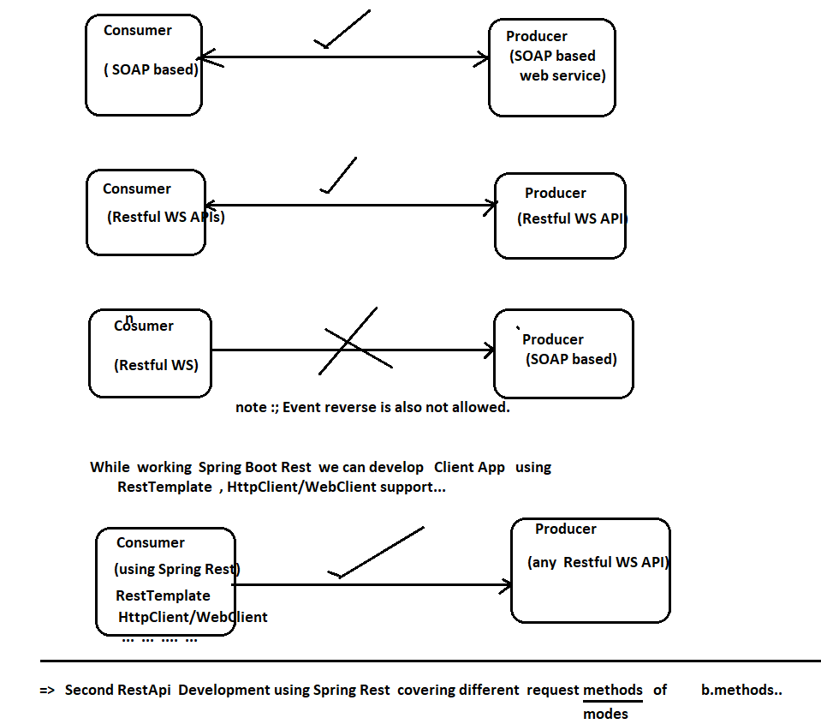

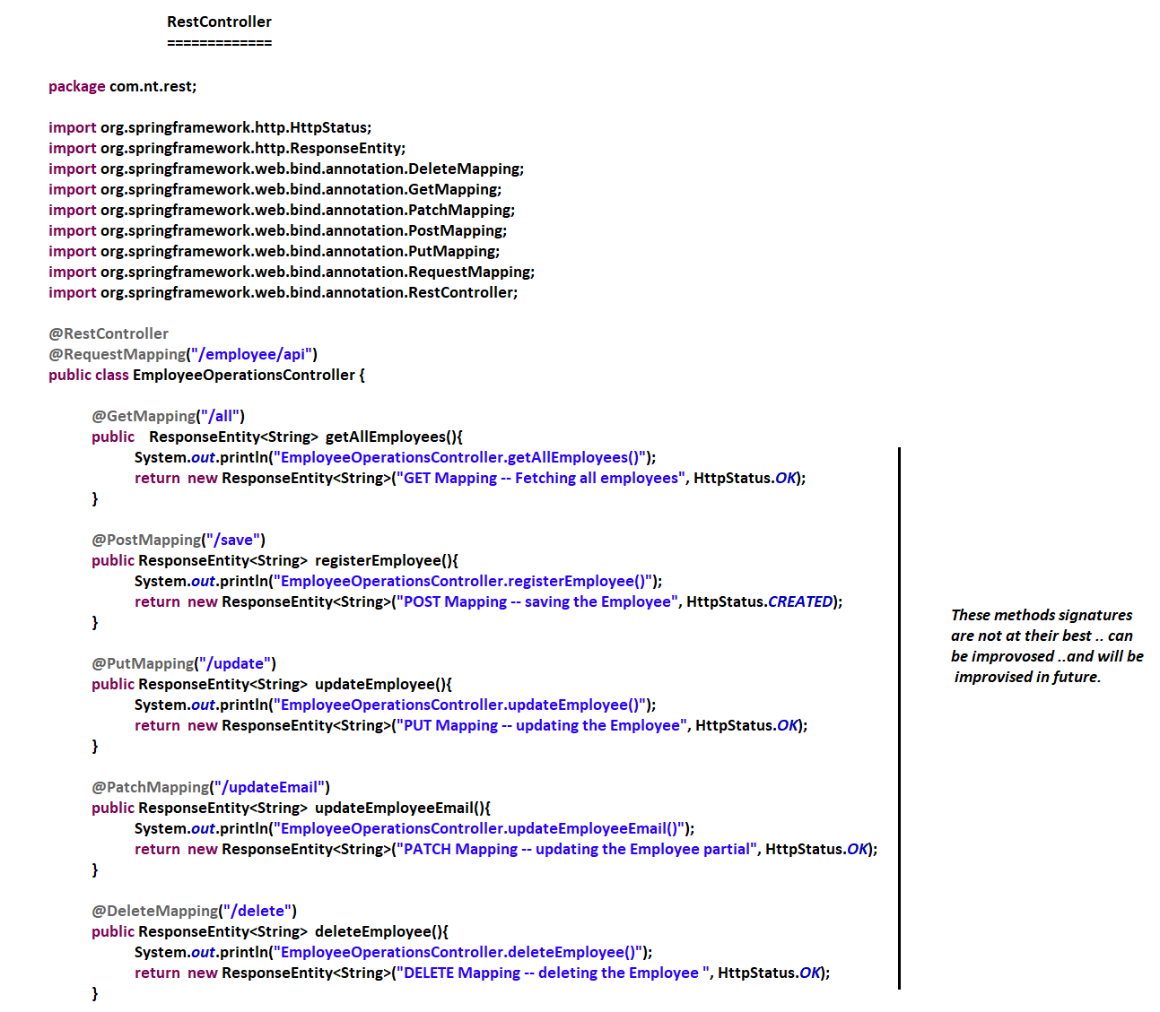

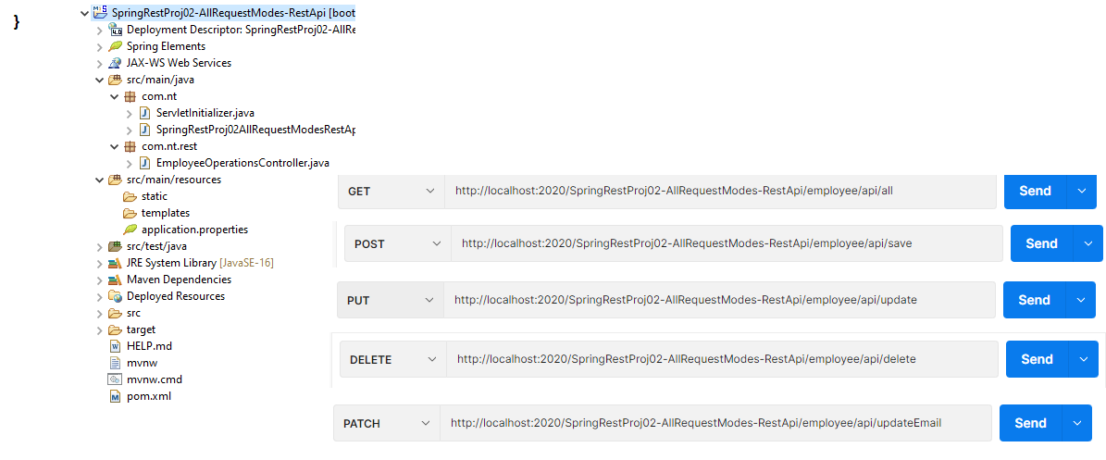

NTSPBMS615-June6th-2022-Working with JSON from @RestController

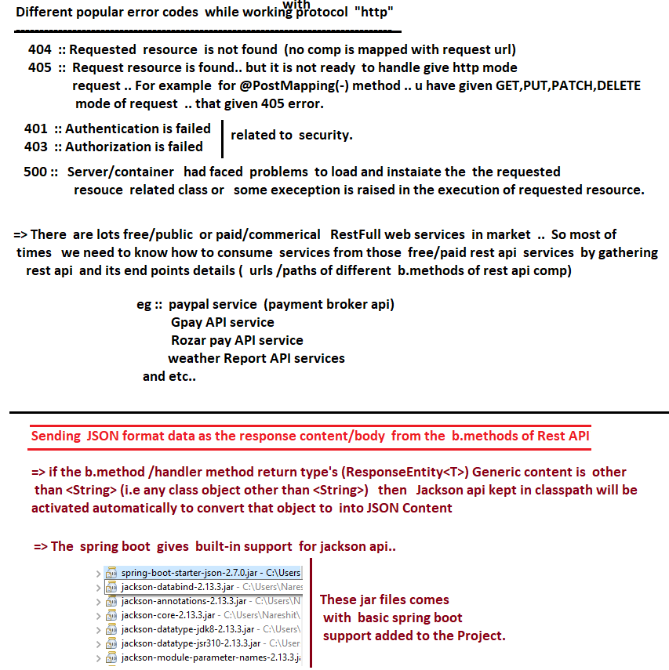

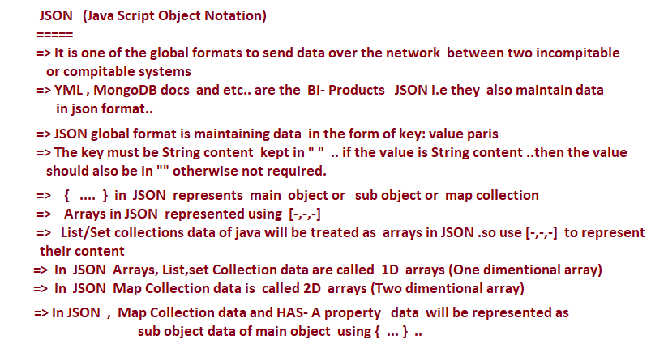



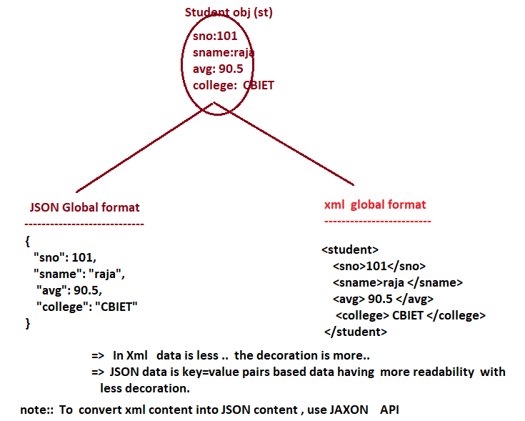

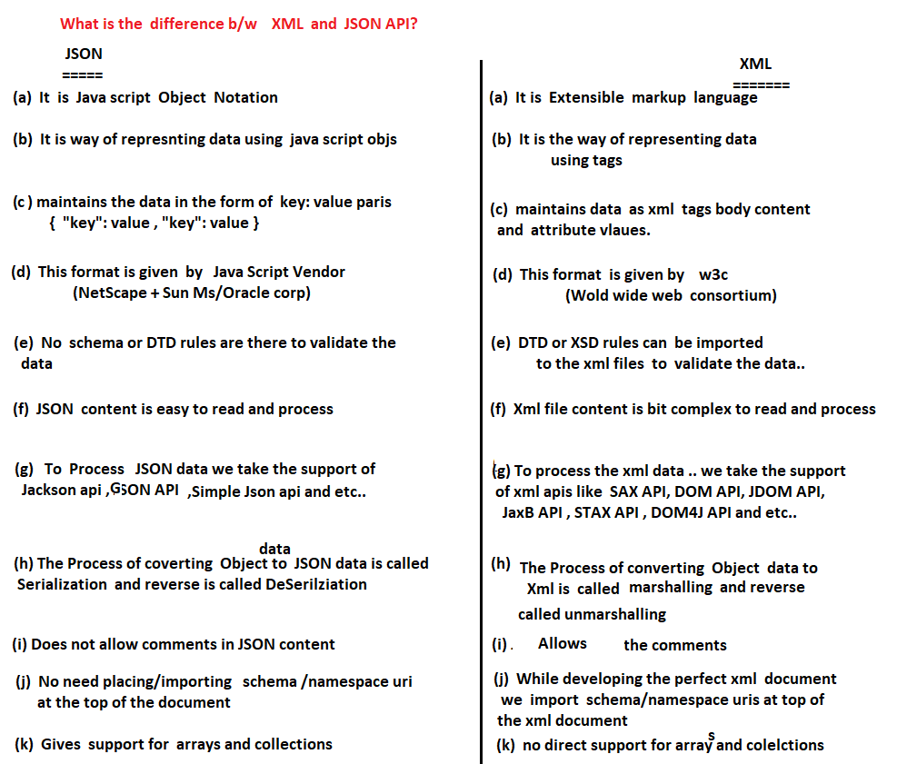

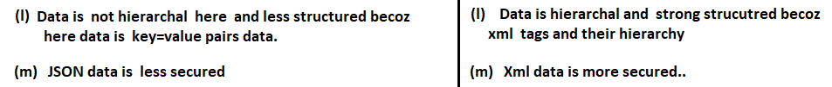

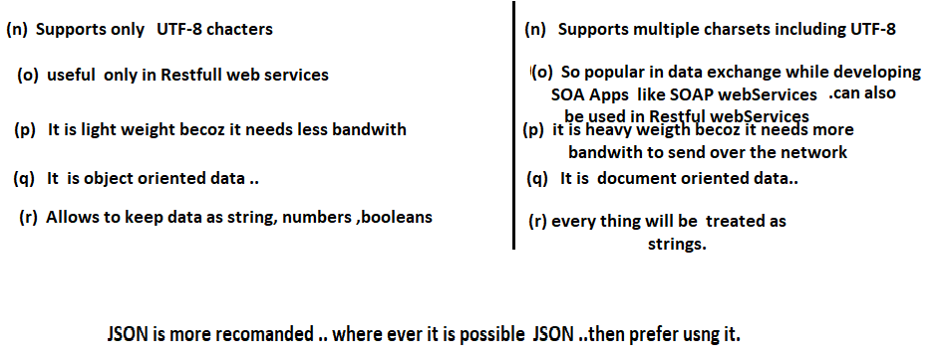

NTSPBMS615-June 7th-2022-Working with JSON format data in @RestController

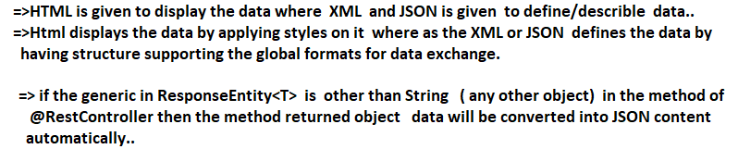

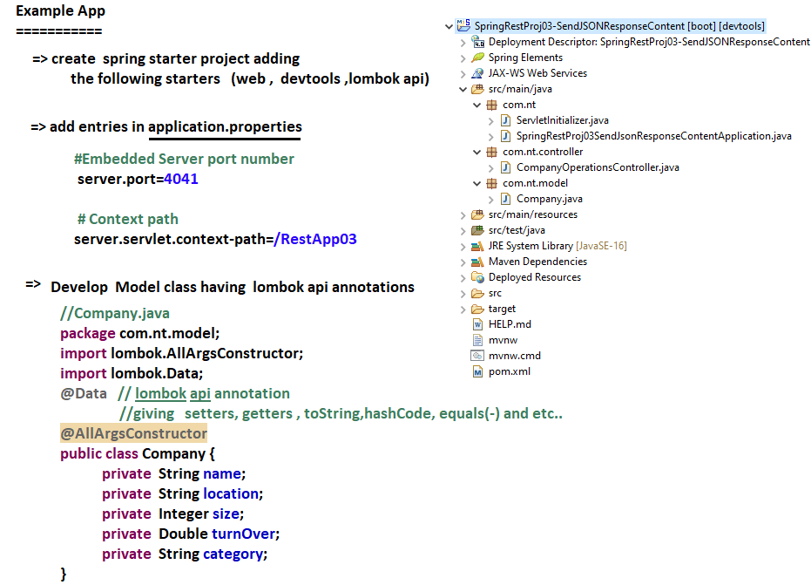

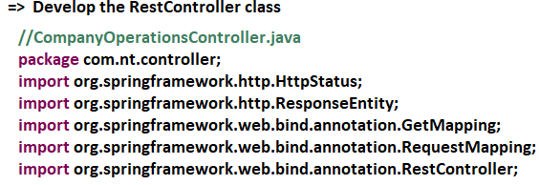

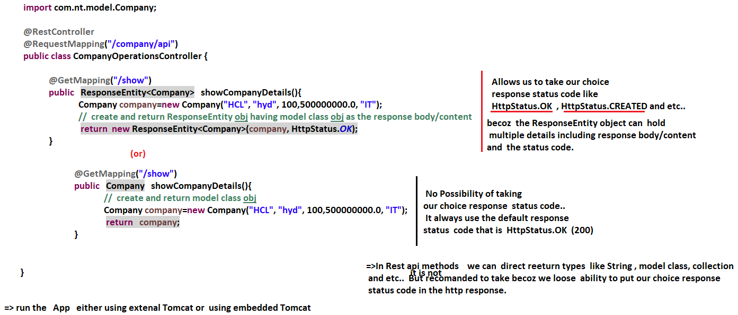

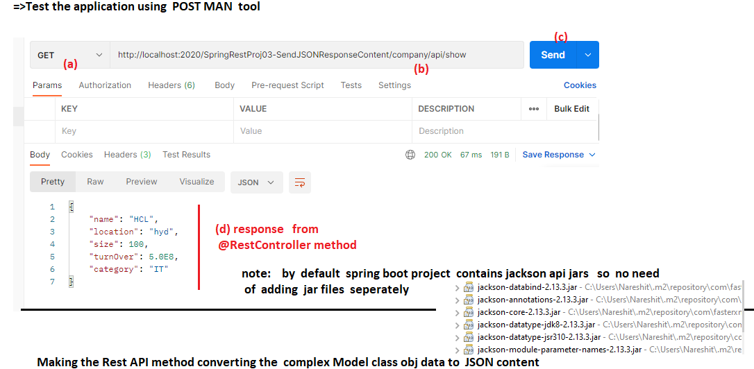

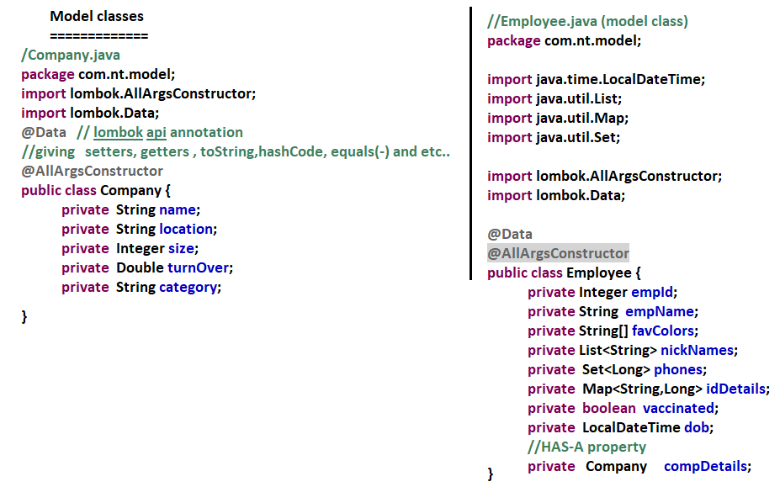

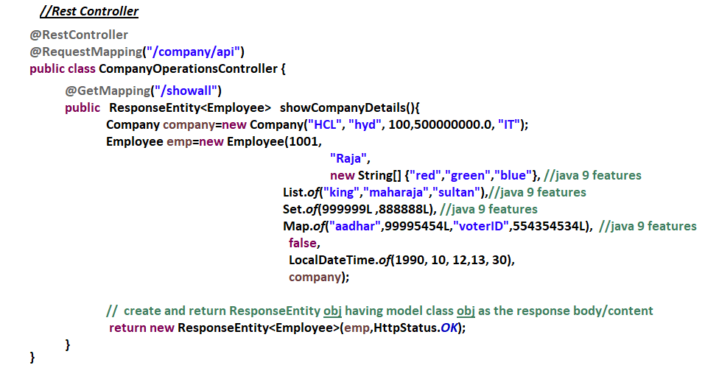



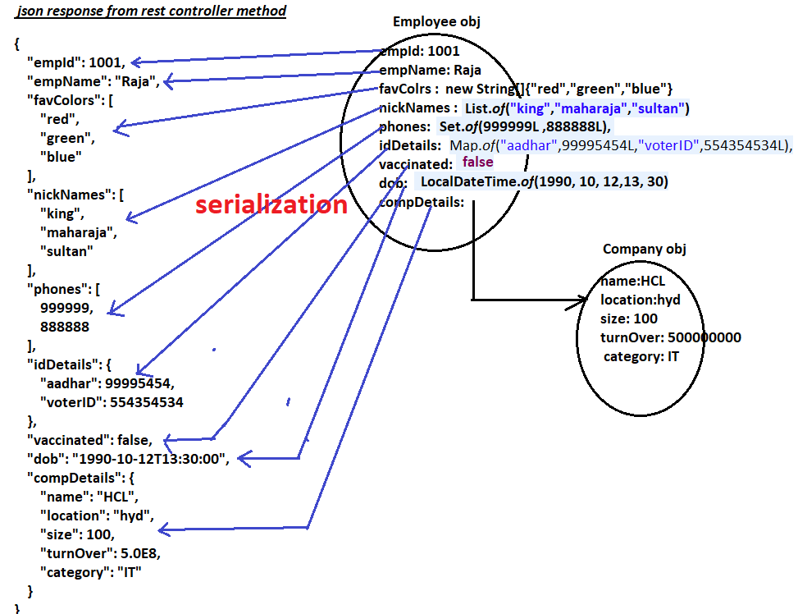

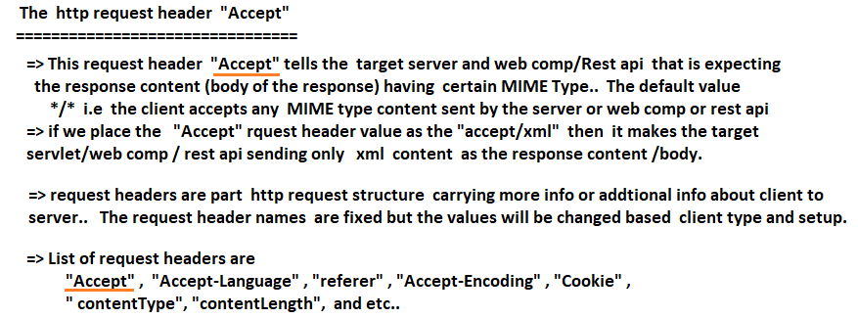

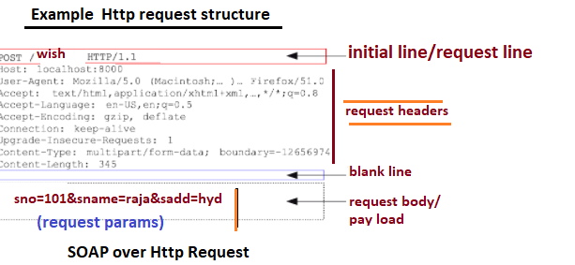

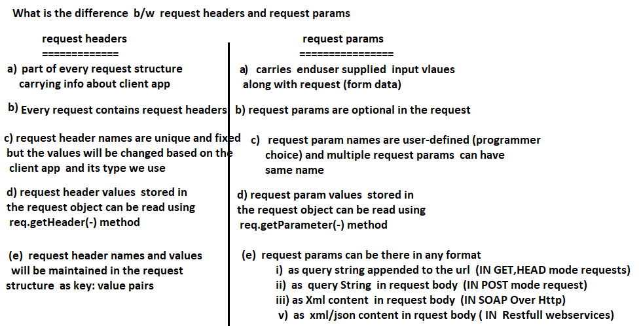

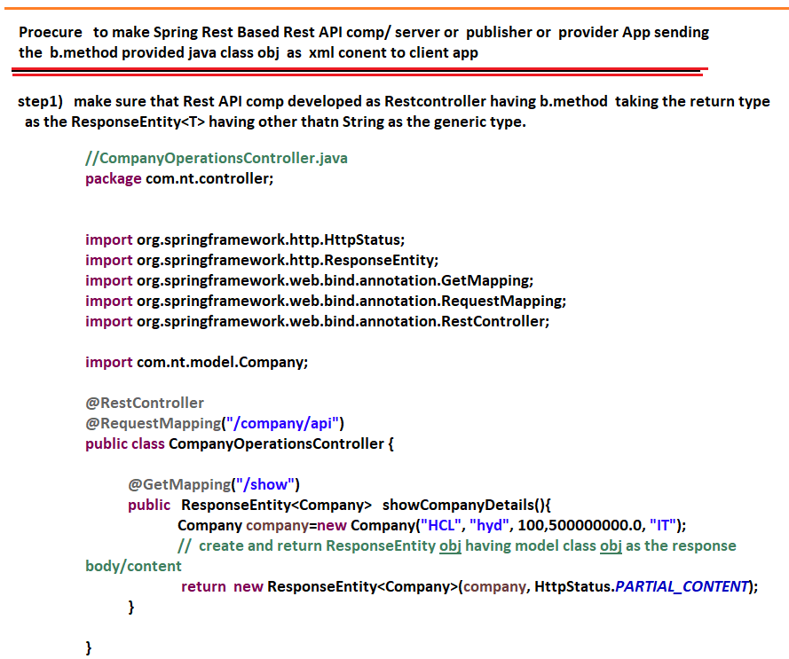

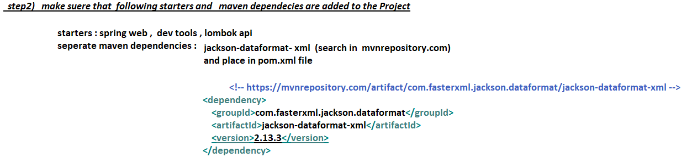

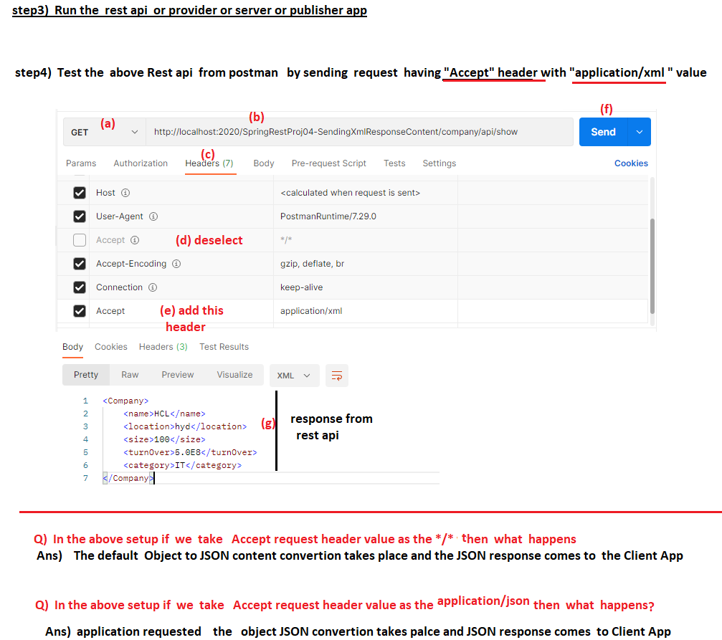

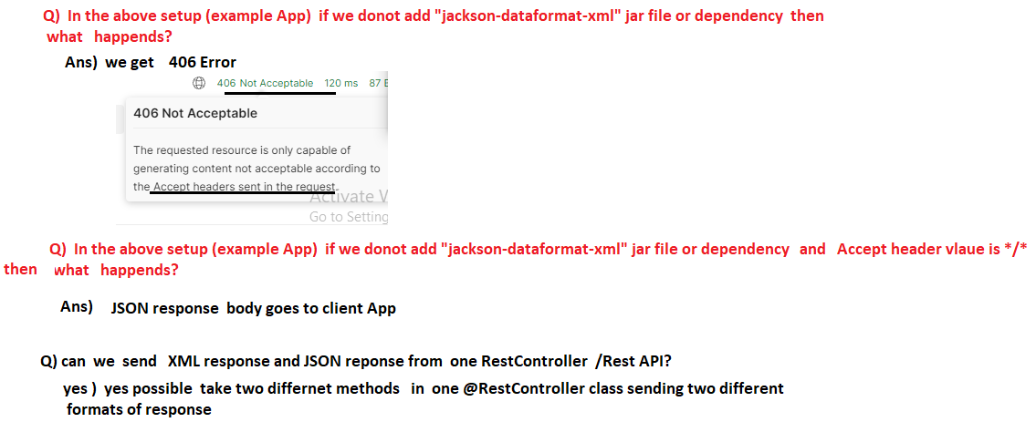

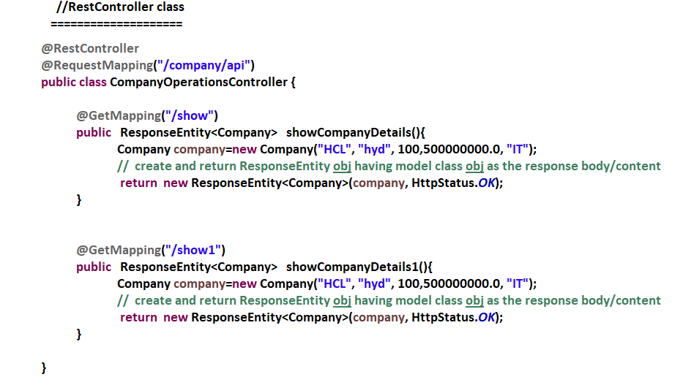

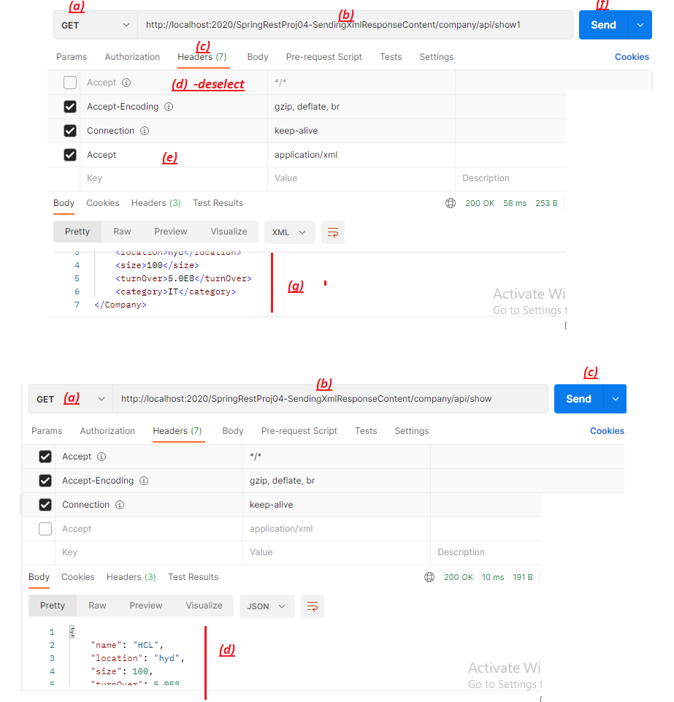

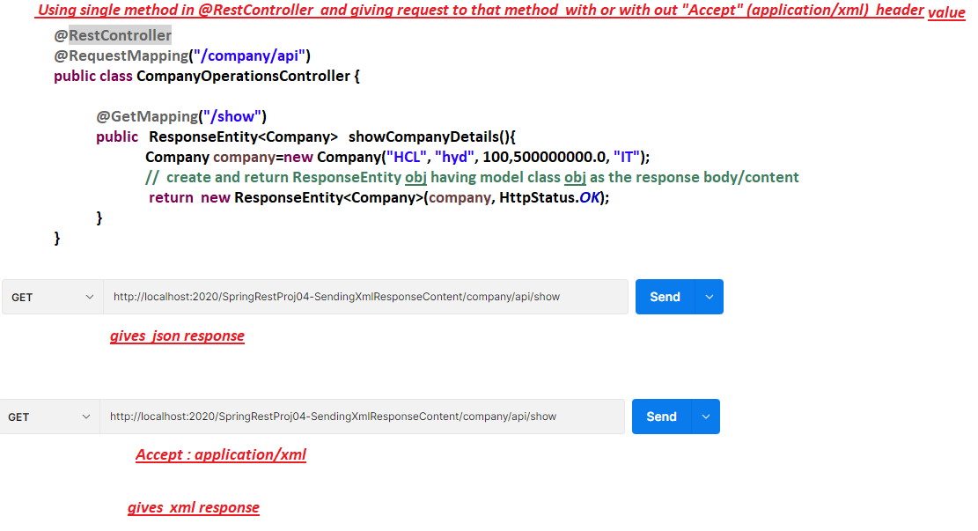

NTSPBMS615-June 10th-2022-Working @RequestBody-@ResponseBodyAnnotations

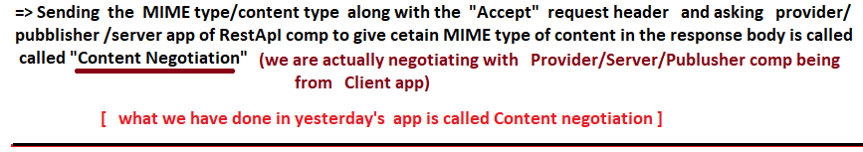

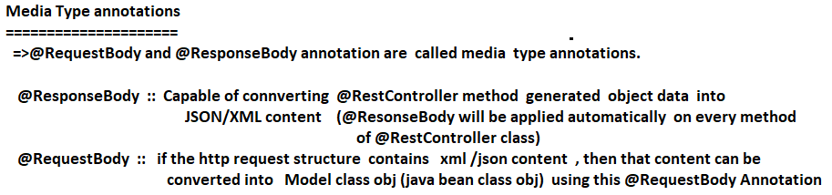

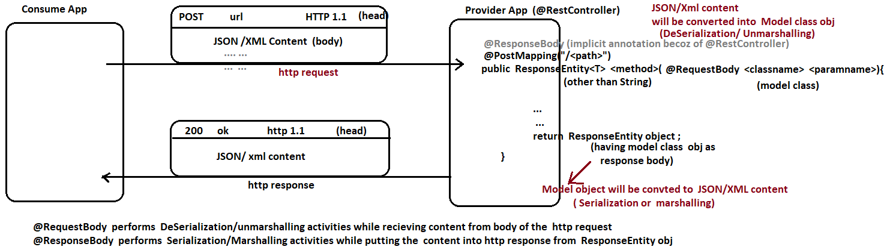

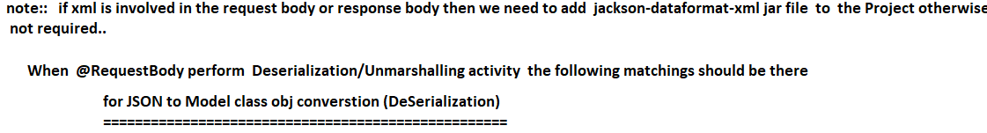

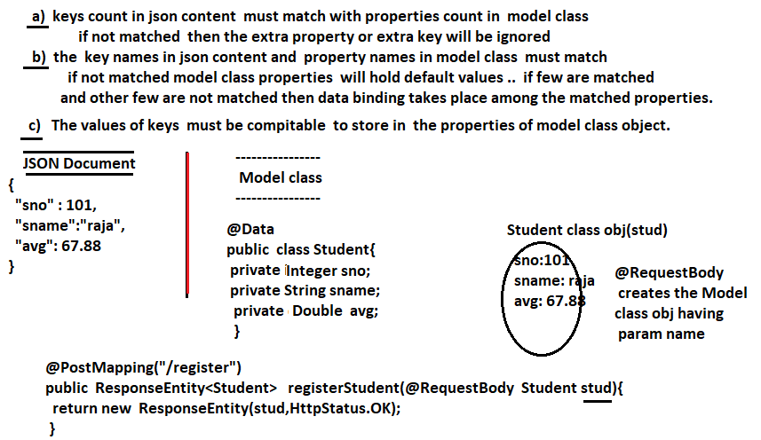

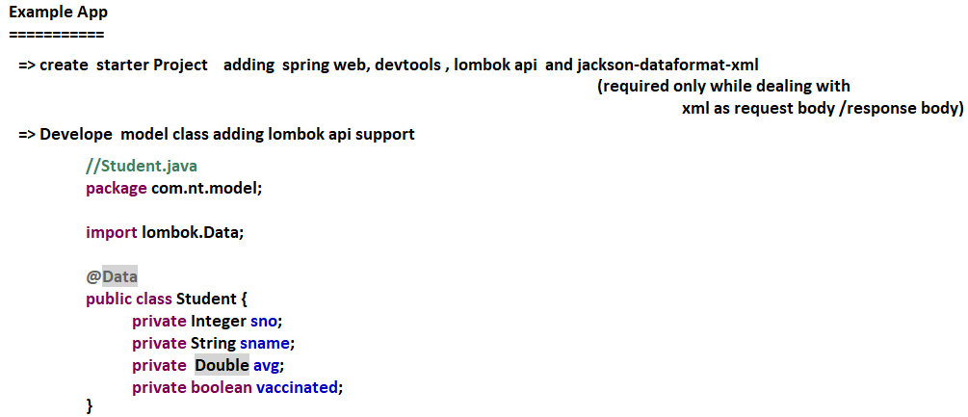

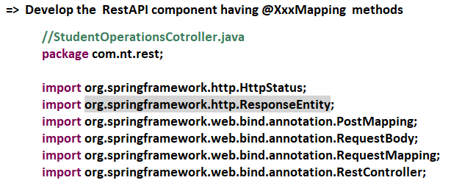

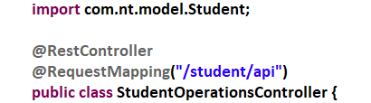

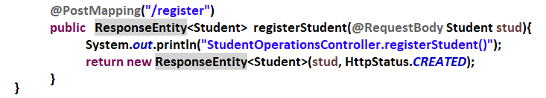

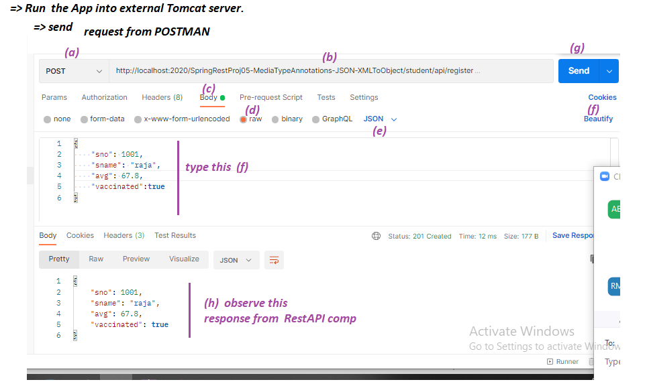

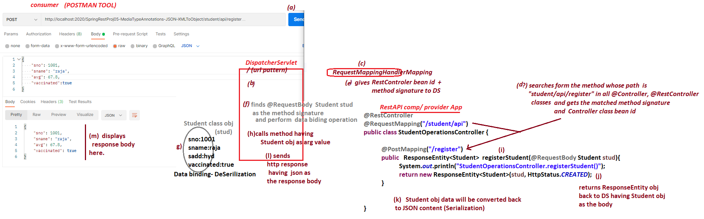

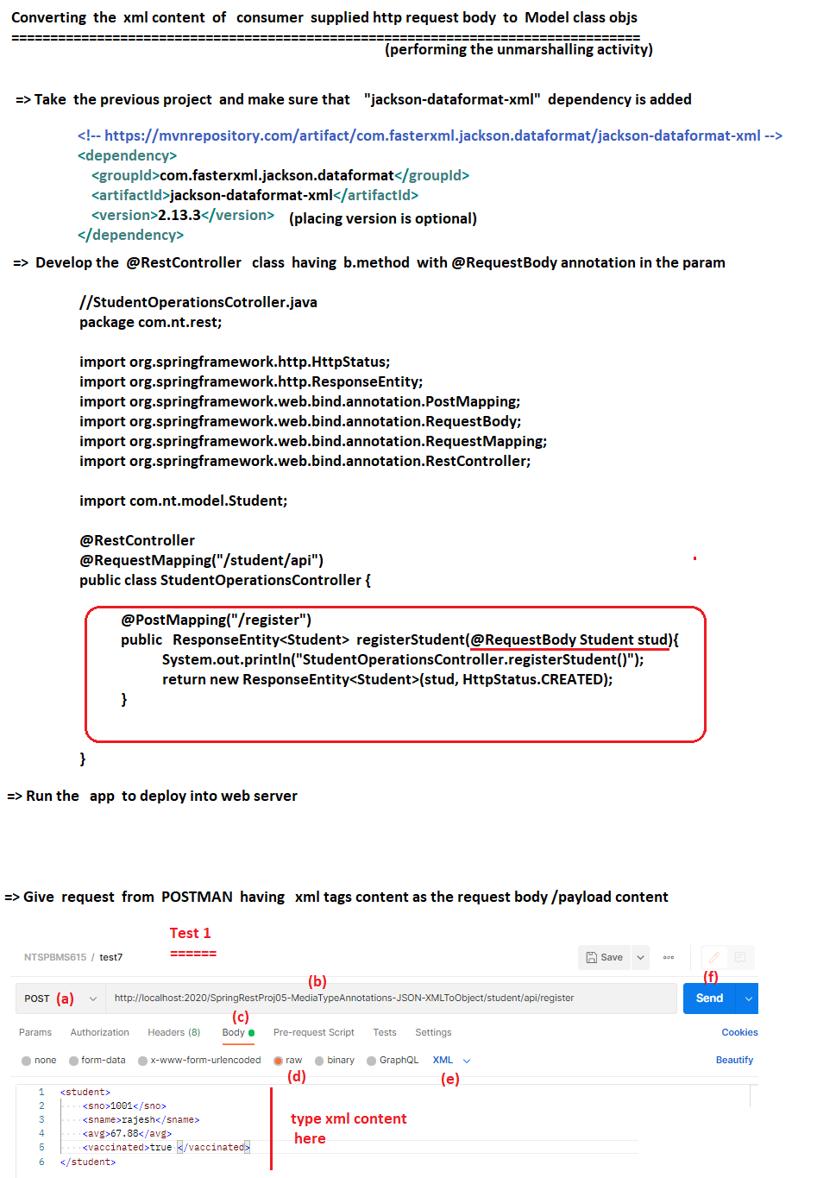

NTSPBMS615-June 14th-2022- Sending Complex Json Data and converting to objs using @ReponseBody

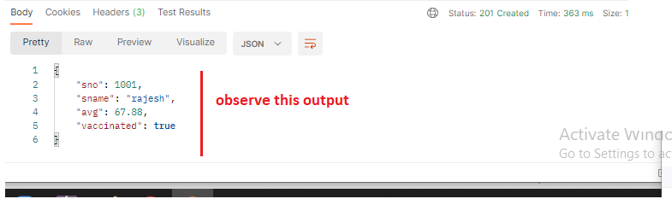

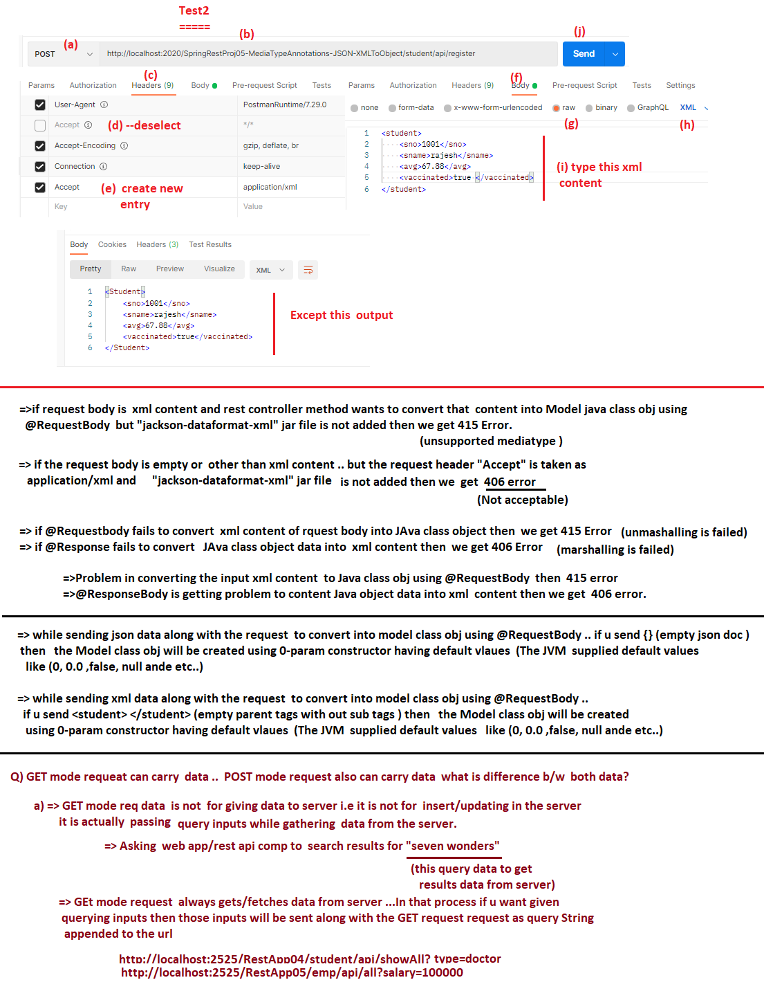

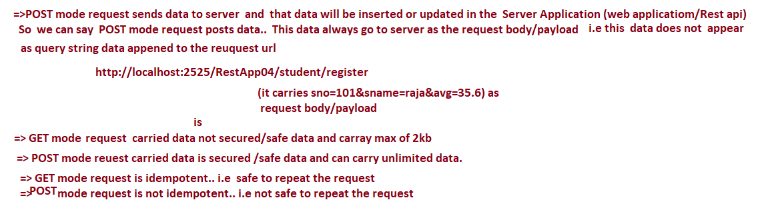

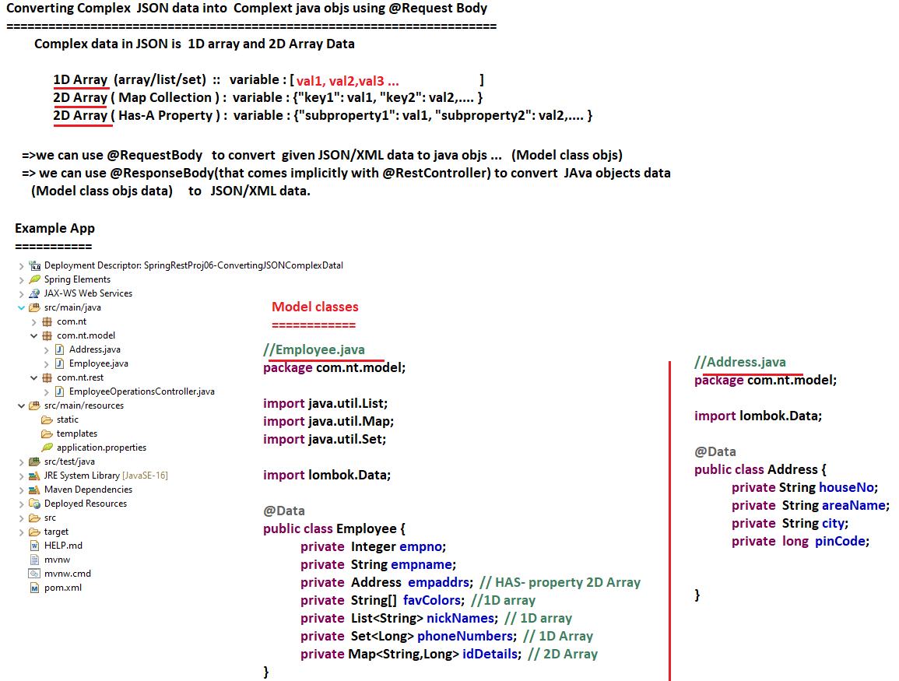

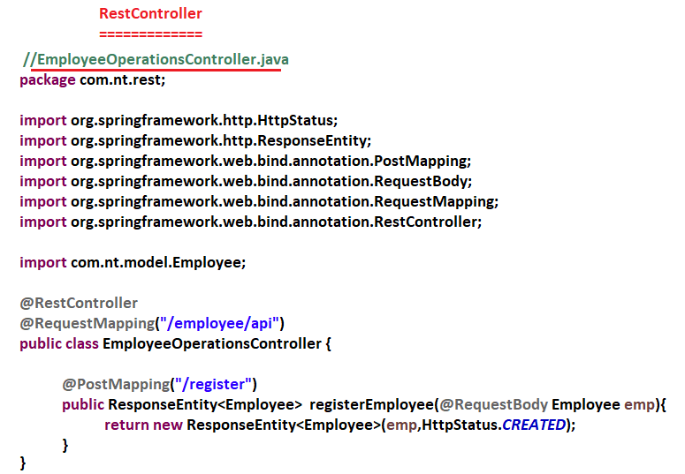

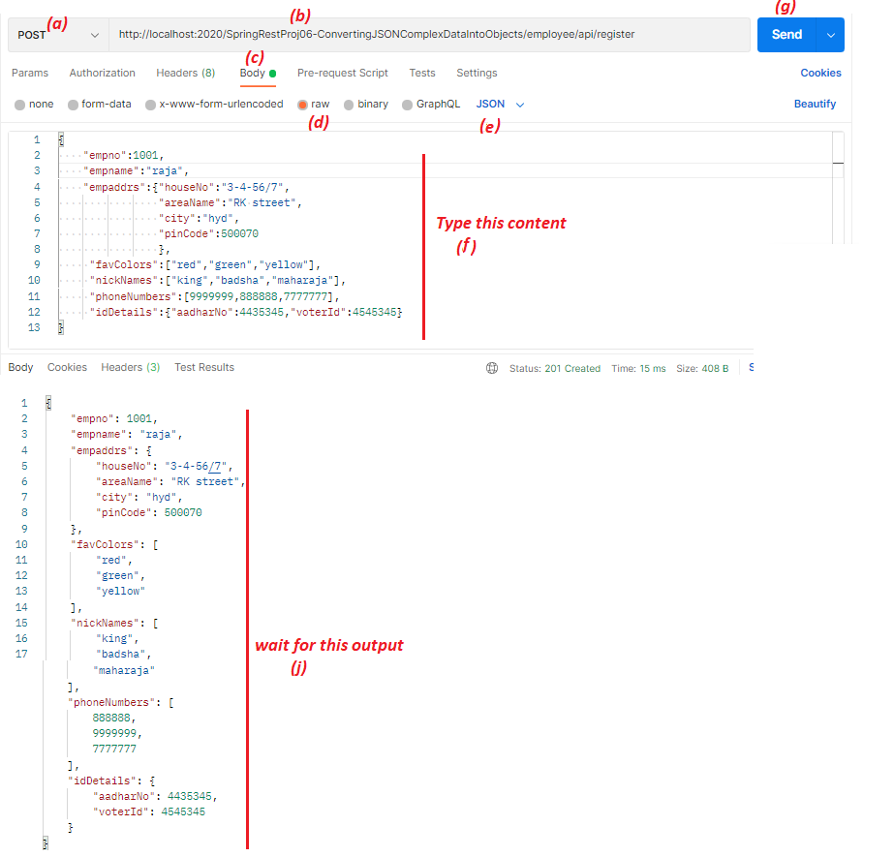

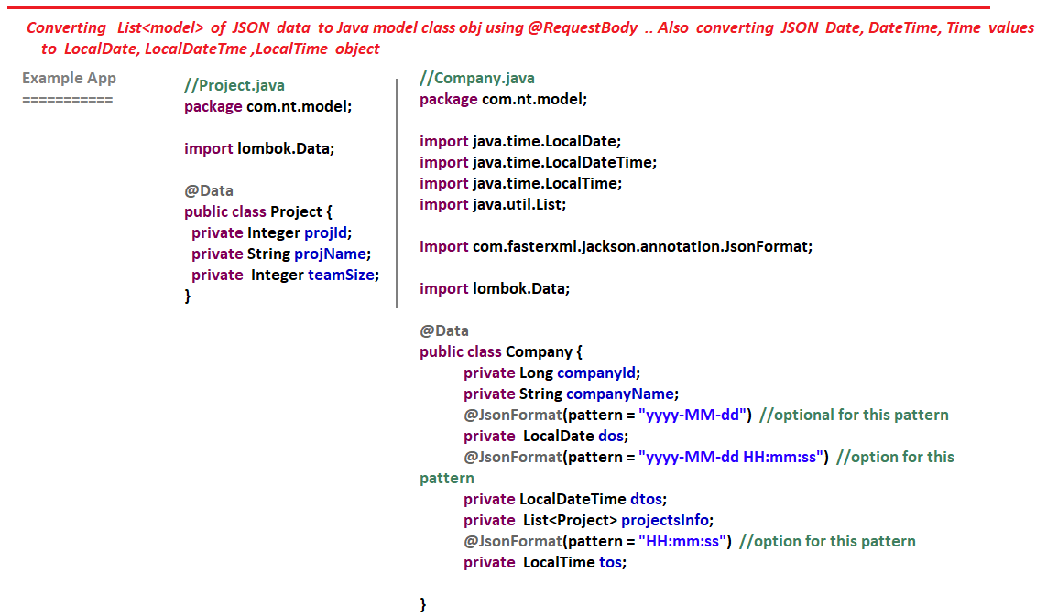

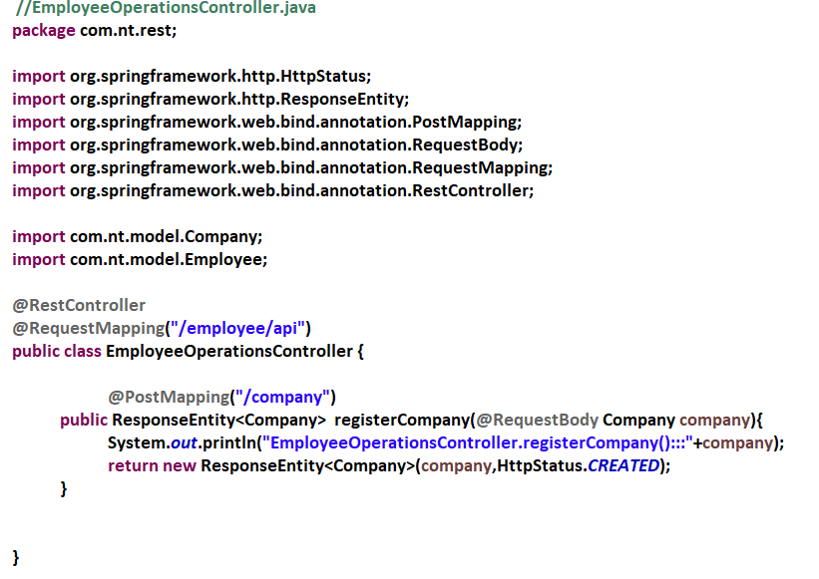

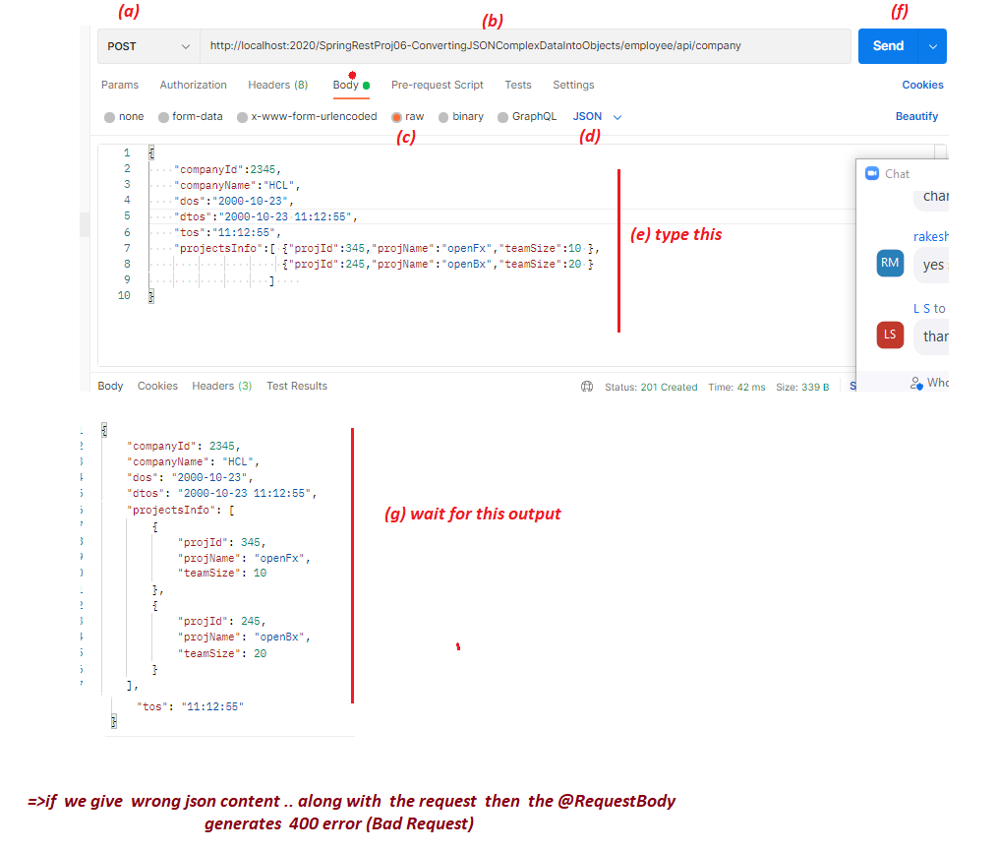

NTSPBMS615-June 15th-2022- Passing input values to RestAPI comp as request params

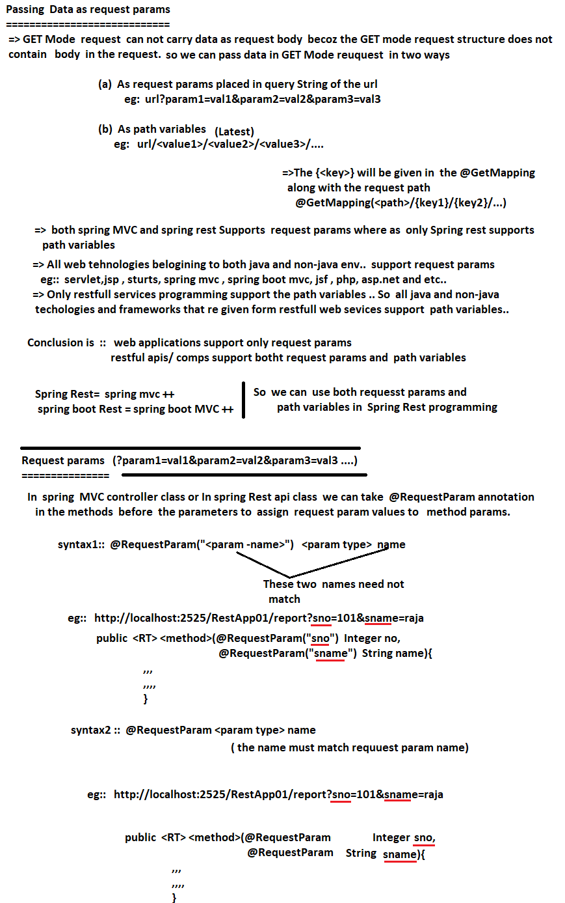

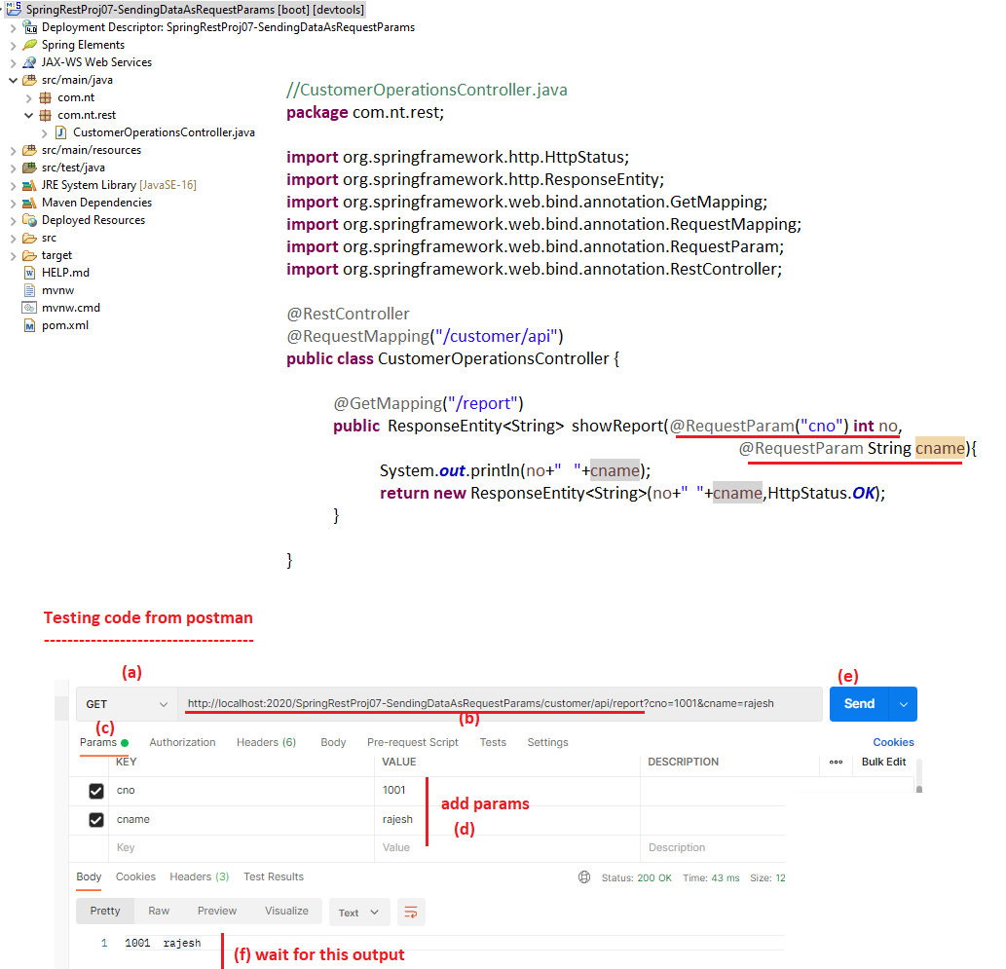

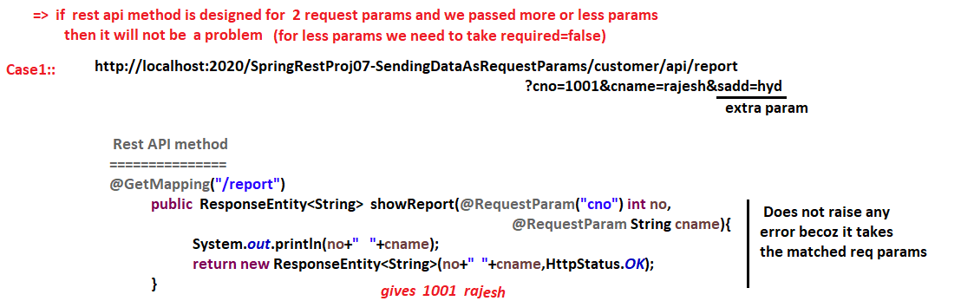

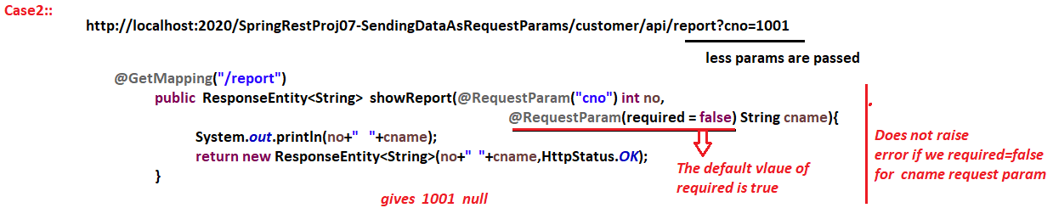

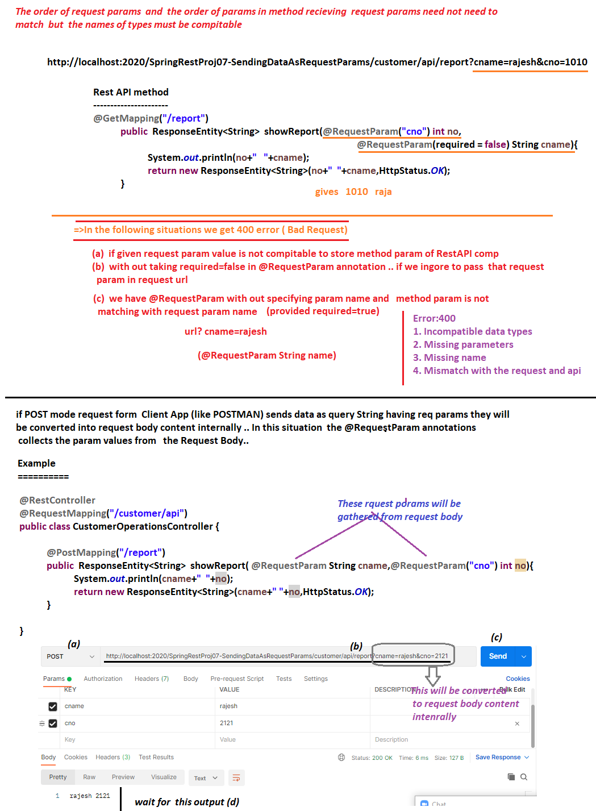



NTSPBMS615-June 16th-2022- Passing input values to RestAPI comp as Path variables

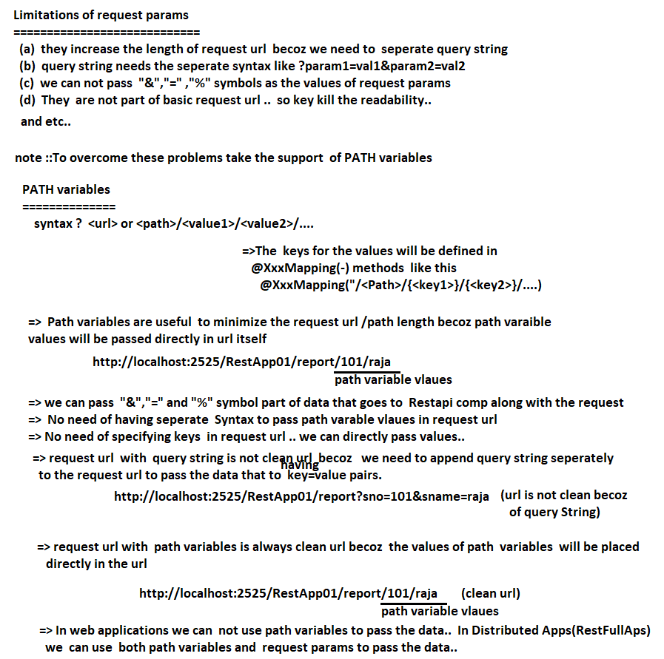

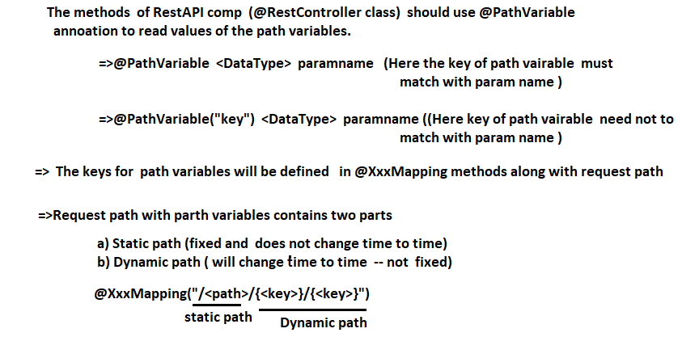

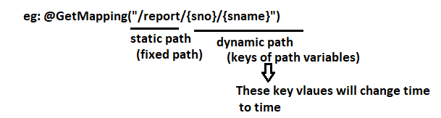

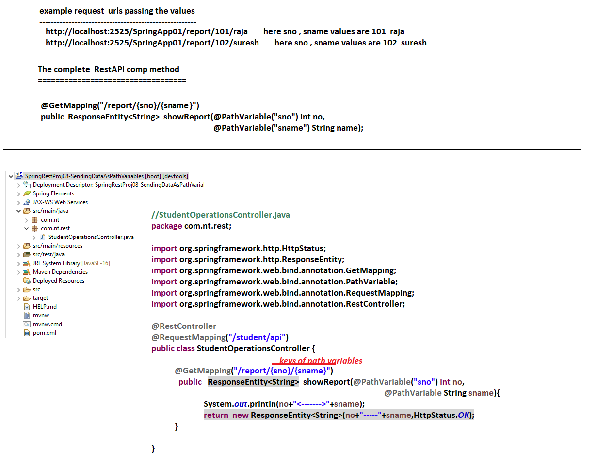

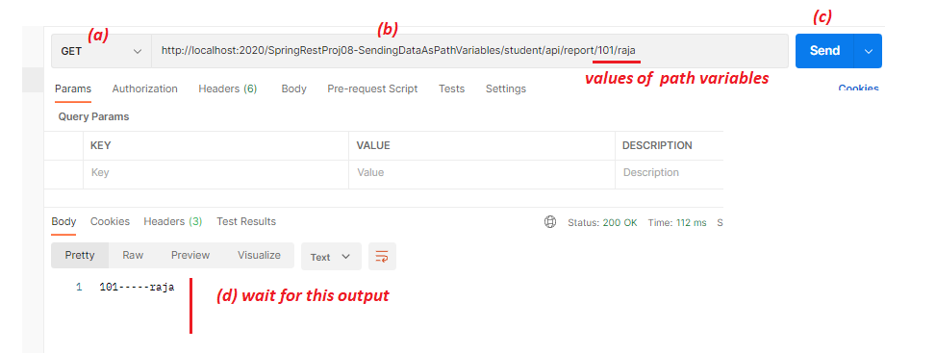

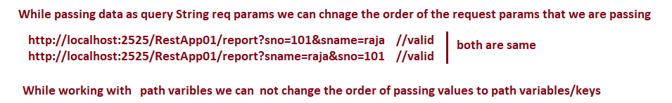

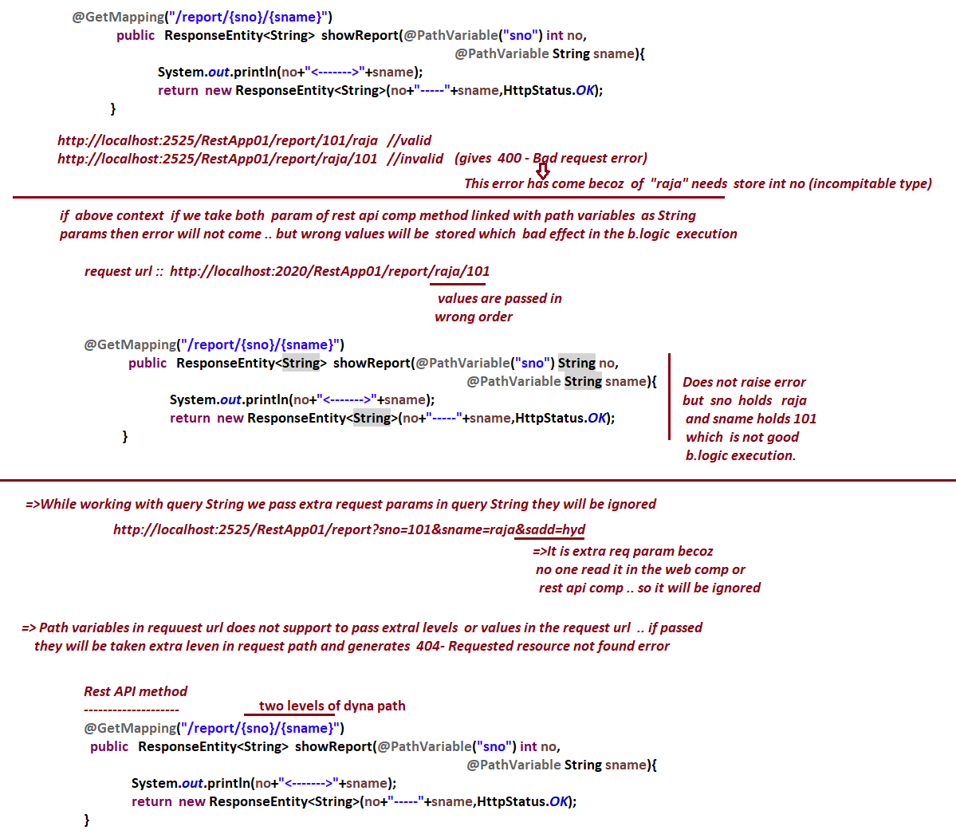

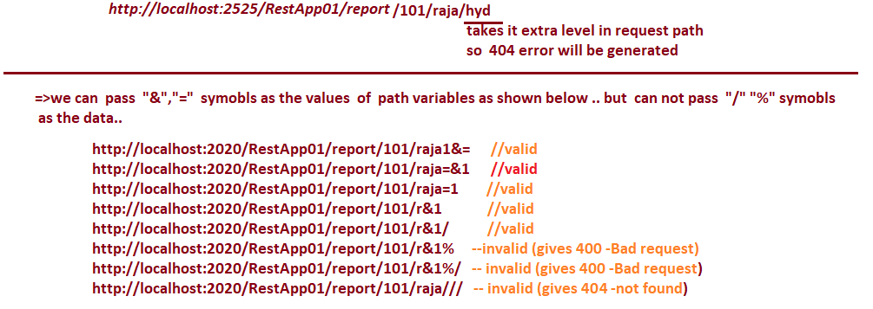

NTSPBMS615-June 17th-2022- More on Path Variables

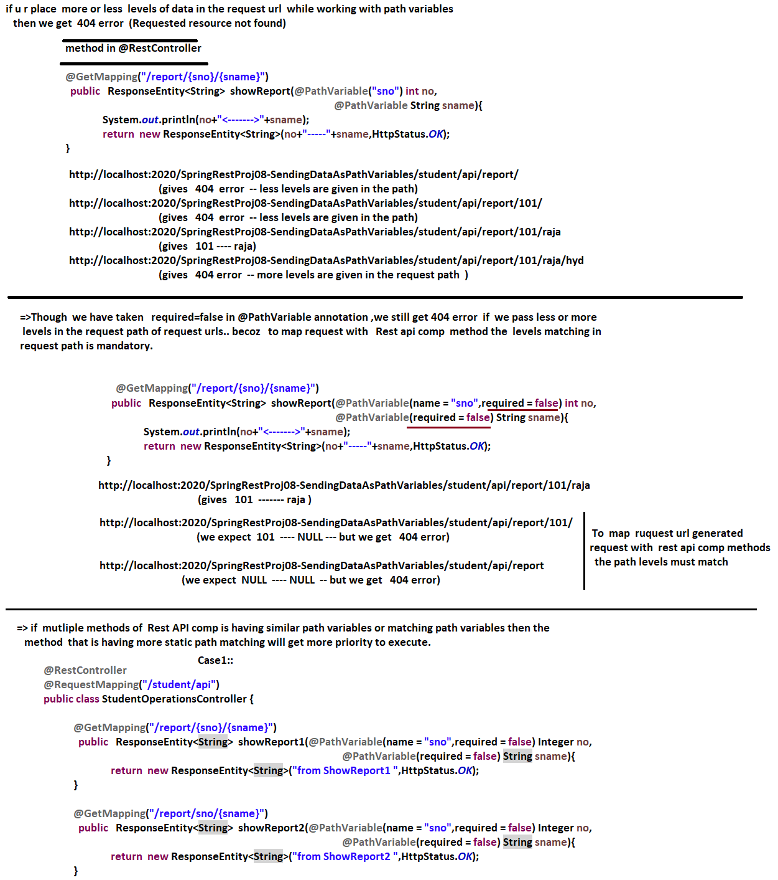

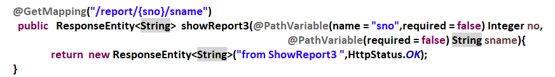

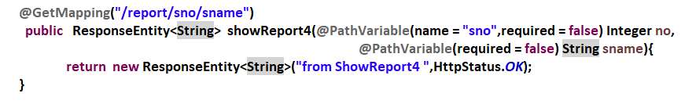

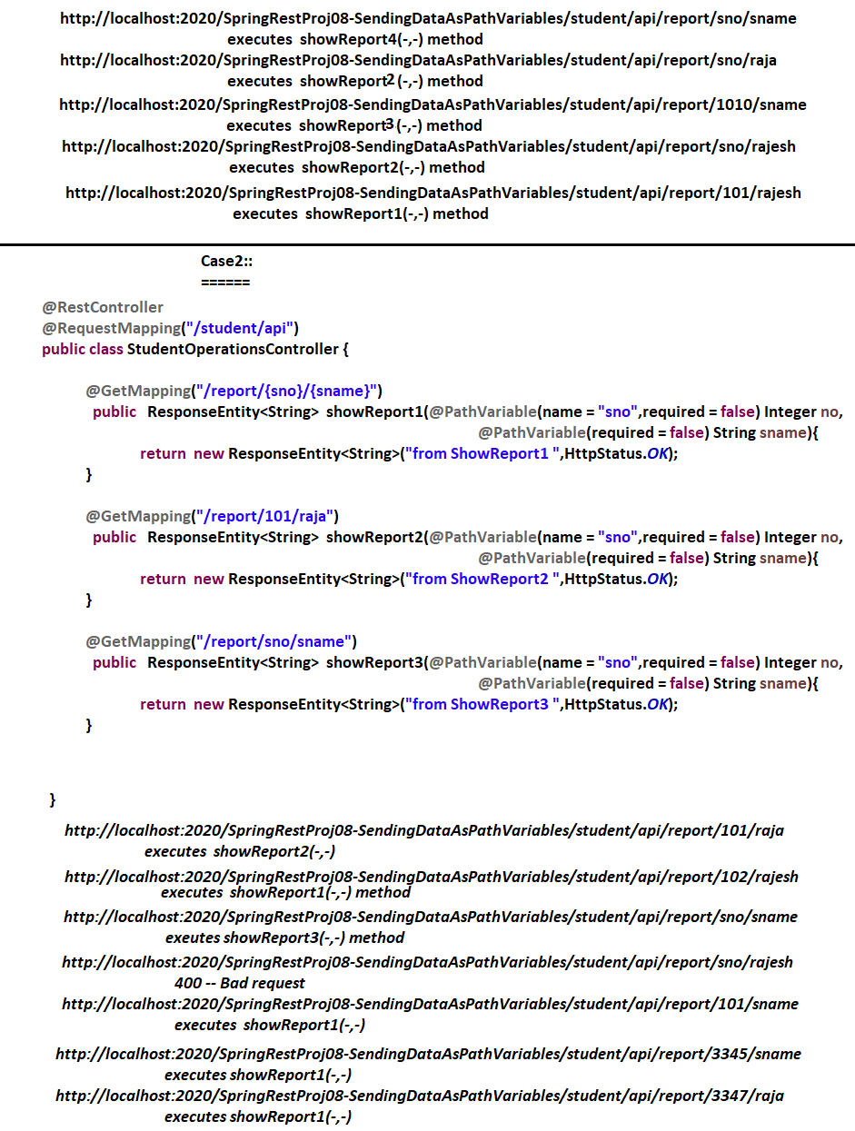



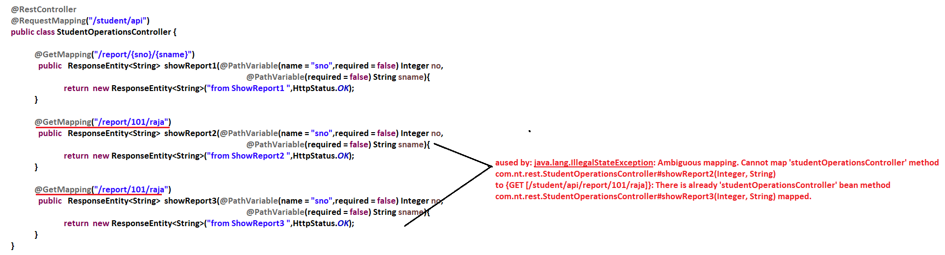

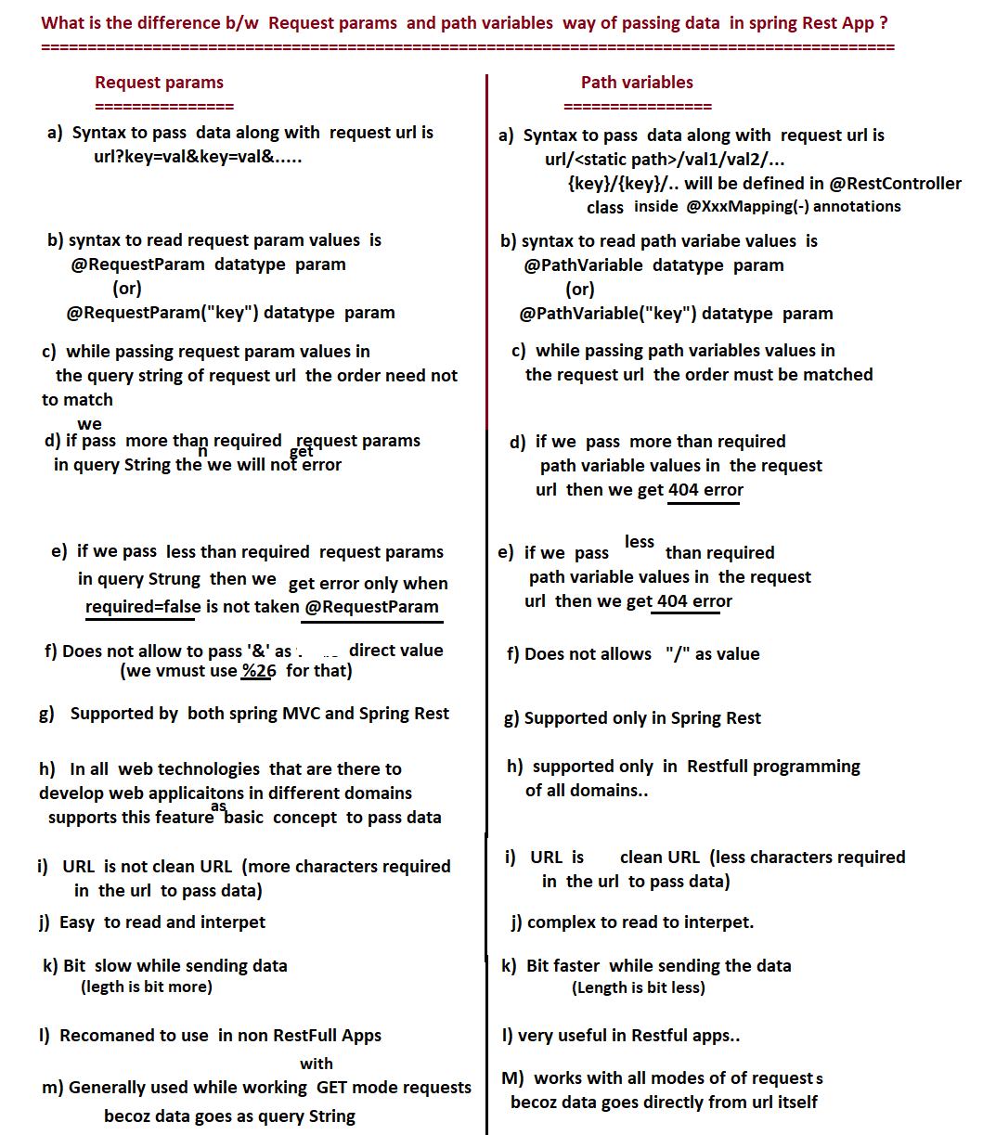

NTSPBMS615-June 18th-2022- MiniProject on SpringRest

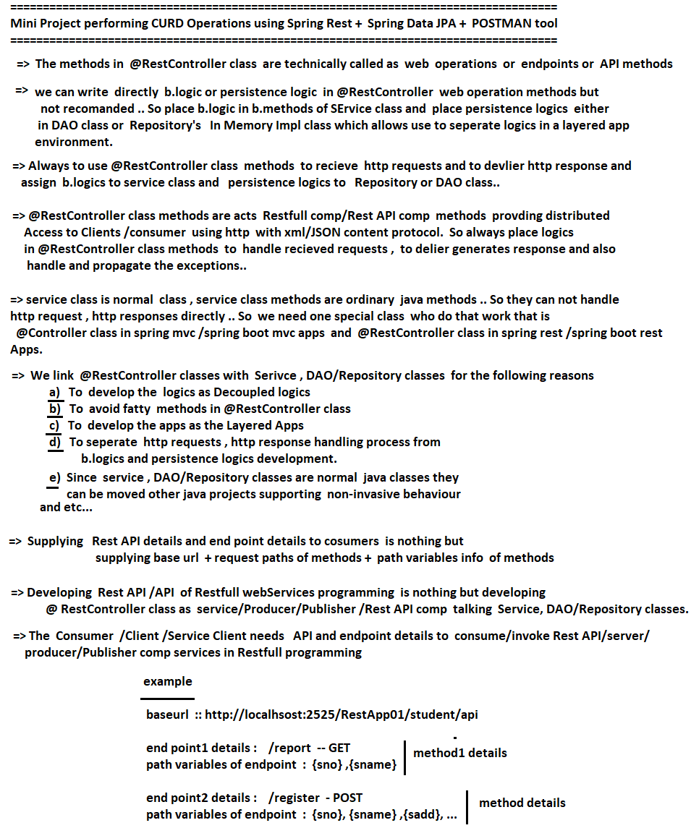

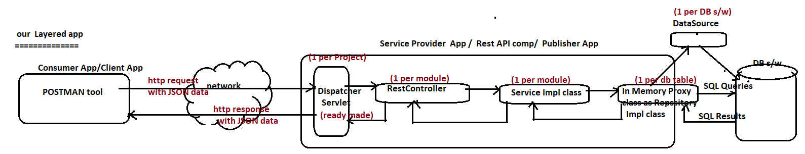

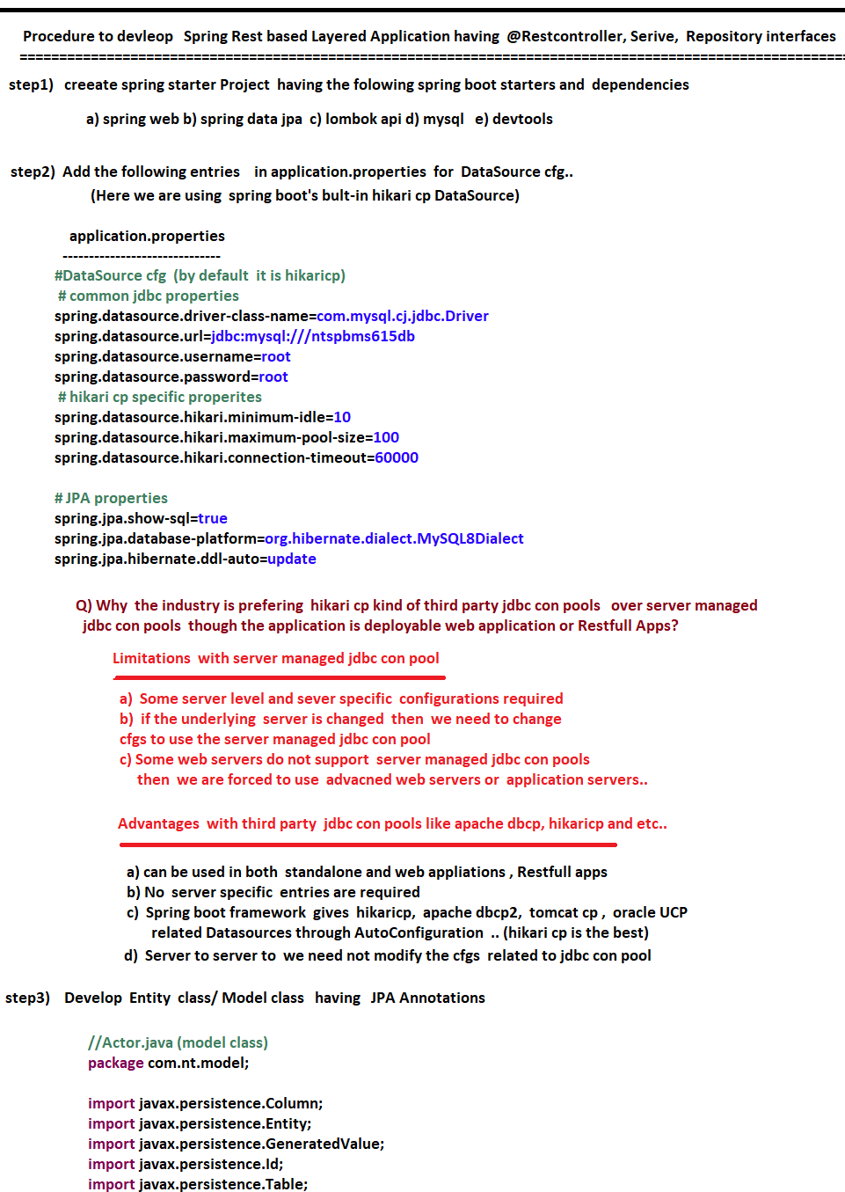

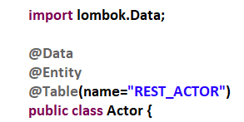

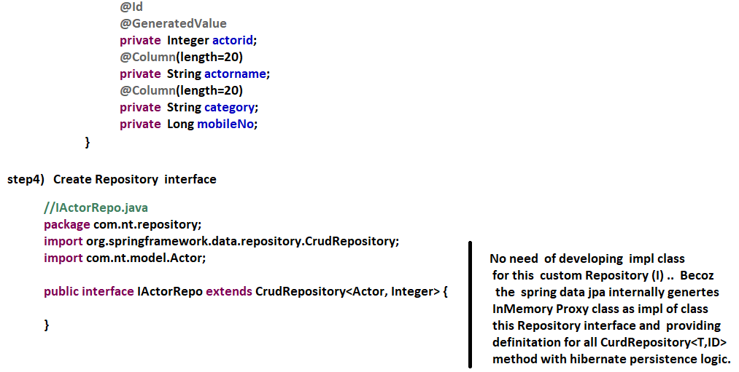

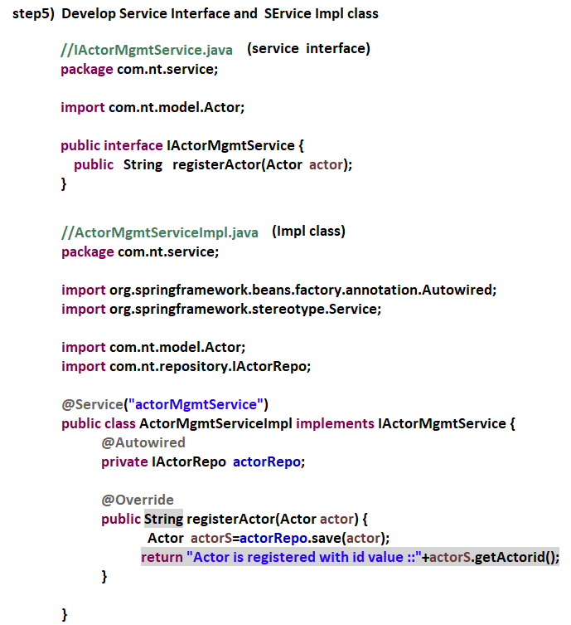

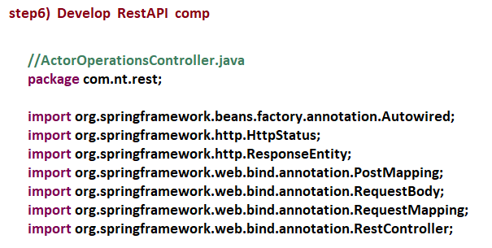

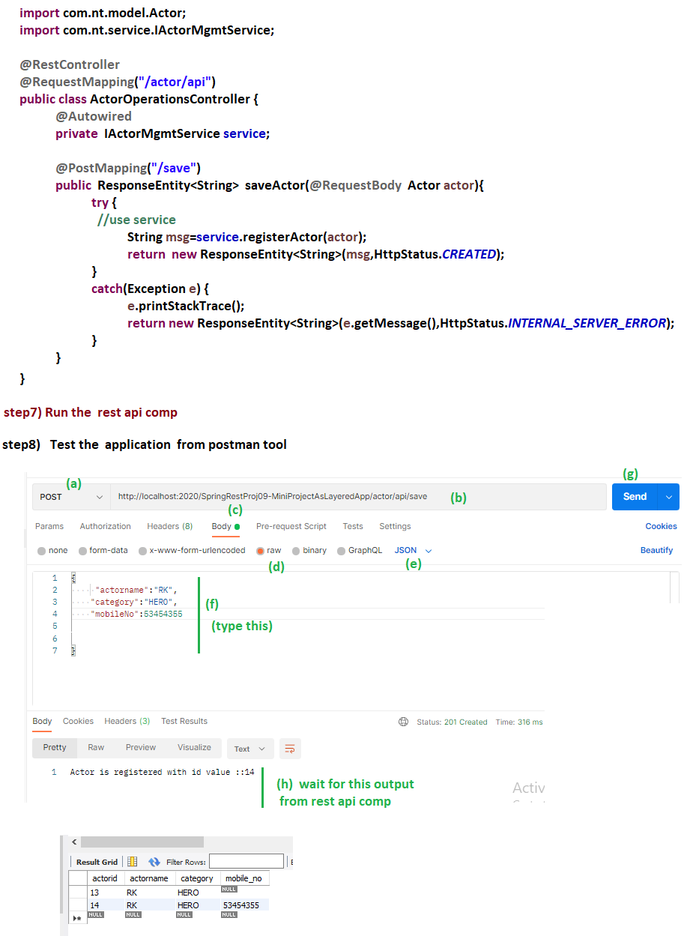

NTSPBMS615-June 22nd-2022- MiniProject on SpringRest-CURD Operations

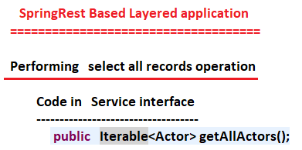

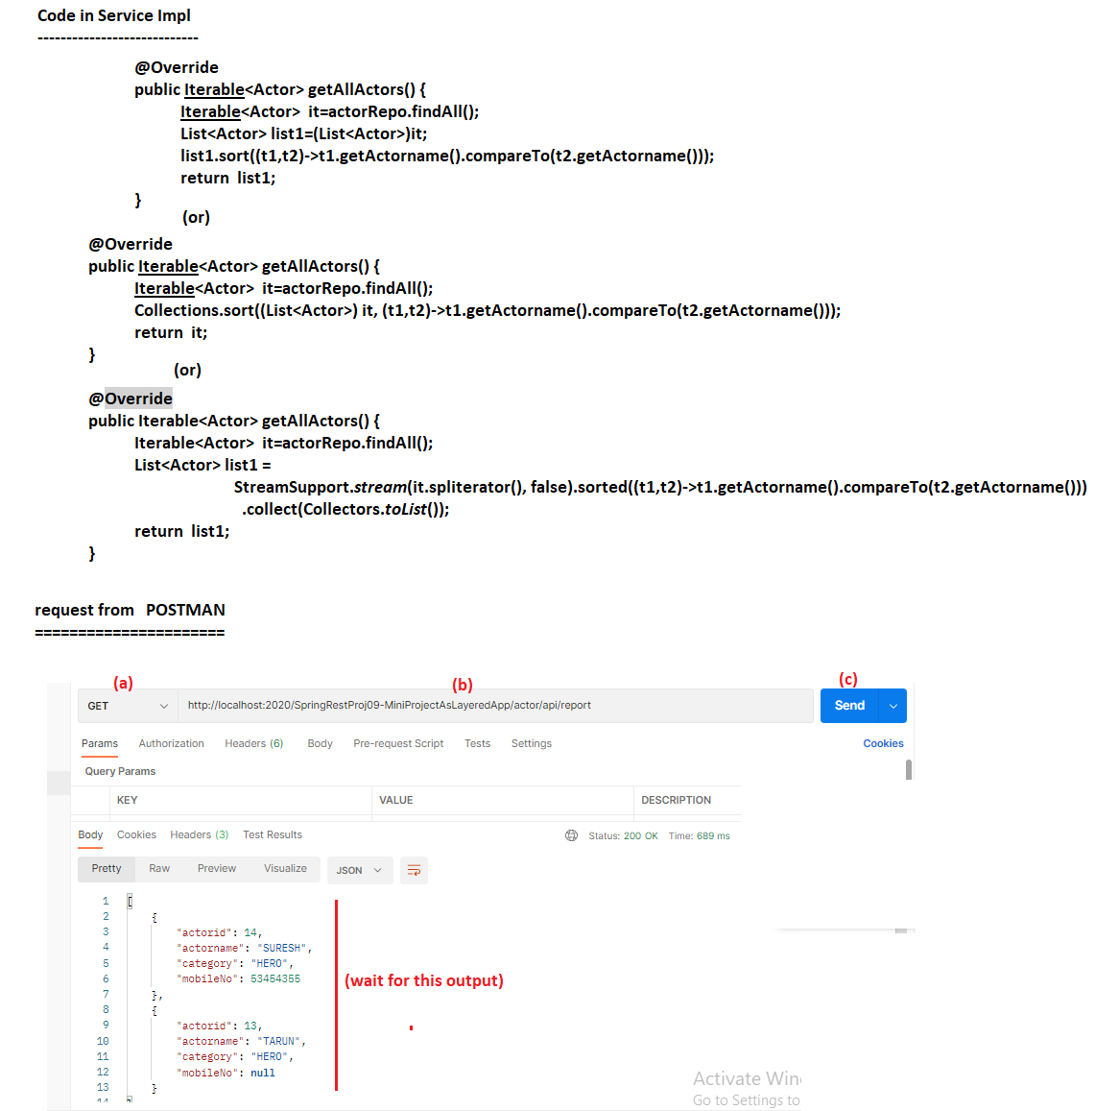

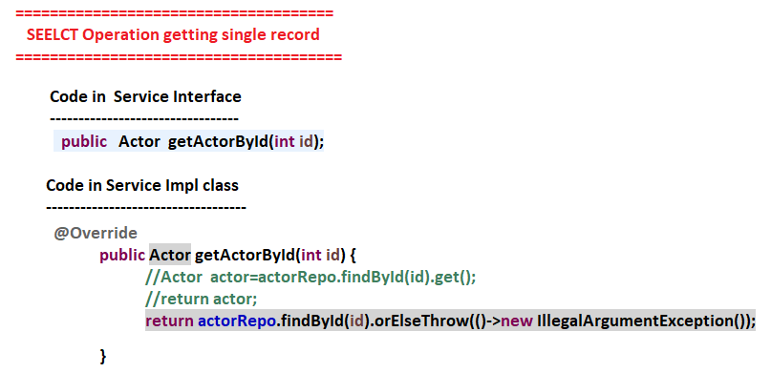

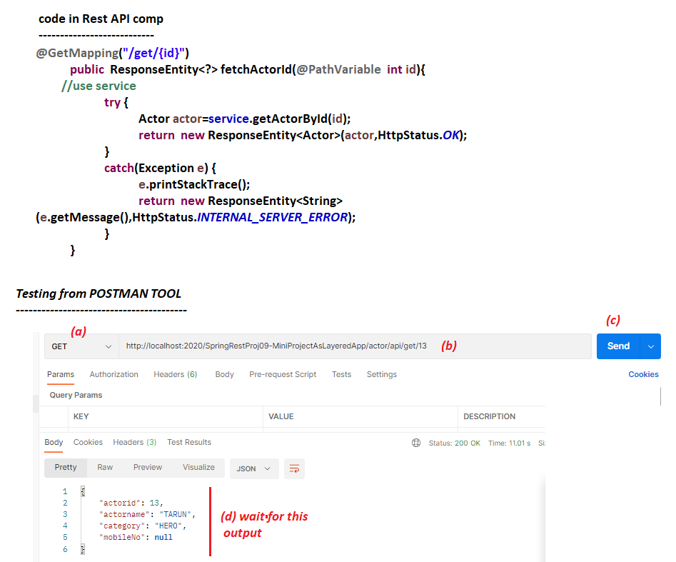

NTSPBMS615-June 24th-2022- MiniProject on SpringRest-CURD Operations

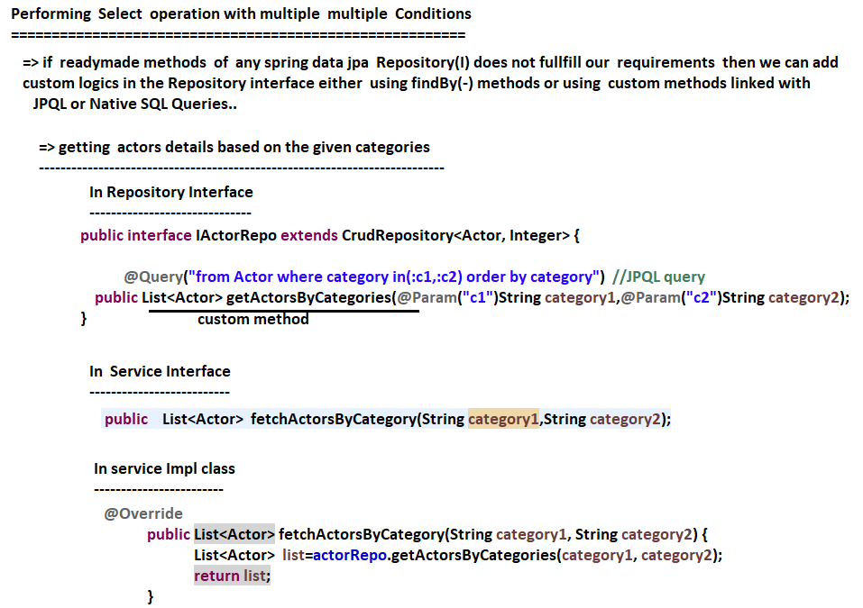

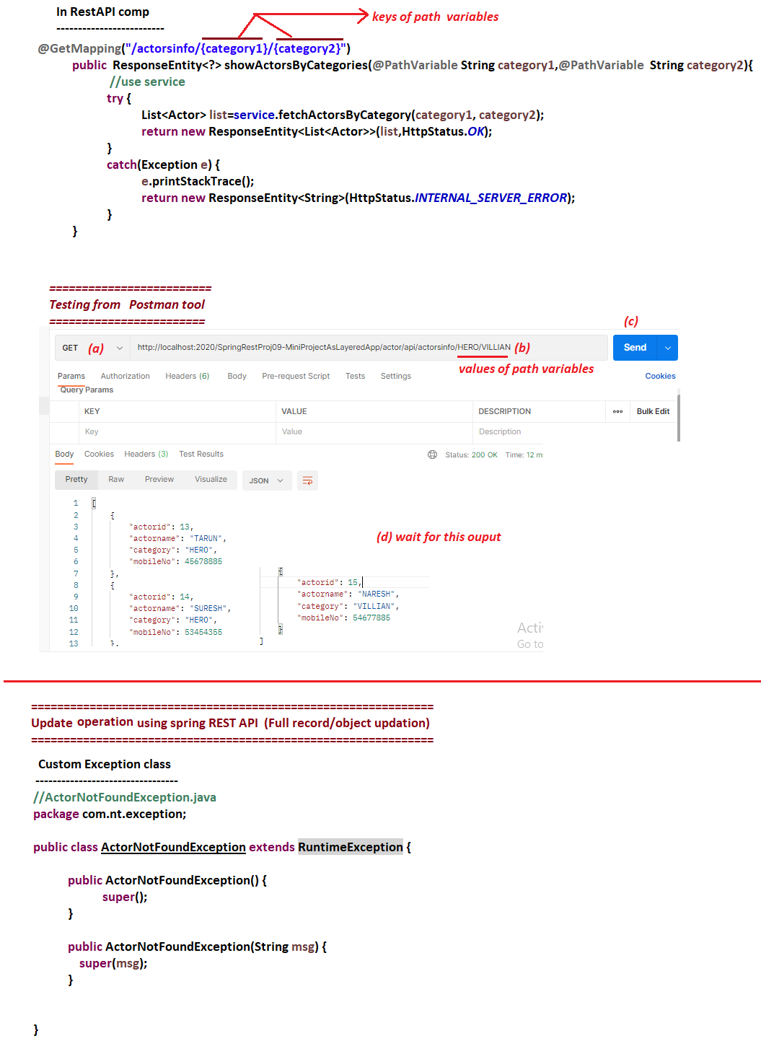

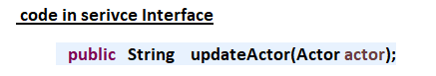

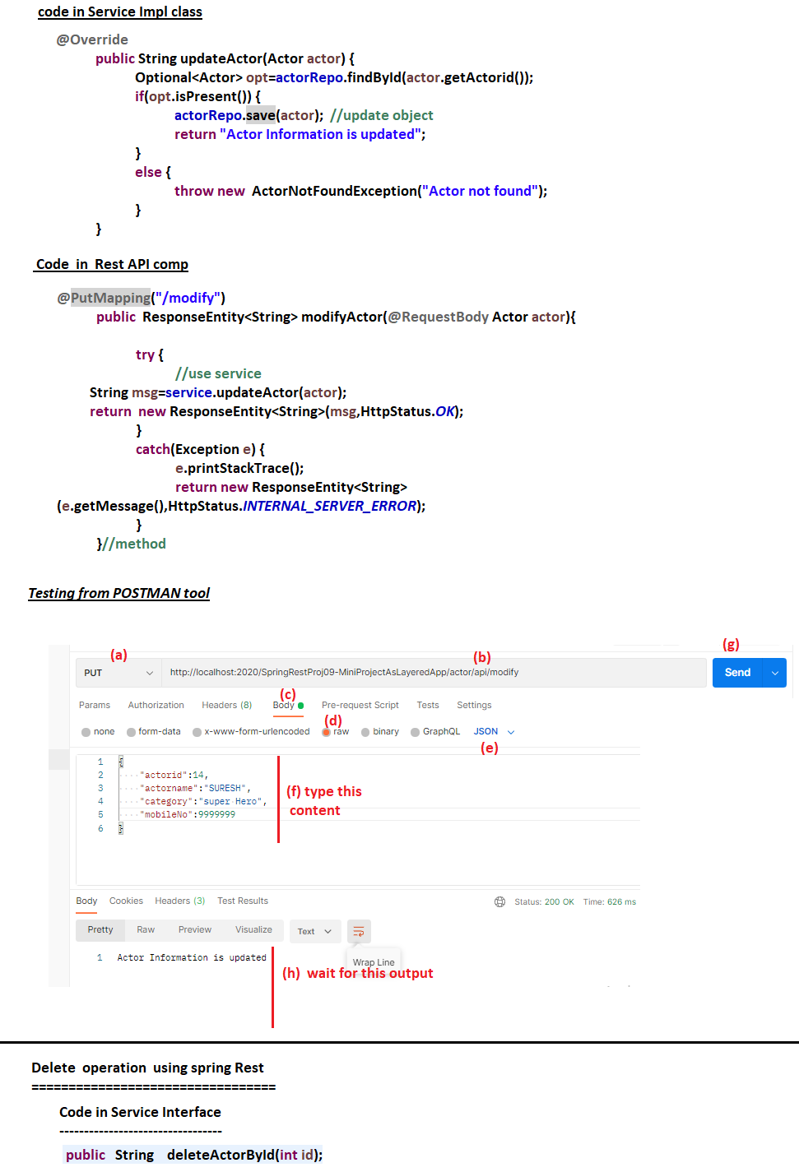

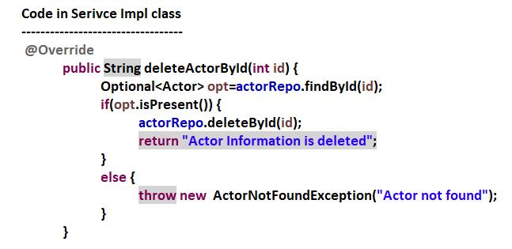

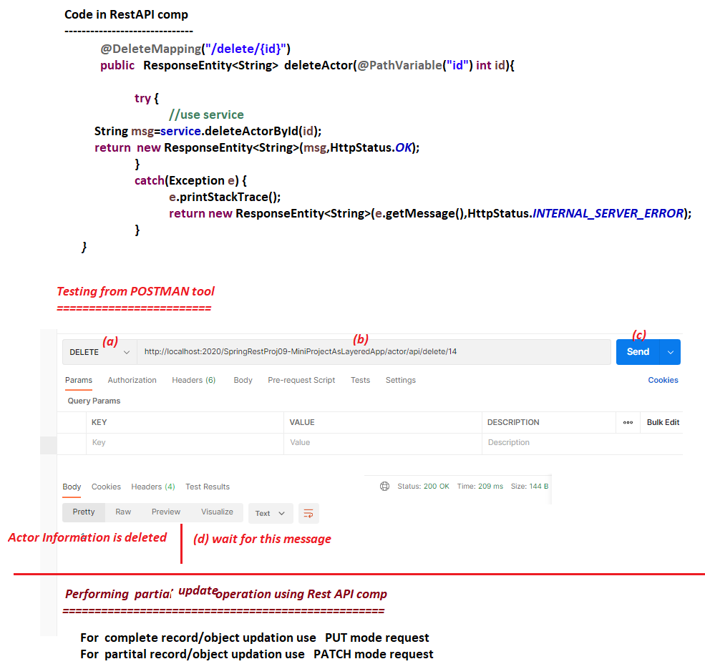

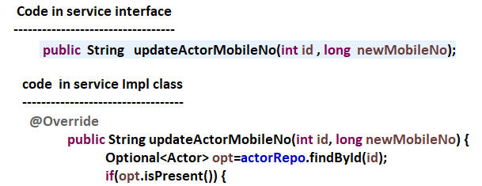

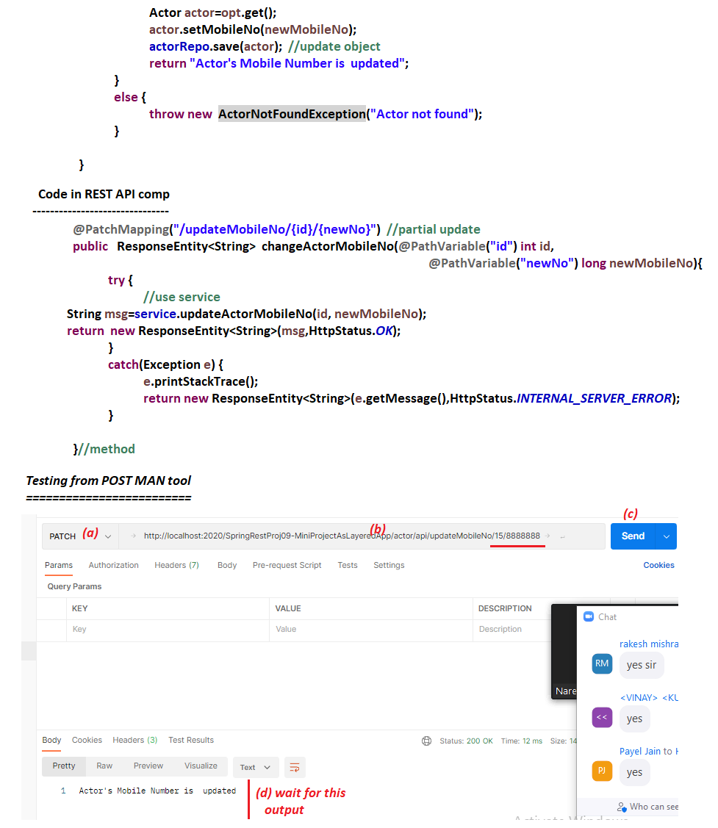

NTSPBMS615-June 25th-2022- @ControlAdvice- ExceptionHandling

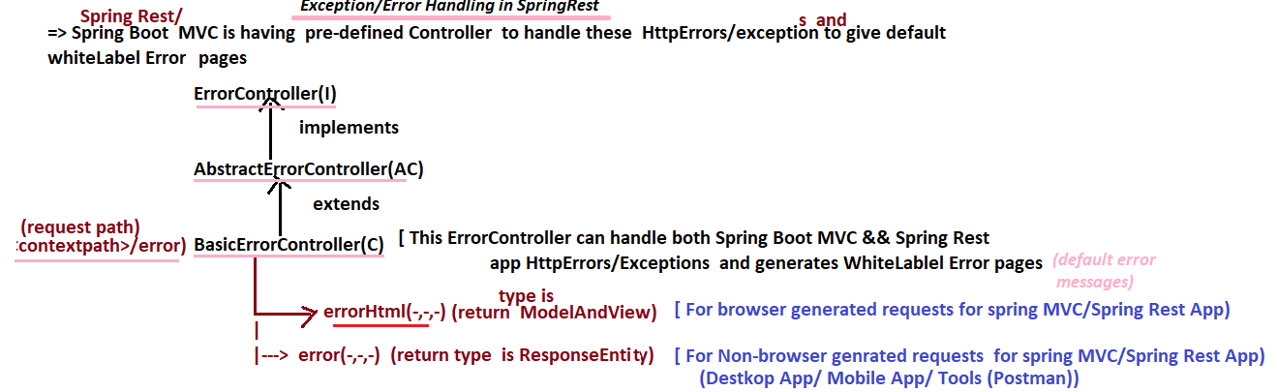

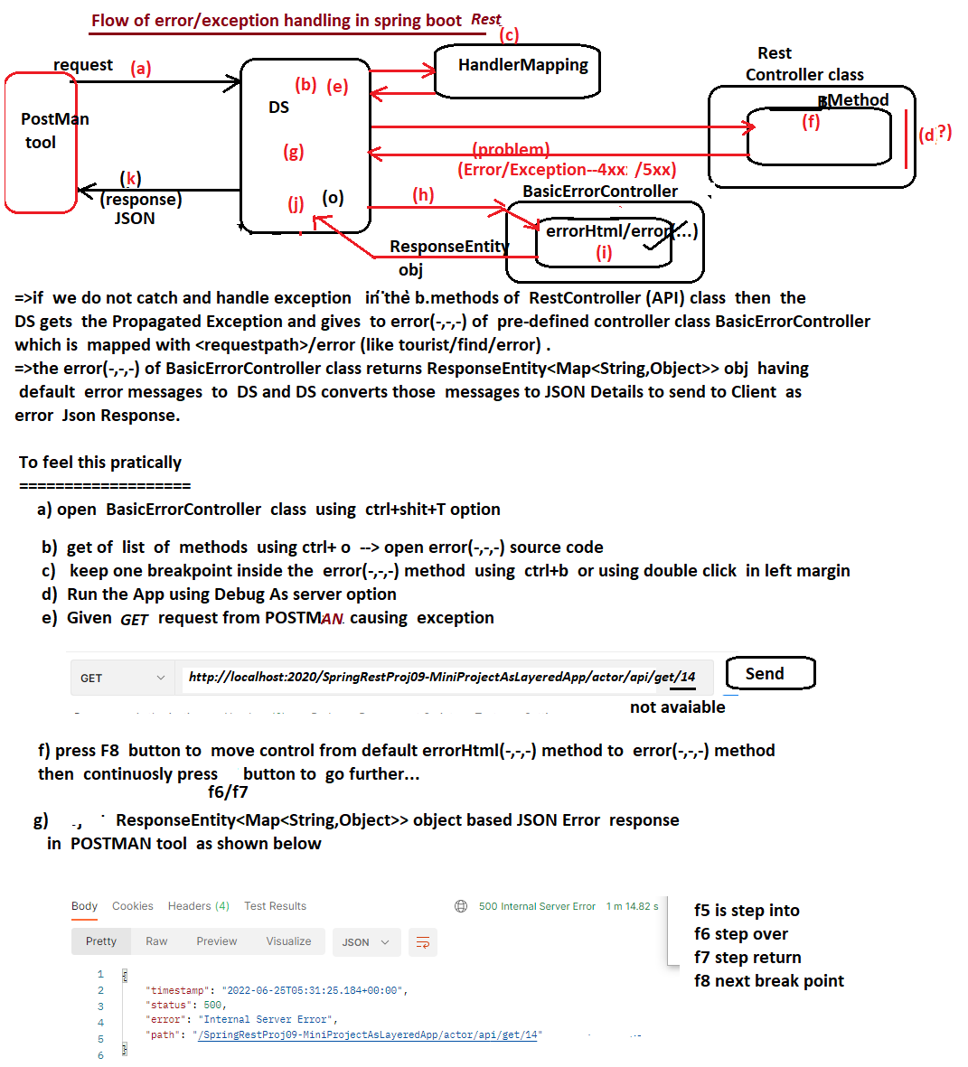

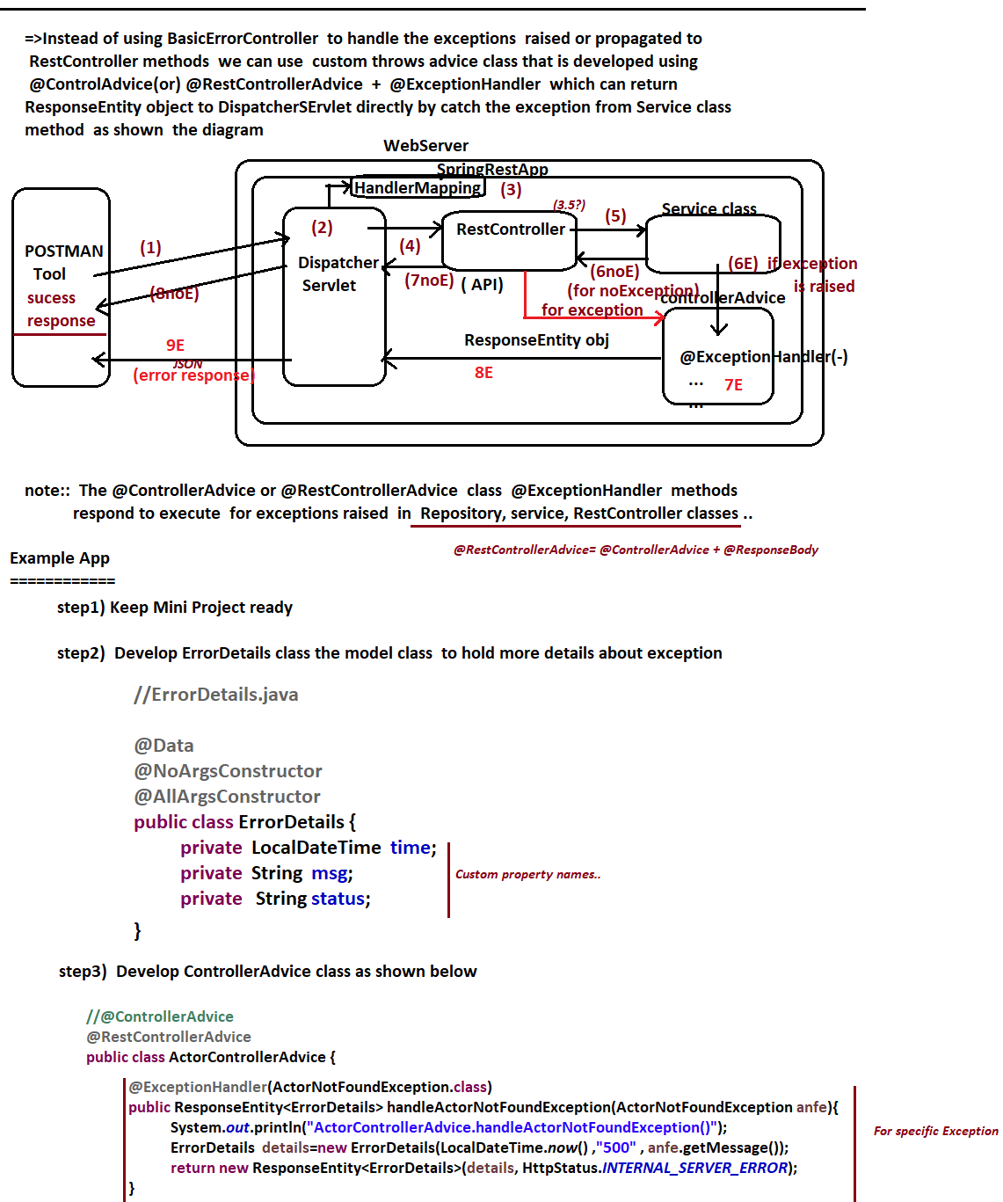

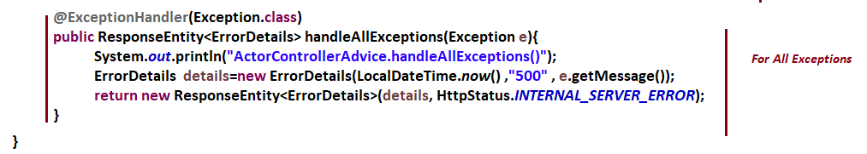



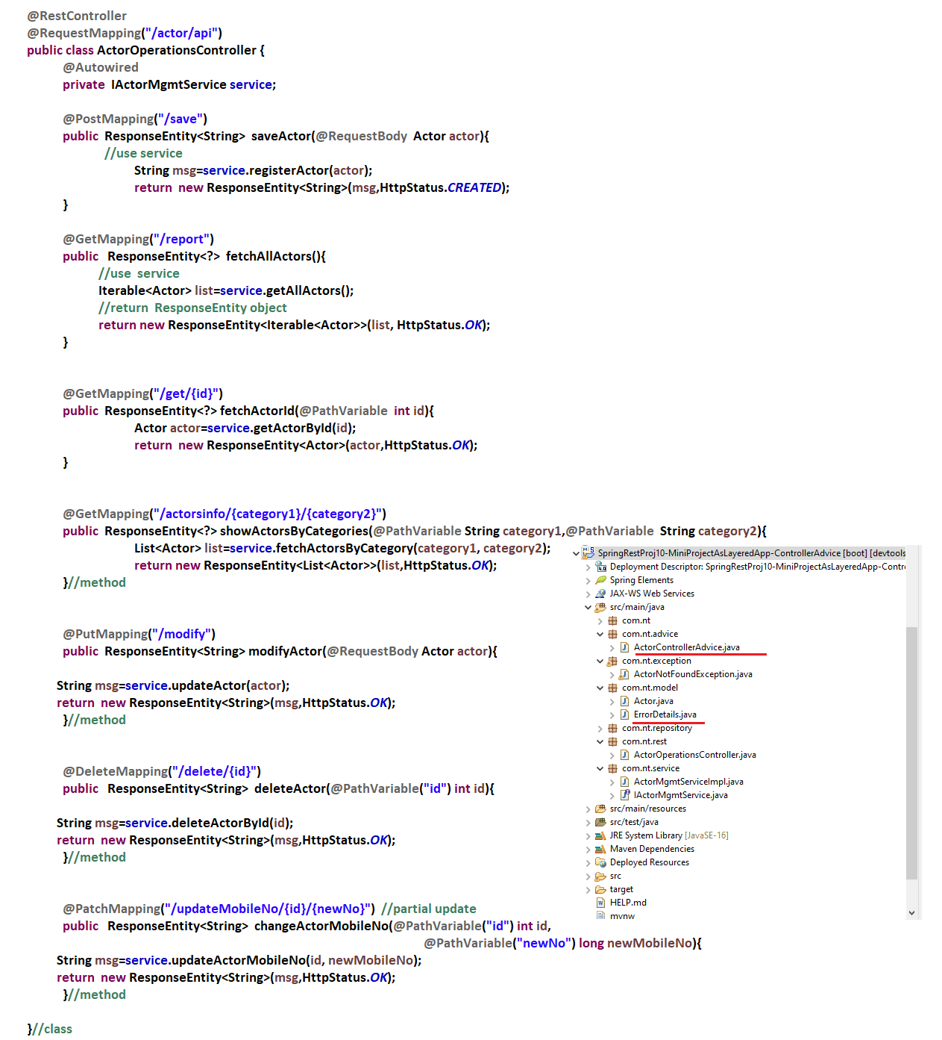

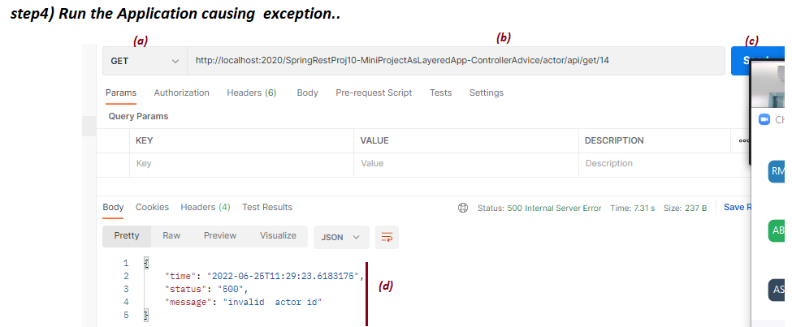

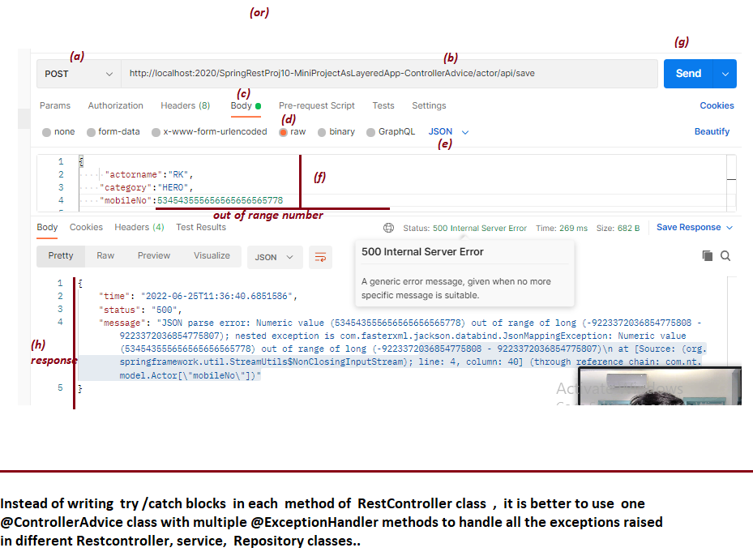

NTSPBMS615- Swagger -Api documentation-june28th-2022

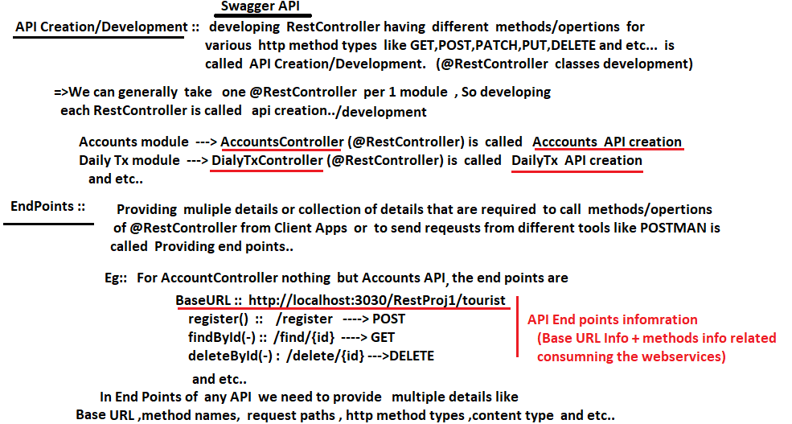

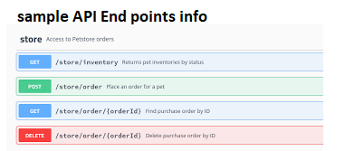

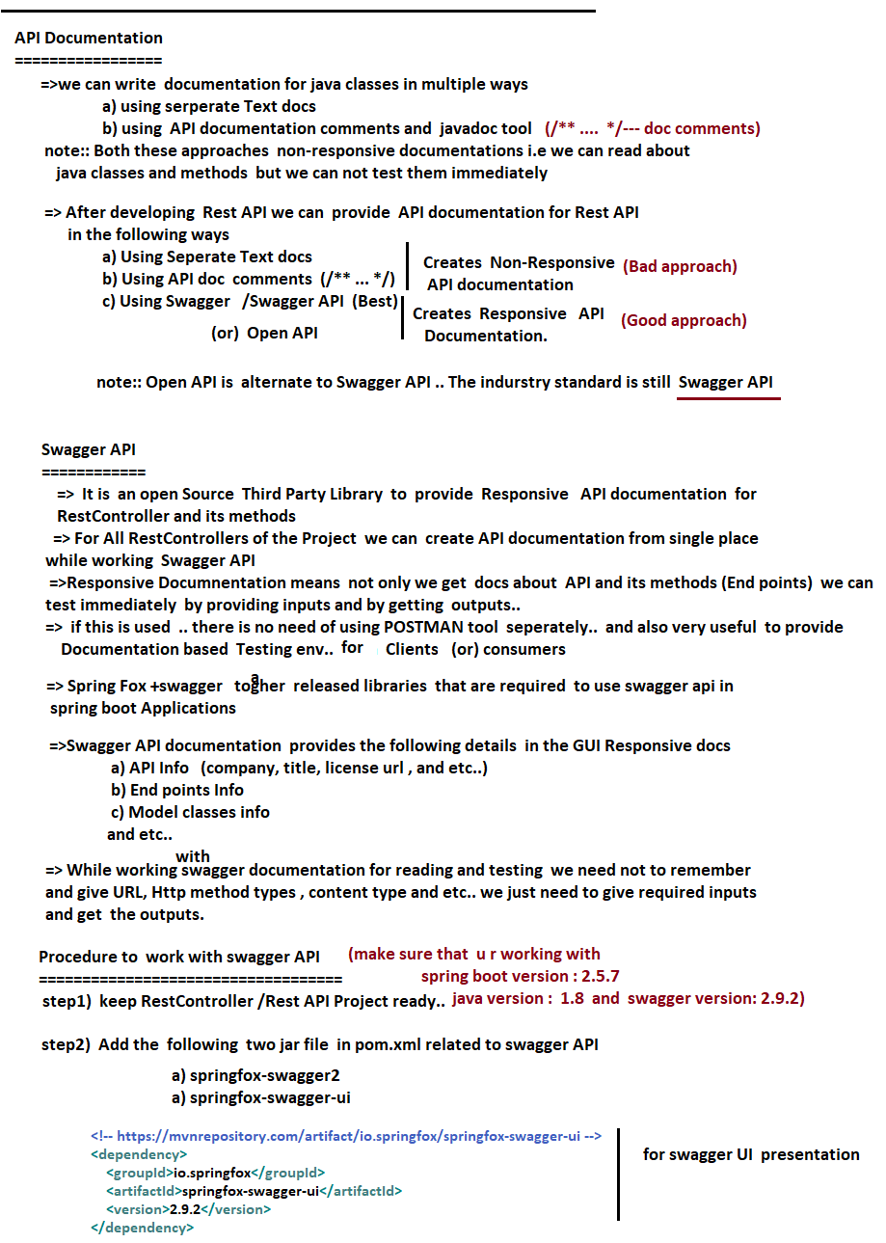

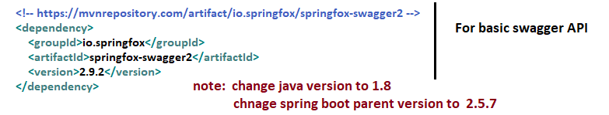

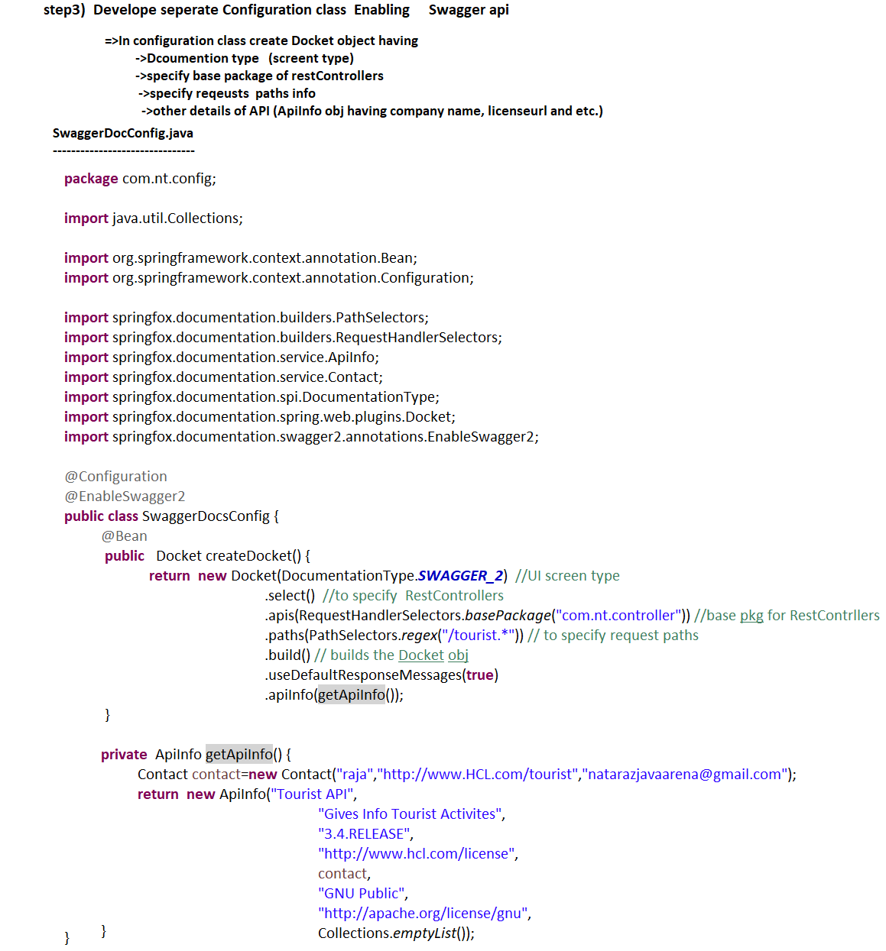

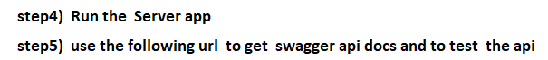

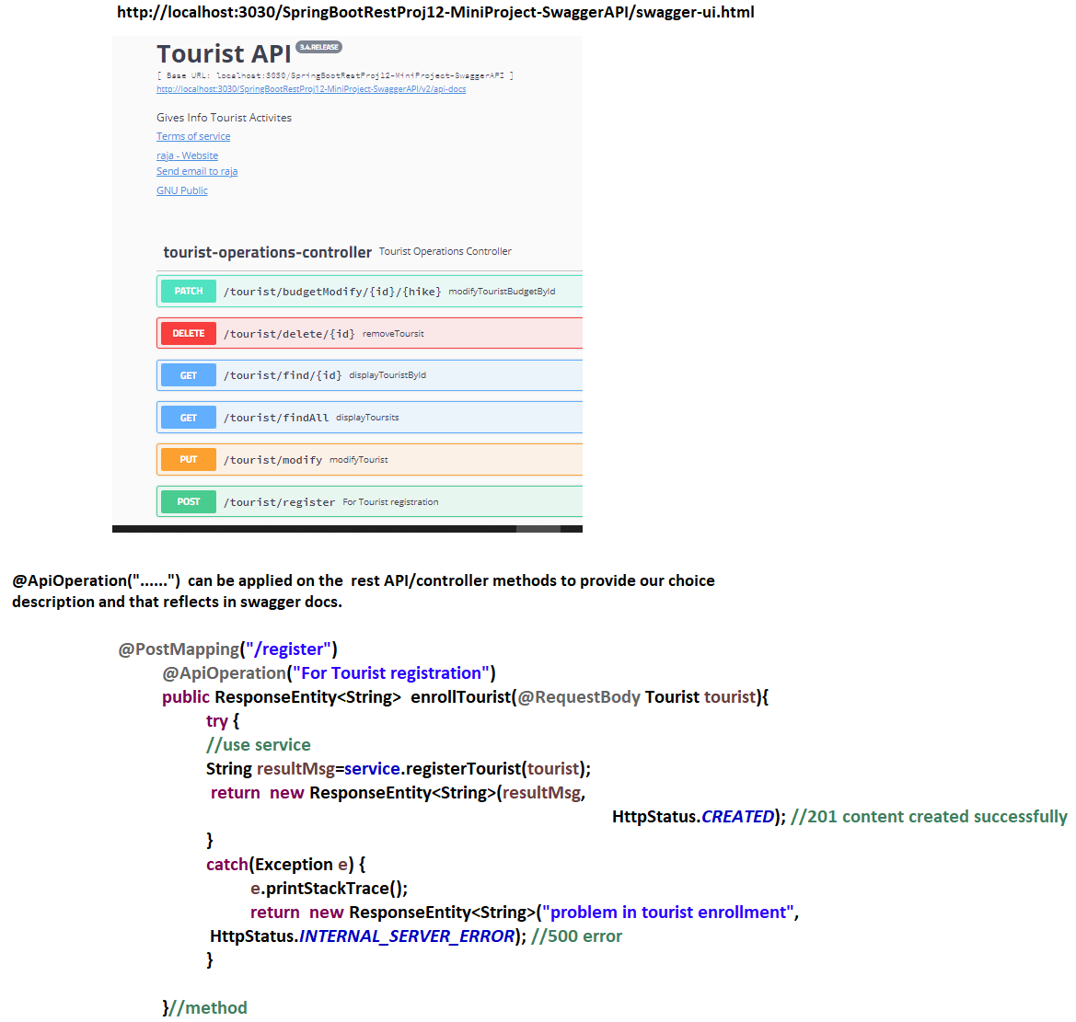

NTSPBMS615- Rest Consumer using RestTemplate-June 30th-2022

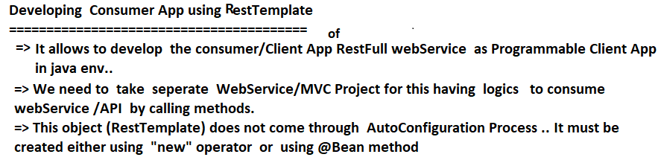

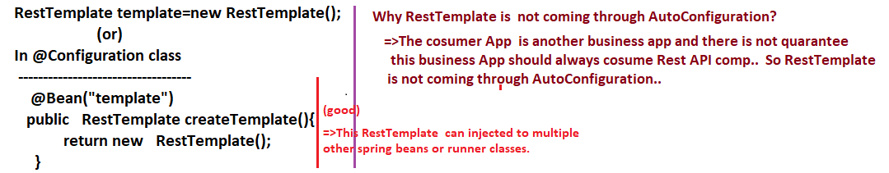

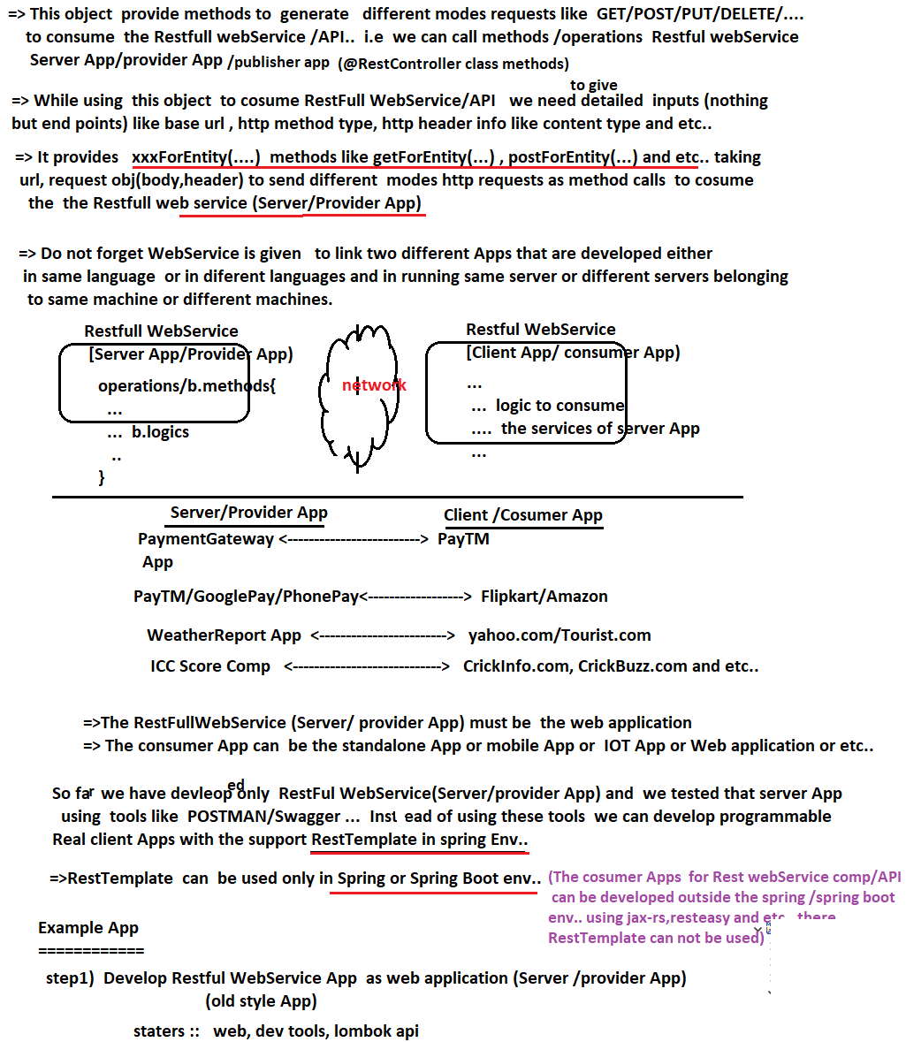

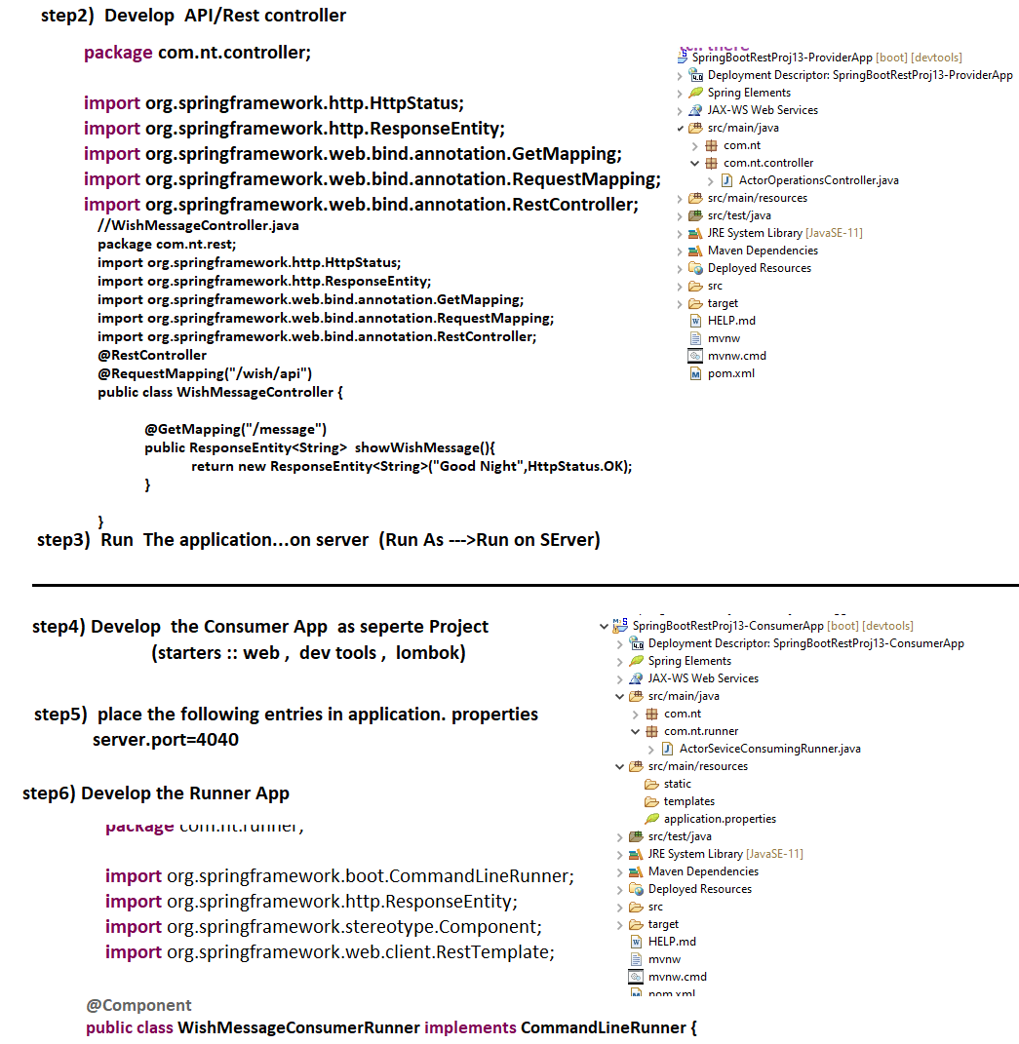

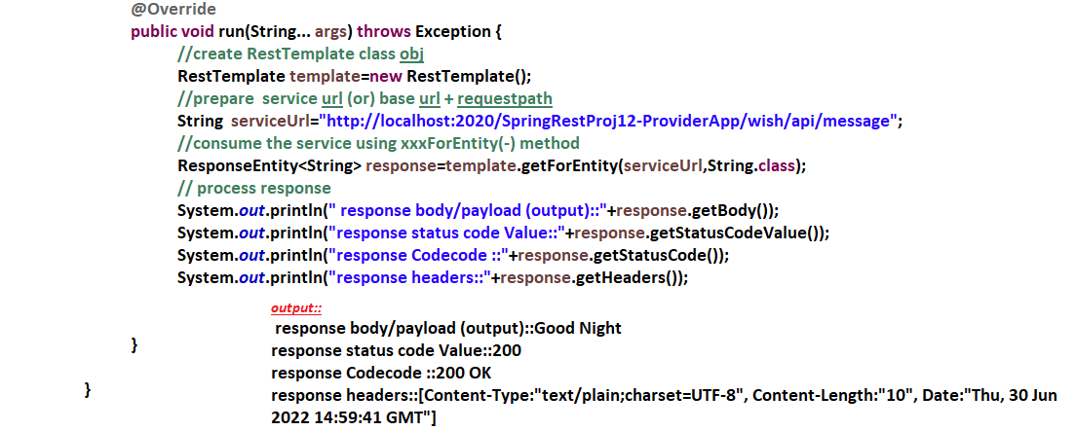

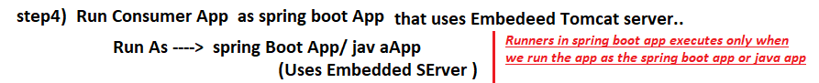

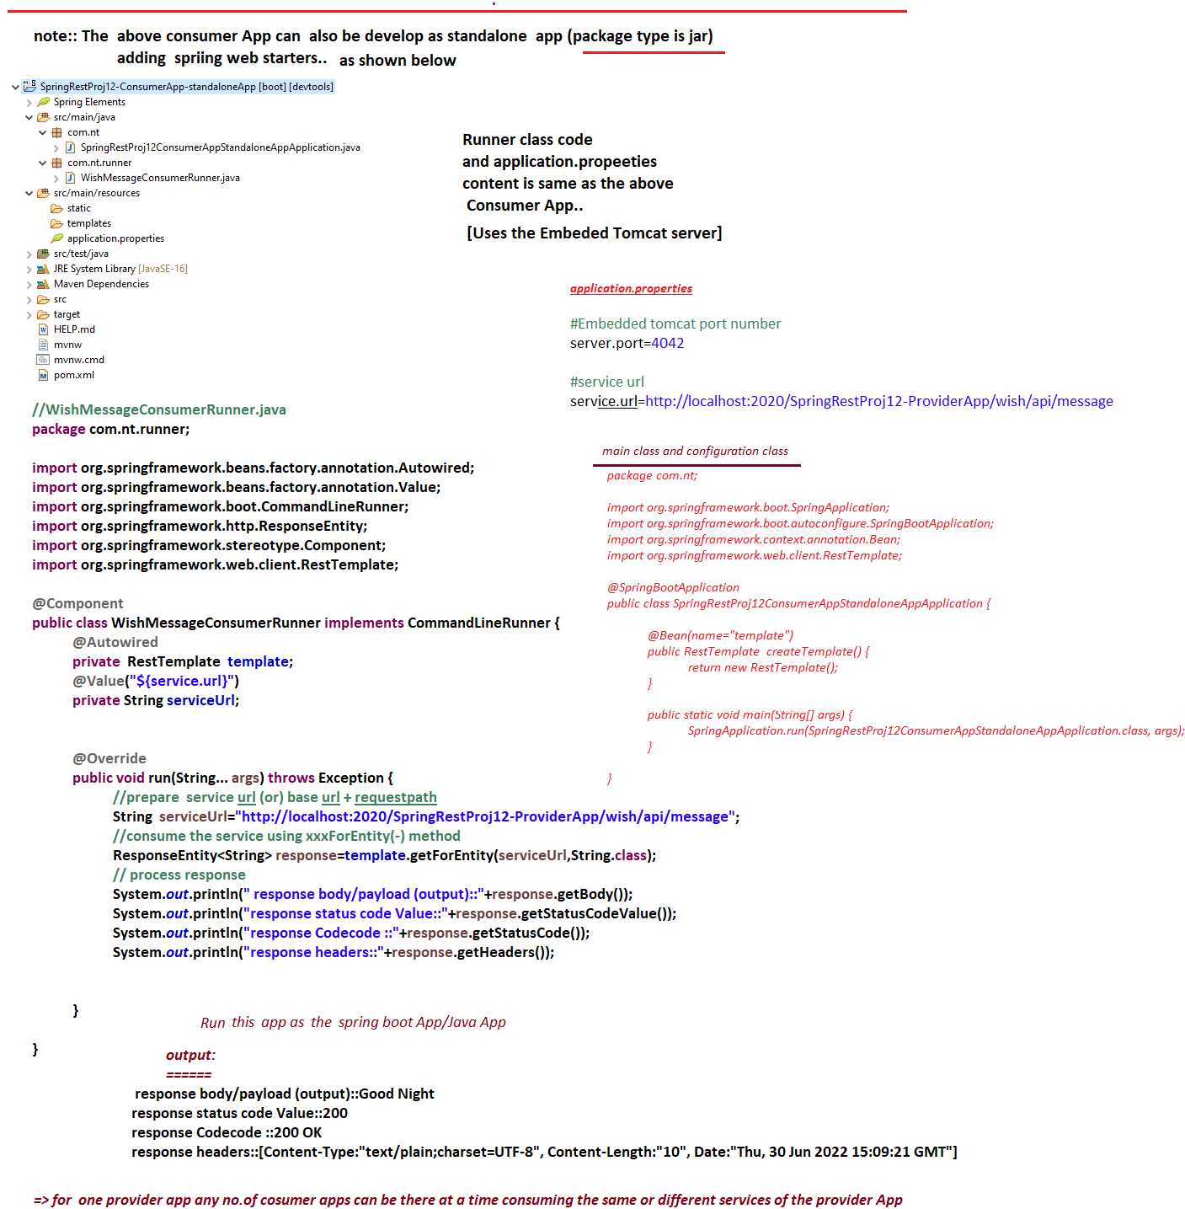

NTSPBMS615- Rest Consumer using RestTemplate-July 1st-2022

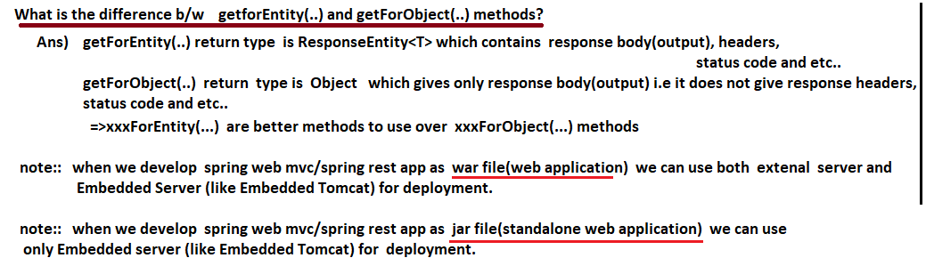

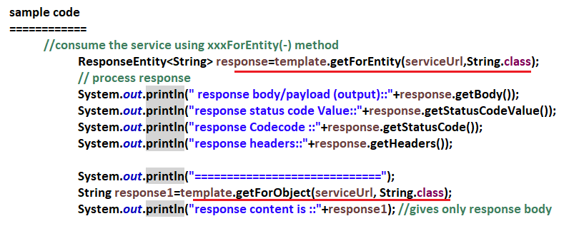

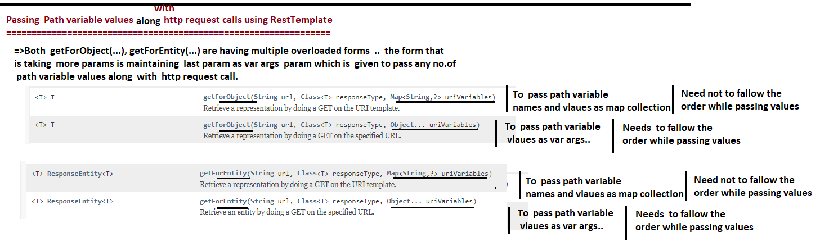

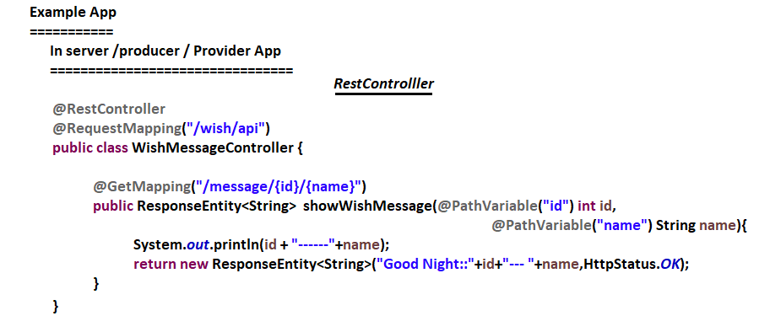

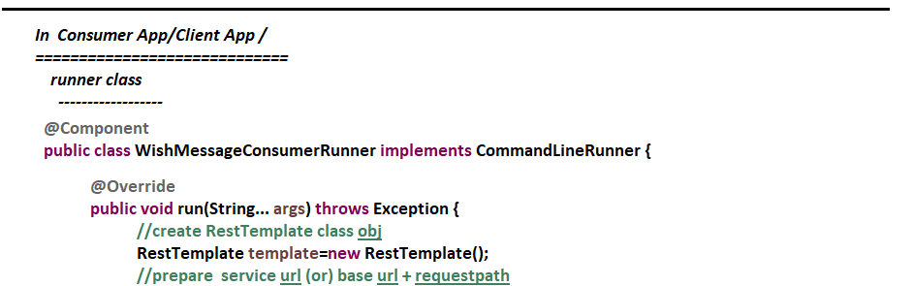

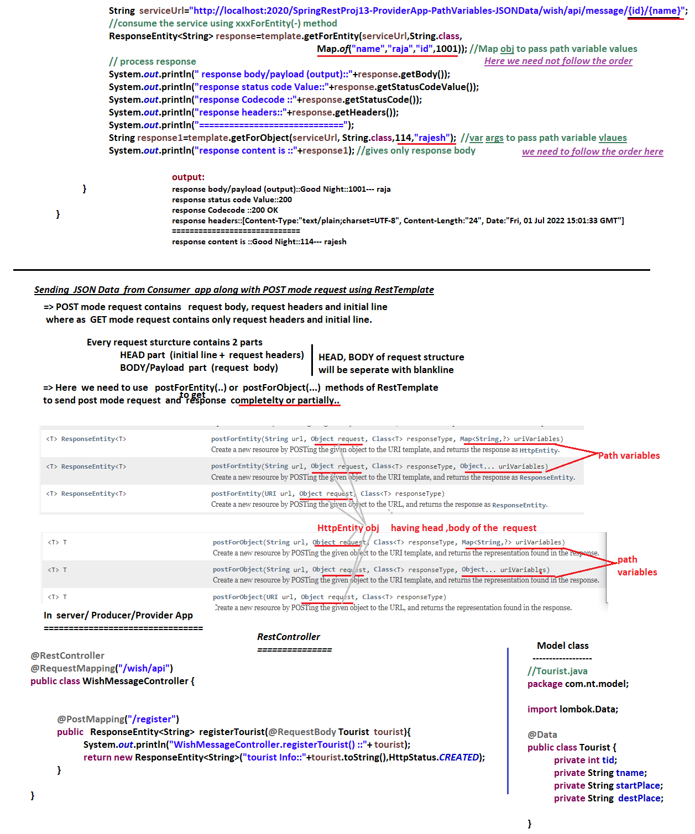

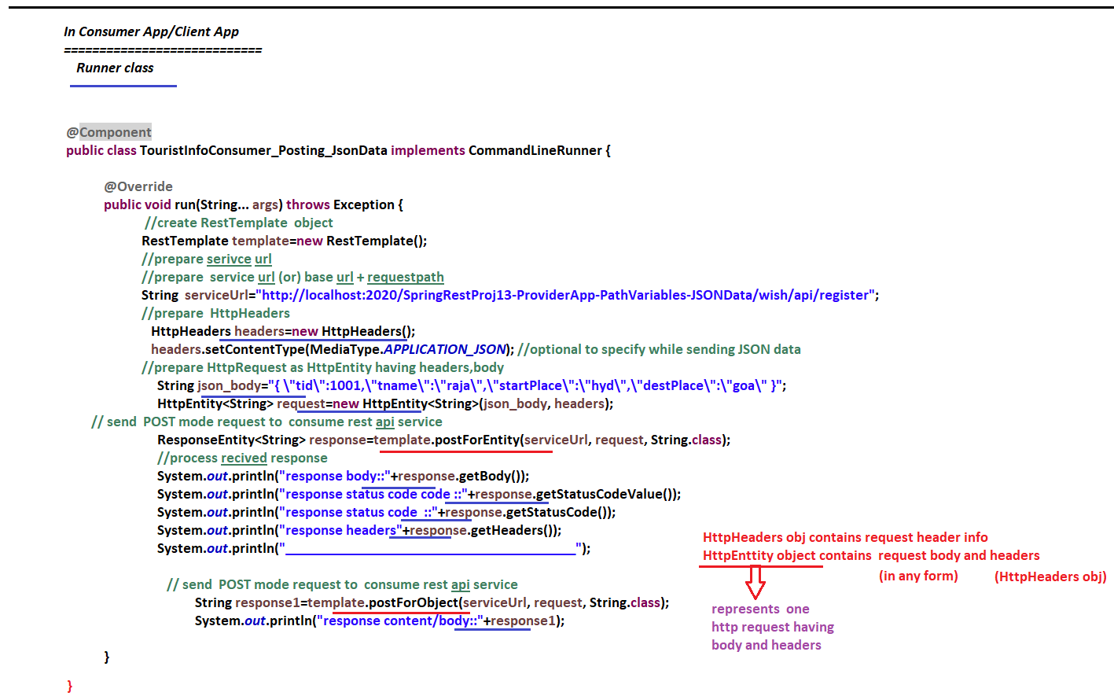

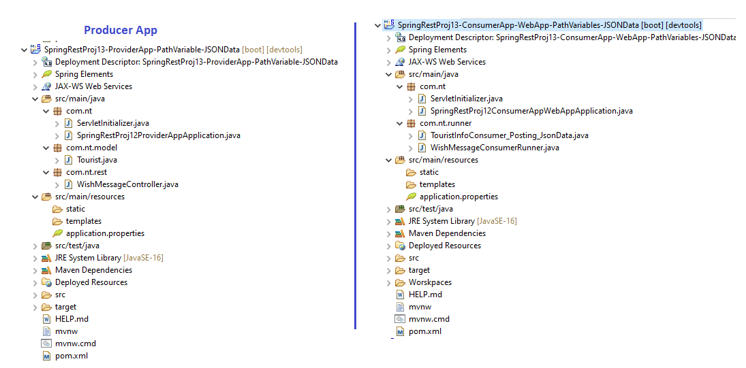

NTSPBMS615- Rest Consumer using RestTemplate-July 2nd-2022-exchange(-) method

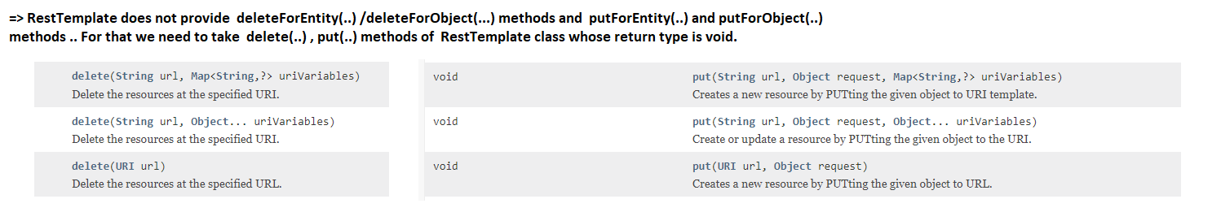

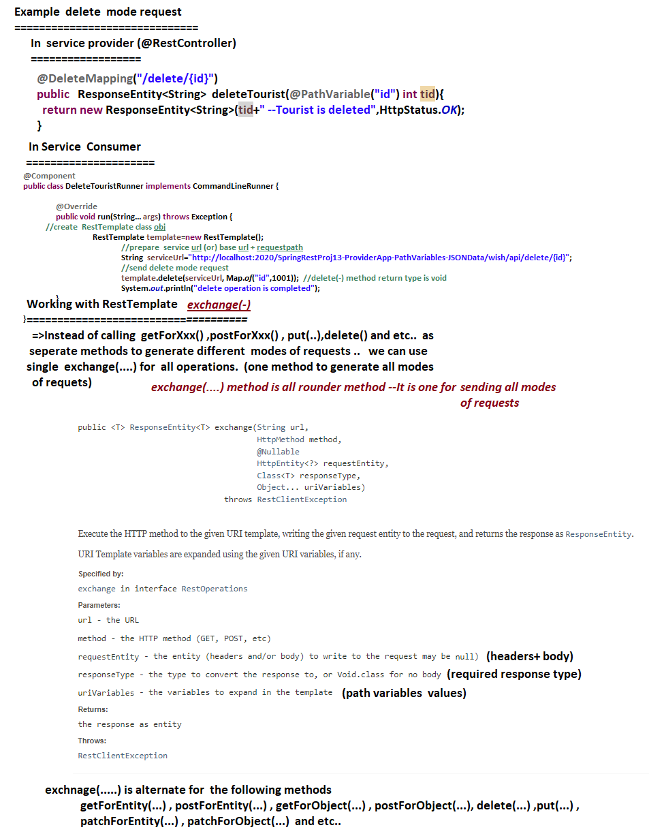

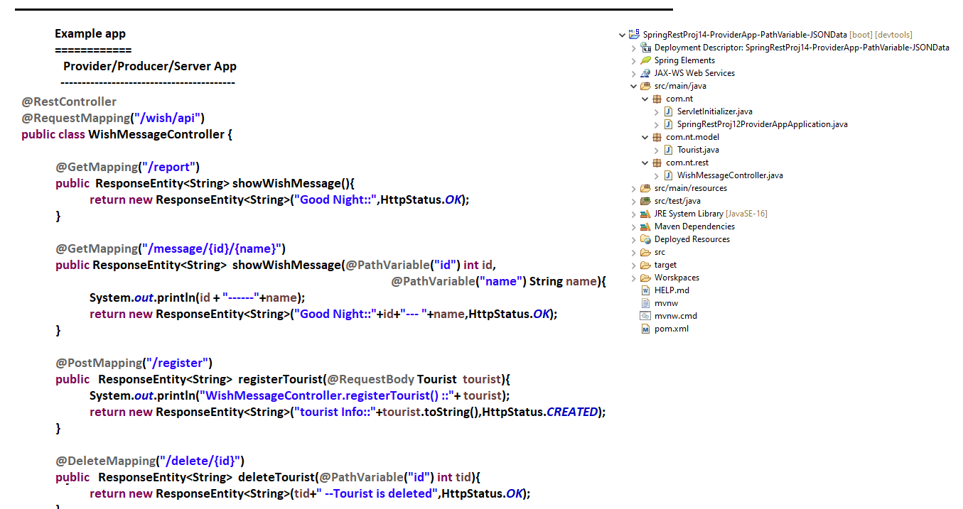

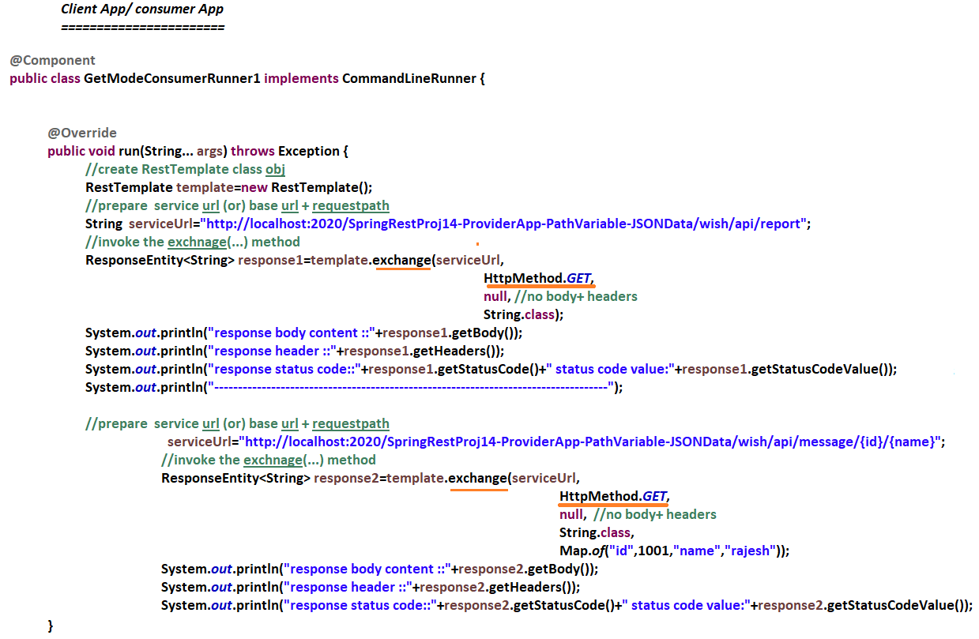

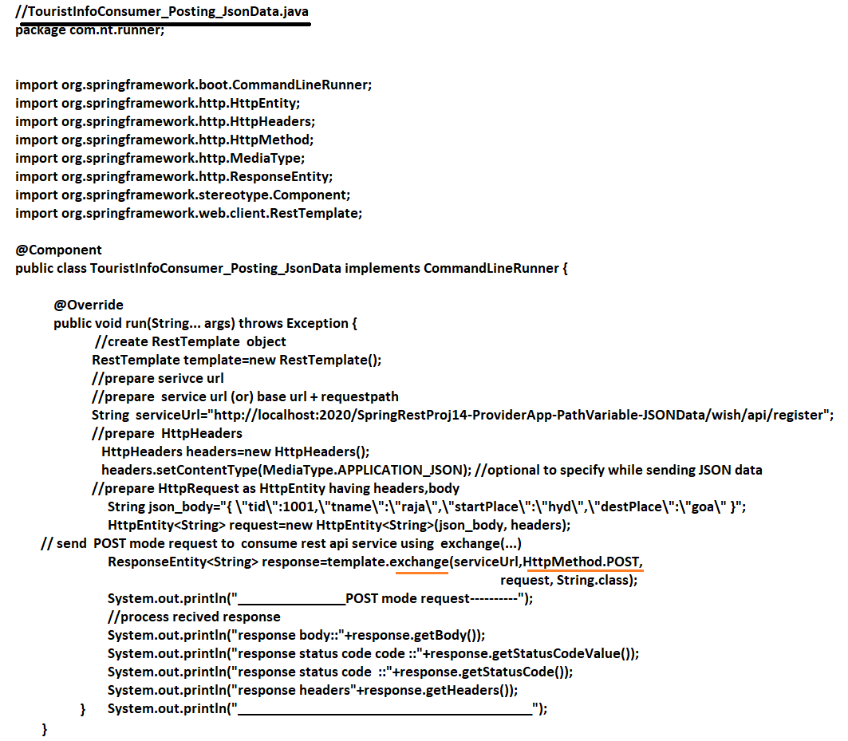

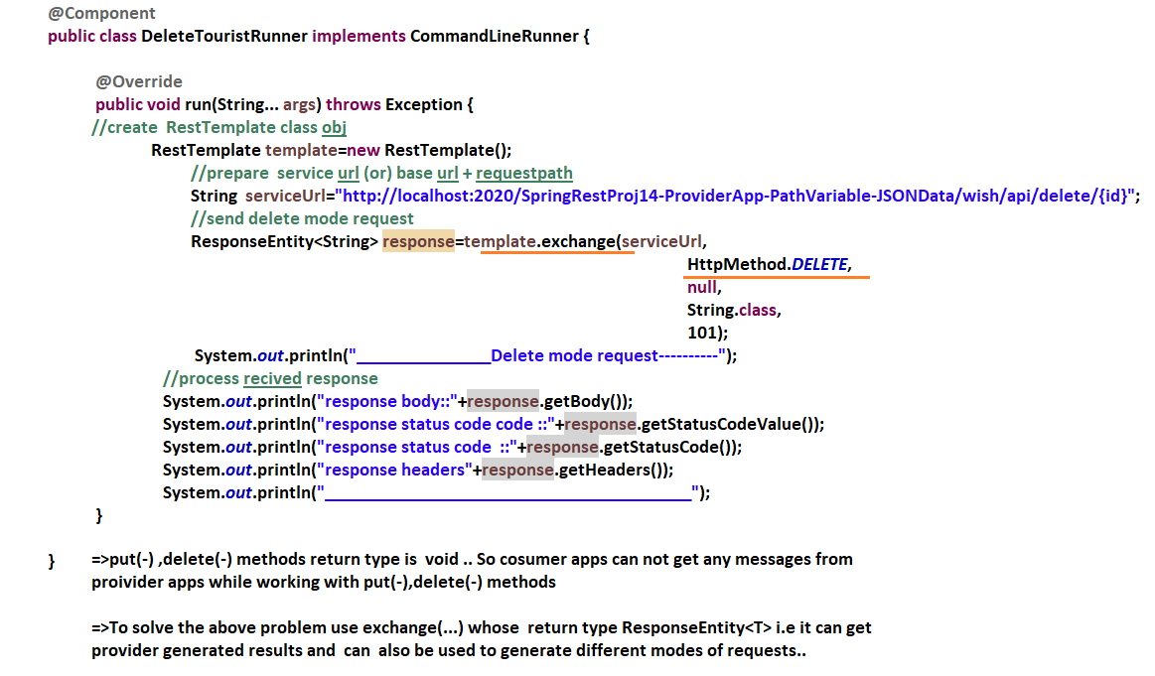

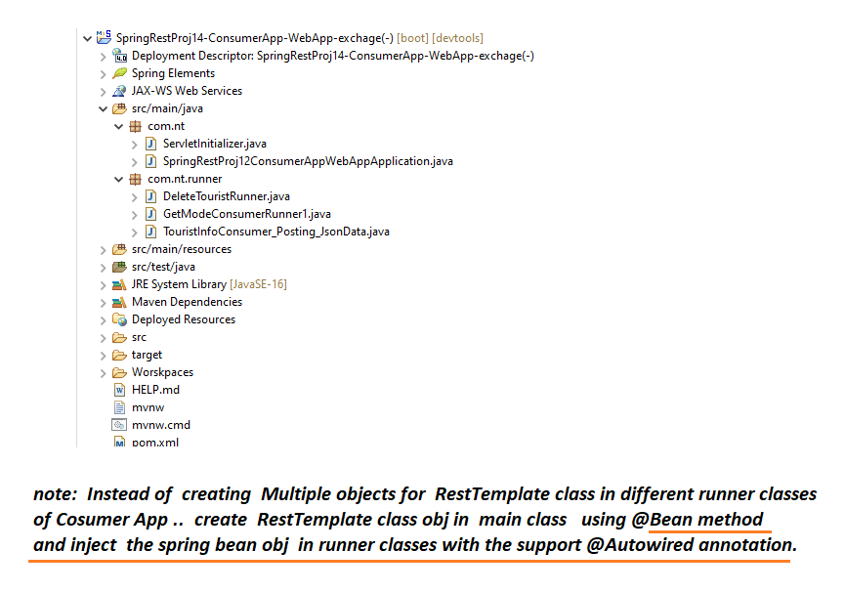

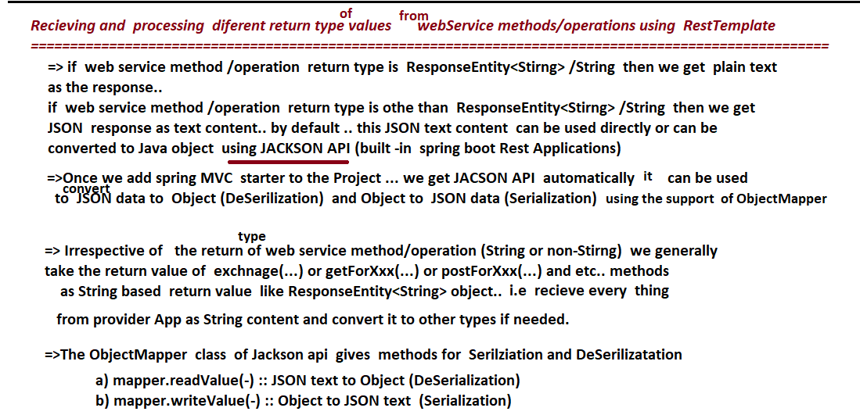

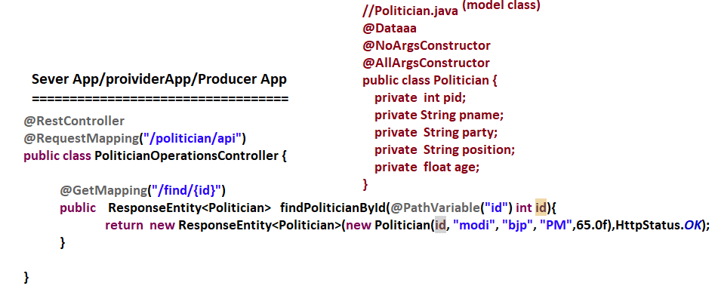

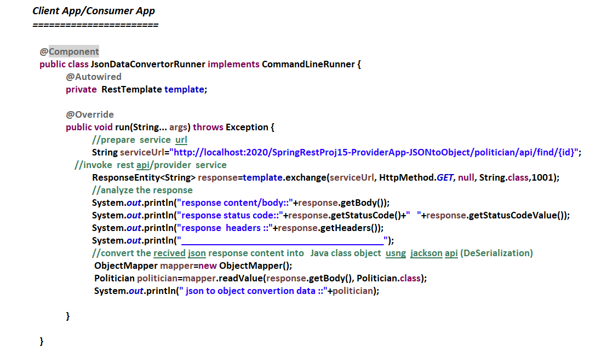

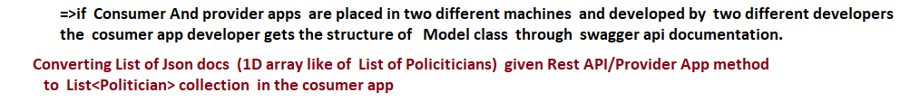

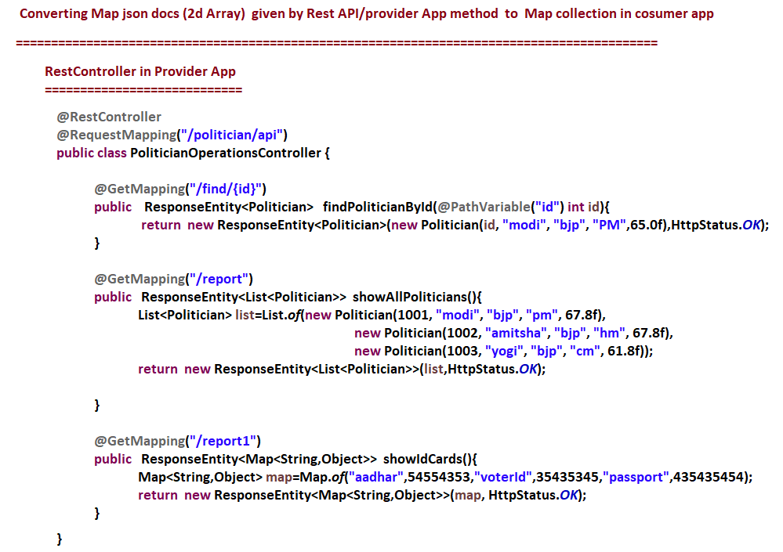

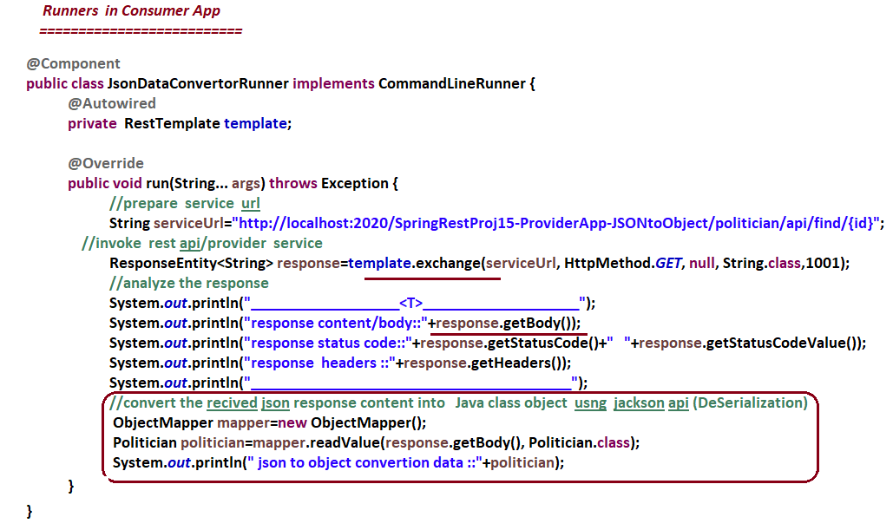

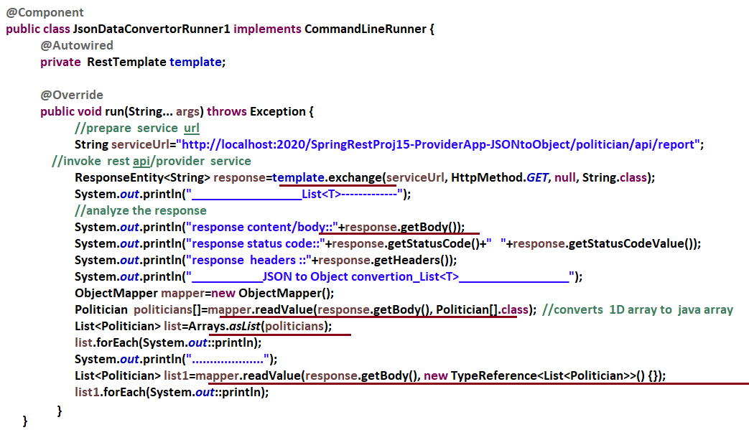

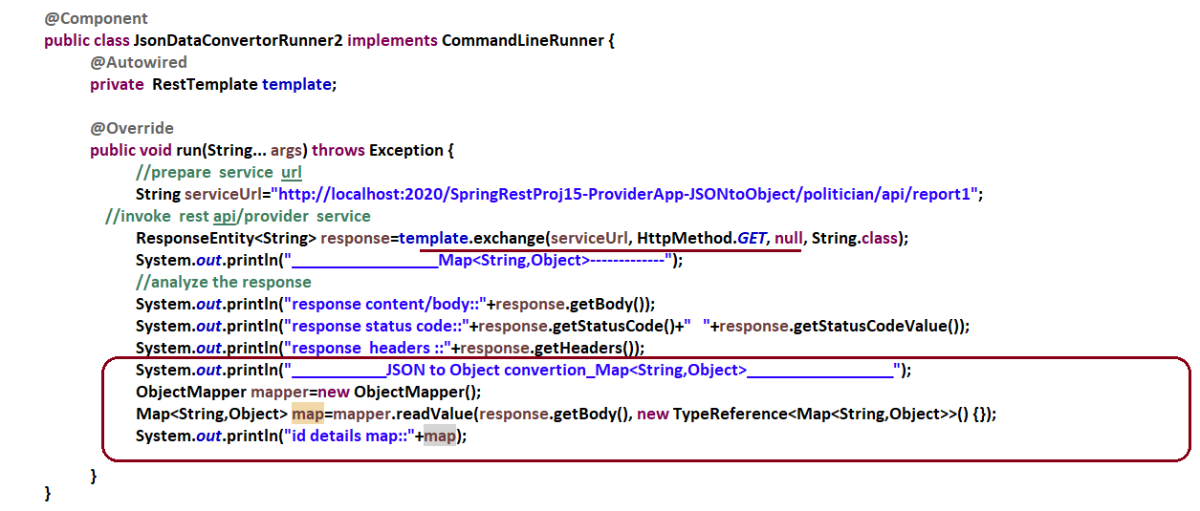

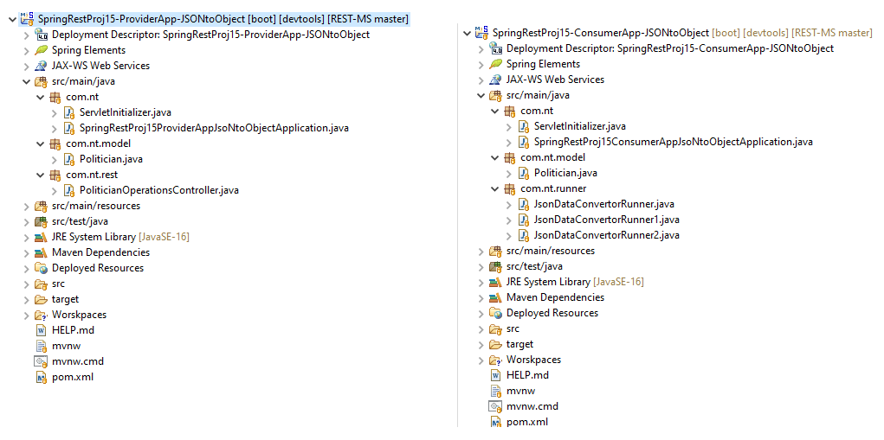

NTSPBMS615- july 4th-Spring MVC and spring Rest Comminication

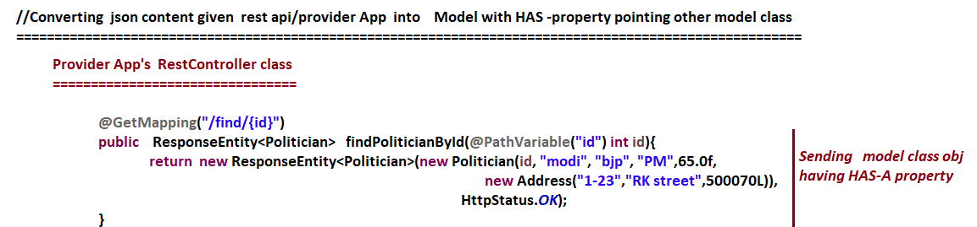

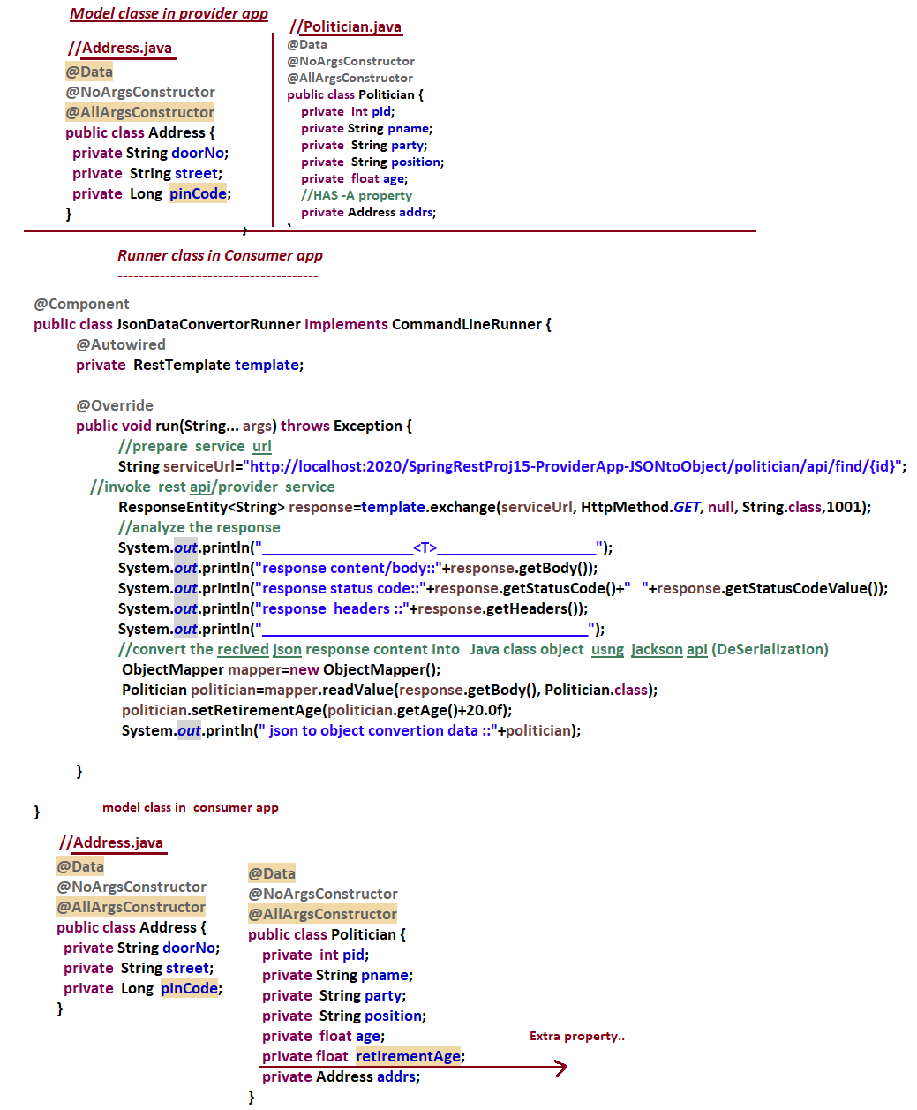

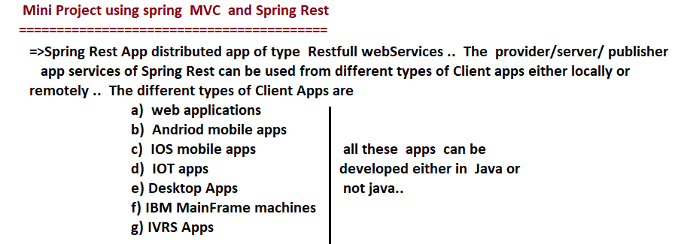

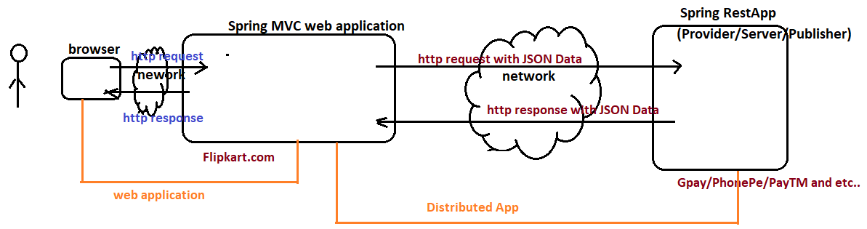

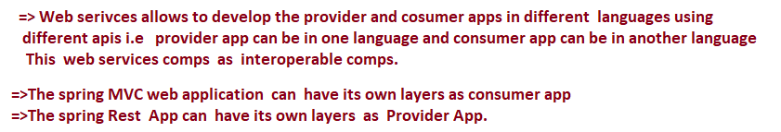

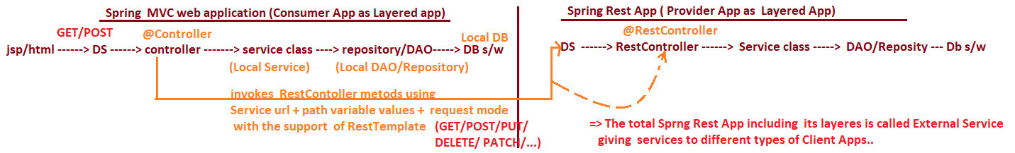

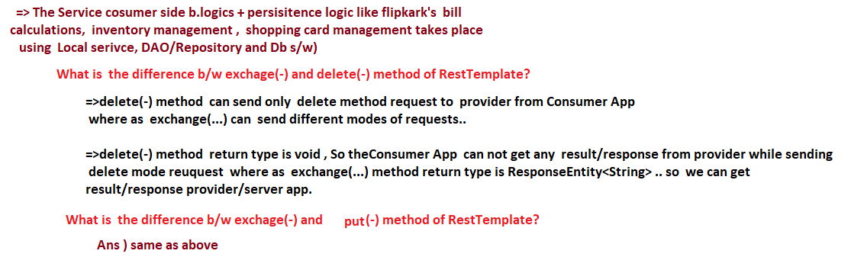

NTSPBMS615- july 9th-Spring MVC and spring Rest Comminication

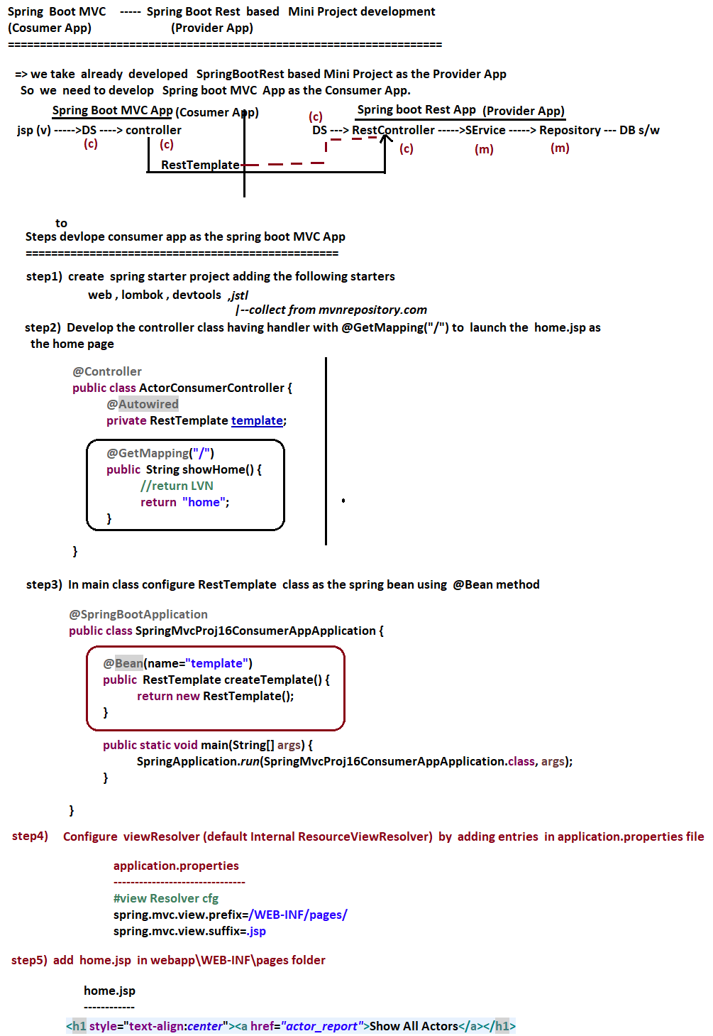



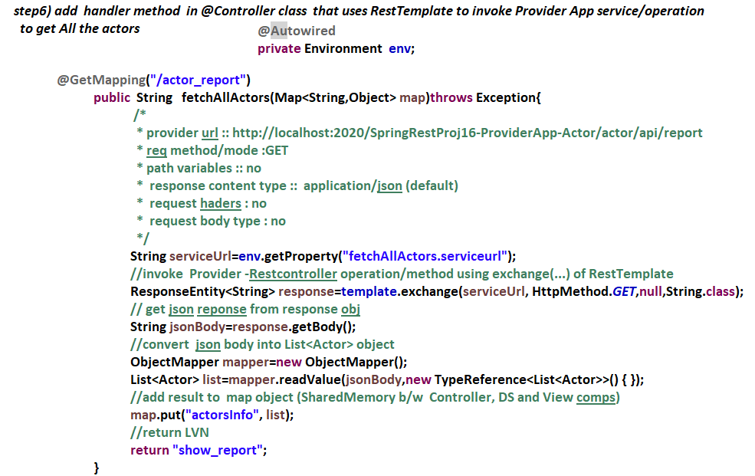

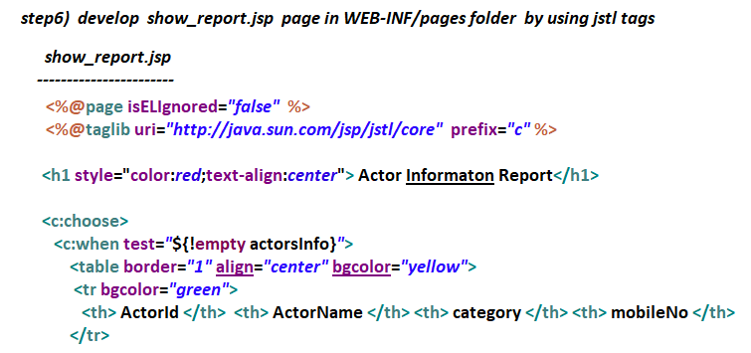

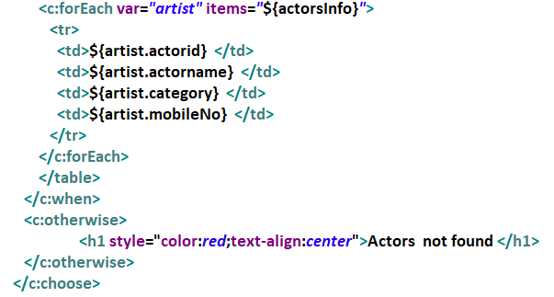



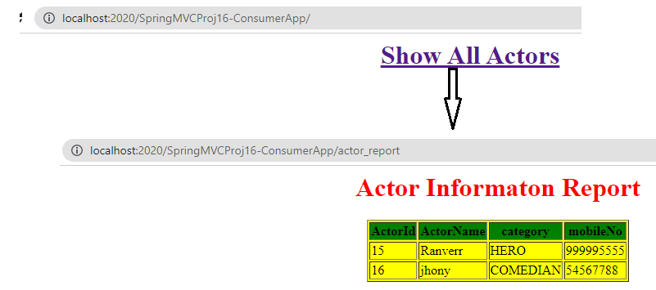

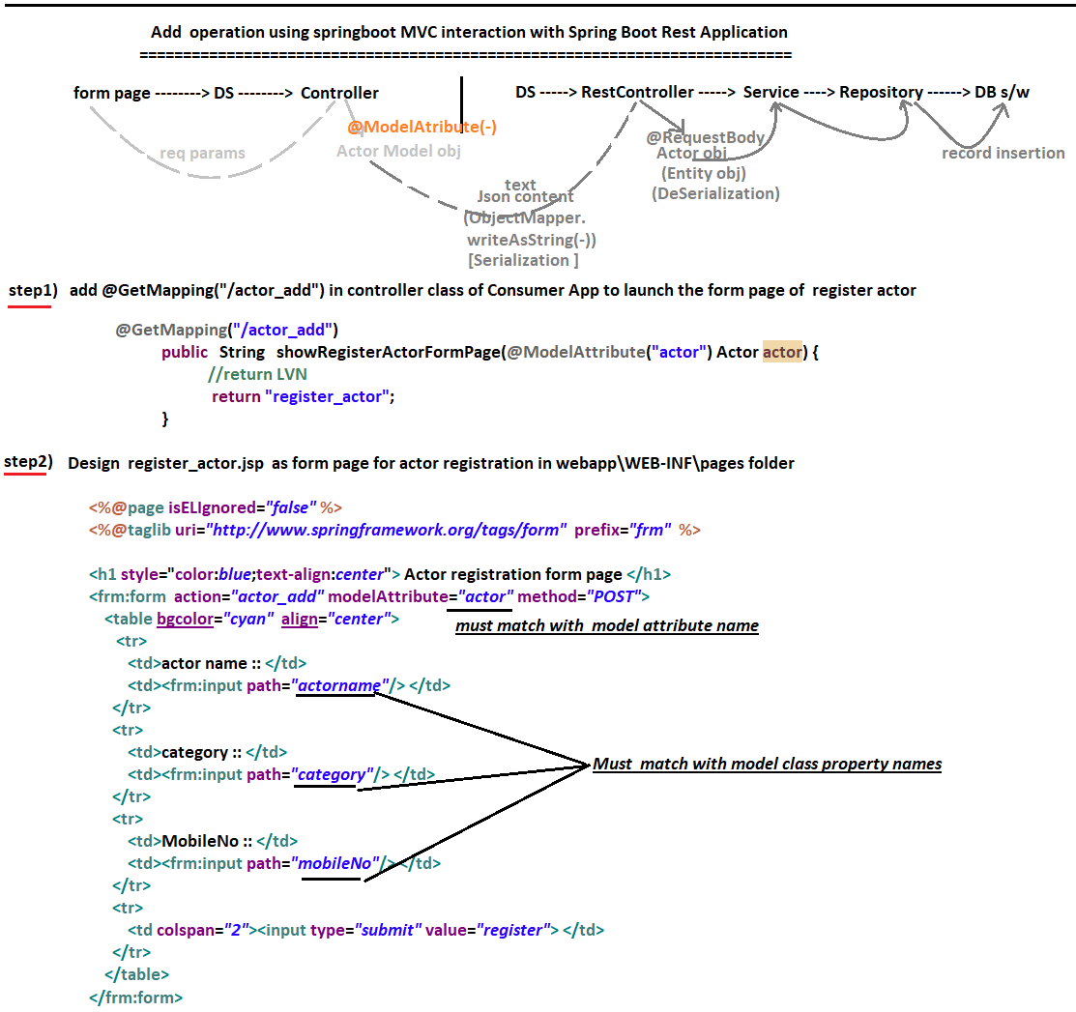

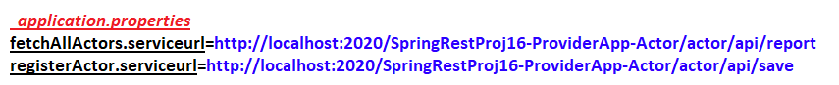

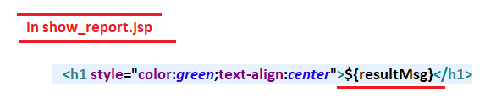

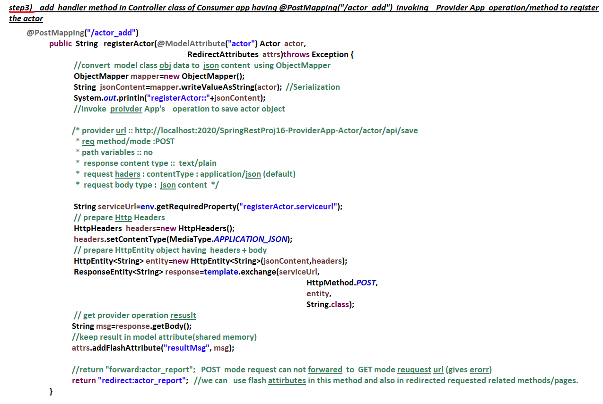

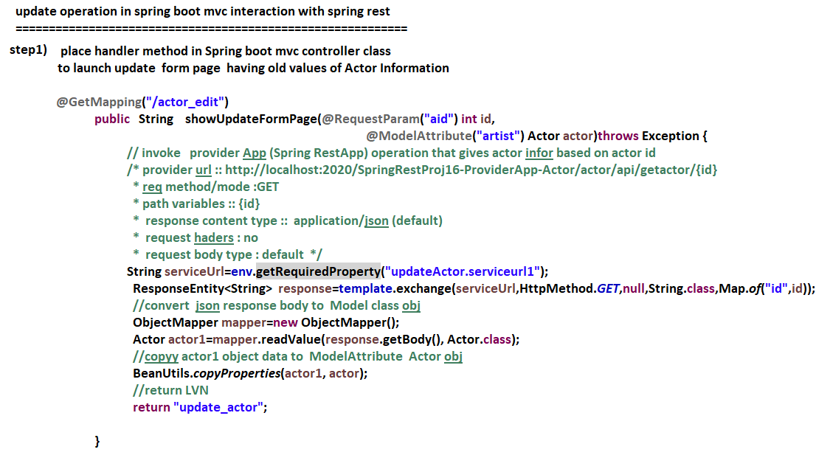

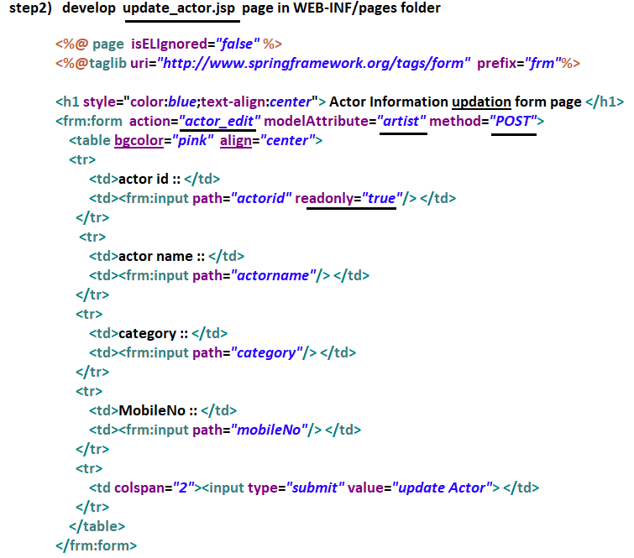

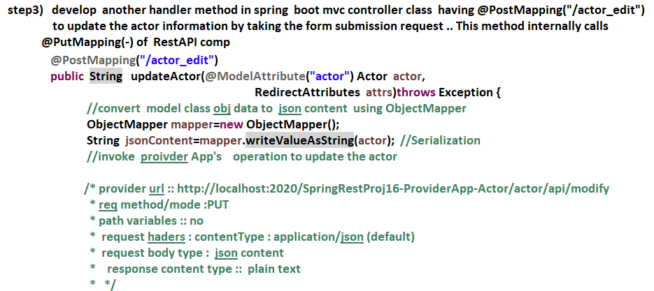

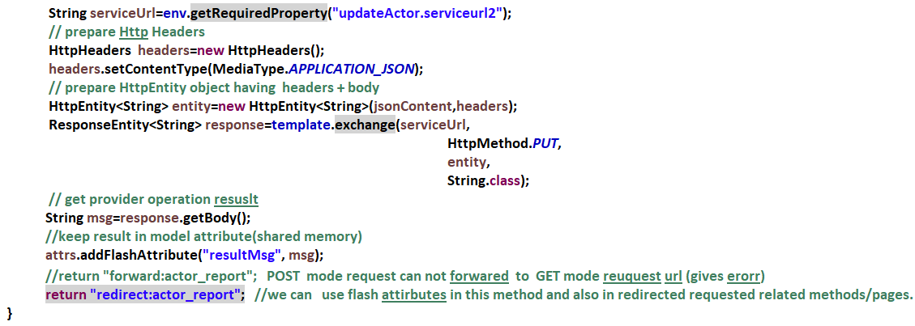

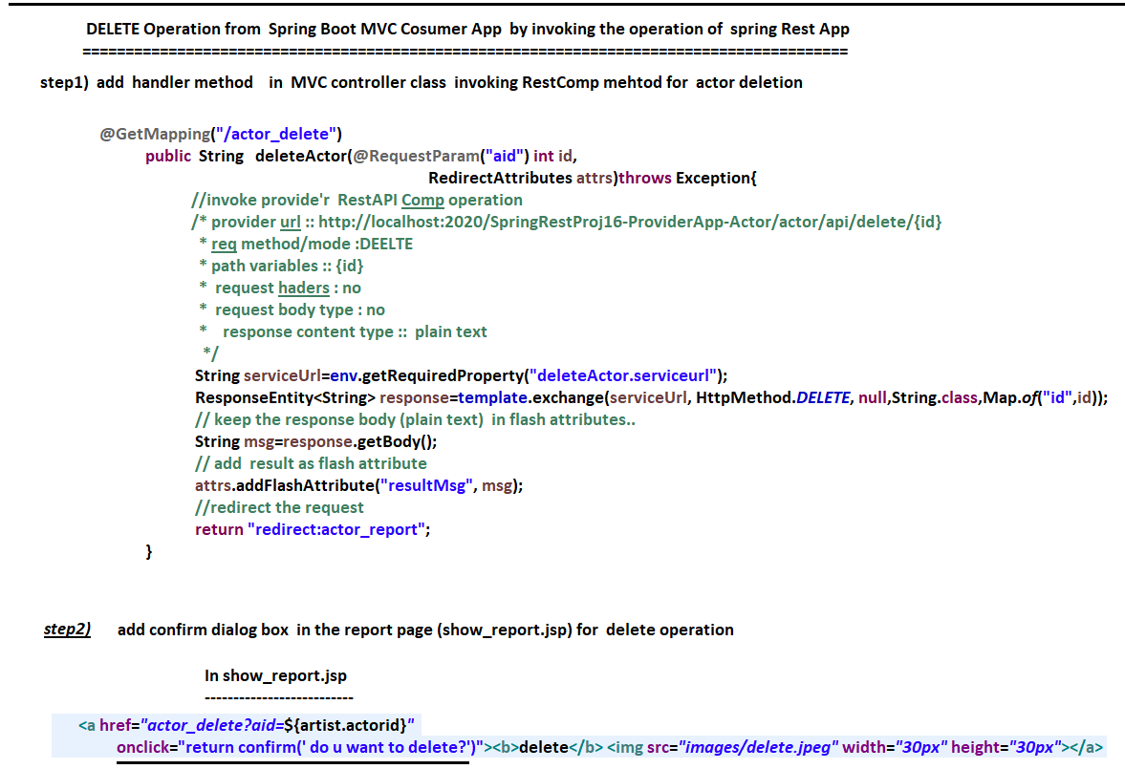

**Spring Cloud**

